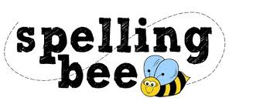

Year 1 & 2 Autumn Term

my | some | Christmas | plant
she | here | improve | break
the | has | children | only
ask | we | busy | would
are | you | after | hour
says | push | parents | wild
they | go | beautiful | whole
full | where | everybody | many
climb | great | father | class

Please practise these spellings if you would like to enter the TSSMAT Spelling Bee. Your class teacher will be running heats in your classroom.
The finals will take place on week commencing 5th February 2024

