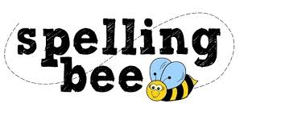

Year 3&4 Autumn Term

eight | increase
enough | important
exercise | interest
experience | island
experiment | knowledge
extreme | learn
famous | length
February | library
forward | material
fruit | medicine
grammar | mention
group | minute
guard | natural
guide | naughty
heard | notice
heart | occasionally
height | often
history | opposite
imagine | ordinary

Please practise these spellings for the MAT Spelling Bee. Your class teacher will be running heats in your classroom to determine who will go on to represent the school in the Summer Term.

You will be tested on these words WC 5th February 2024
Good luck!

