Test date: 6.9.21 | Test date: 13.9.21 | Test date: 20.9.21 | Test date: 27.9.21
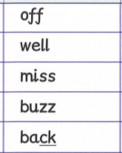 | 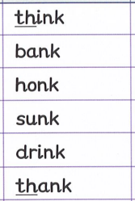 | 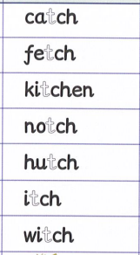 | 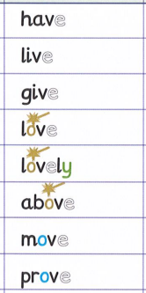
Test date: 4.10.21 | Test date: 11.10.21 | Test date: 18.10.21 | Year 1 will start with 5 spellings and gradually build up to 10 spellings. All spellings contain sounds we have learnt in Phonics lessons prior to each week.
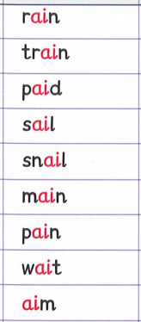 | 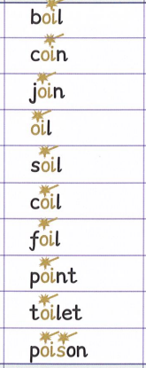 | 