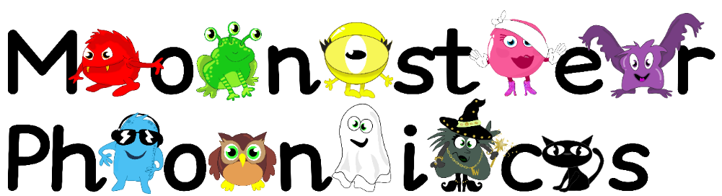
14.9.2020
Dear Parents,
Last week we starting our phonics learning with the Monster Phonics! We really enjoyed our first week of Monster Phonics and learning more about the sounds s,a,t and p.
Nursery are starting school with us this week so we are going to be playing with our new Nursery friends and helping to settle them into school. This week we will continue learning the following letter sounds in phonics.
The Black Cat sounds- s a t p
The children are learning the sound the letter makes in phonics. This will help them to read and spell as early as possible. We will continue to practice reading words with these sounds in such as; sat, tap, sap, pat.
We will also continue to focus on learning the following key words:
a at
Please encourage your child to look out for these sounds and these words in the environment, at home and in books. This will help put learning at school into a different context. I have also added activities with these sounds in to each child’s Education City homework account to support their learning at home. Remember your child’s username is their name with a 0 at the end e.g Tom0 and the password is dog. It would be fantastic if you could practice writing the letters s,a,t and p at home too. This could be done in foam, sand, on paper, with chalk- whatever you like! Send me a picture on your Class Dojo portfolio so we can see how you have been learning phonics at home.
We appreciate you supporting learning at home.
Thank you!
Mrs Coleman-Harris

