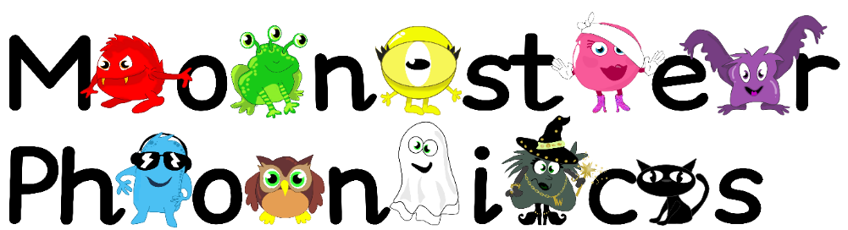
21.9.2020
Dear Parents,
Last week Reception really enjoyed learning more about the sounds s,a,t and p. We went on sound hunts, played initial sound games and read words with the sounds in using the Robot reading machine.
This week we will be learning the following letter sounds in phonics.
The Black Cat sounds- n and i
The children are learning the sound the letter makes in phonics. This will help them to read and spell as early as possible. Hear the pure sounds here - https://youtu.be/mRoFpvC0yn0
This week we will practice reading words with these sounds in such as; nap, tan, pan, sit, pit, nit, pip, sip, tip, tin and pin
We will focus on learning the following key words by sight:
a at in is it I
Please encourage your child to look out for these sounds and these words in the environment, at home and in books. This will help put learning at school into a different context. I have also added activities with these sounds in to each child’s Education City homework account to support their learning at home. Remember your child’s username is their name with a 0 at the end e.g Tom0 and the password is dog. It would be fantastic if you could practice writing the letters i and n at home too. This could be done in foam, sand, on paper, with chalk- whatever you like! Send me a picture on your Class Dojo portfolio so we can see how you have been learning phonics at home.
We appreciate your support.
Thank you!
Mrs Coleman-Harris

