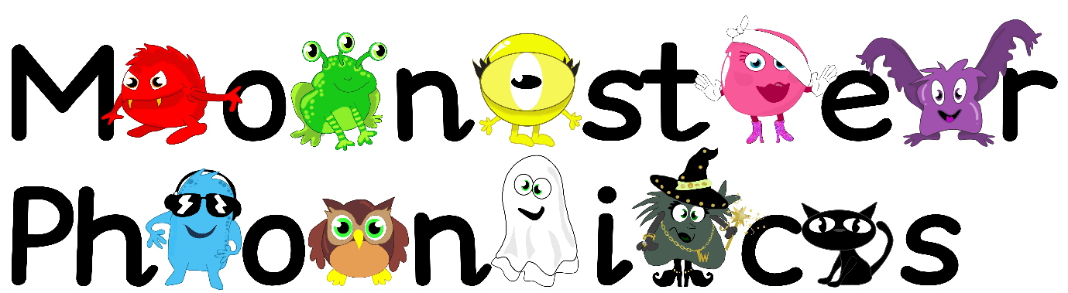

7.9.2020
Dear Parents,
This week we are starting Monster Phonics! We have already met the Monsters and we cannot wait to learn more about the sounds with them soon.
In our Monster Phonics lessons this week, the Reception children will be learning the following letter sounds.
The Black Cat sounds- s a t p
Please remember the children are learning the sound the letter makes in phonics. This will help them to read and spell as early as possible. We will practice reading words with these sounds in such as; sat, tap, sap, pat.
We will also focus on learning the following key words:
a at
Please encourage your child to look out for these sounds and these words in the environment, at home and in books. This will help put learning at school into a different context.
We appreciate you supporting learning at home.
Thank you!
Mrs Coleman-Harris

