Getting to know Parent pay

When your child joins our school in September you will be set up on the parent pay system. We use this to pay school trips, music lessons etc. When your child reaches KS2 you will also use it to pay for school lunch.
New Parents

To create a new account, you will need to have the account activation letter provided by your school to hand.
You will also need to be able to access your email because your email address will become your username and is used for the verification process.
You will receive your activation letter from school in September.
Navigate to parentpay.com
  - Select Login at the top right corner of the screen.
  - Enter the username and password (activation codes) provided in your account activation letter and select Login.
  - Complete the activation as detailed on the screen.
You can now log in to your account.
Existing Parents

If you have a ParentPay account you should log in to this account and follow the add a child process. You do not need to create a new one.
Parentpay is broken down into separate sections for each item. It shows different balances for the various items. The photo below shows a dinner money section. It clearly gives you your child’s name/s and the balance on each particular area.
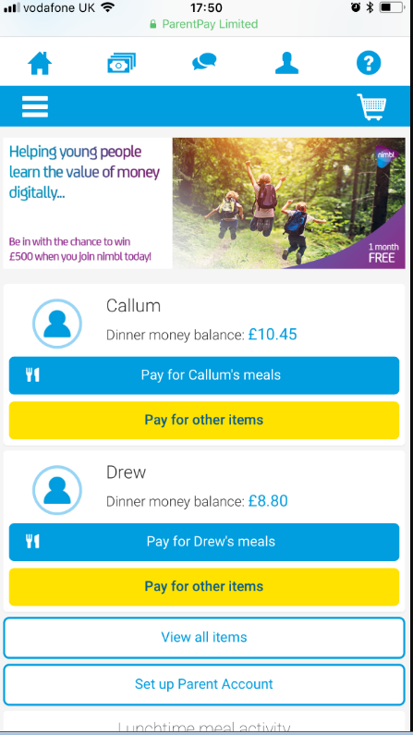

You can get a more in depth statement for your child by selecting their name. It will take you to their page and will list all the items you COULD have to pay for during the school year
Please note: Care Club and uniform automatically appear for all students.

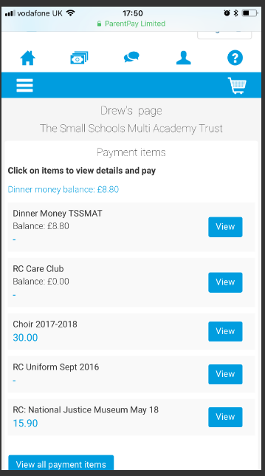

To make a payment: simply click on the item you wish to pay for e.g dinner money, select your payment amount and
then pay for it by following the instructions on screen.
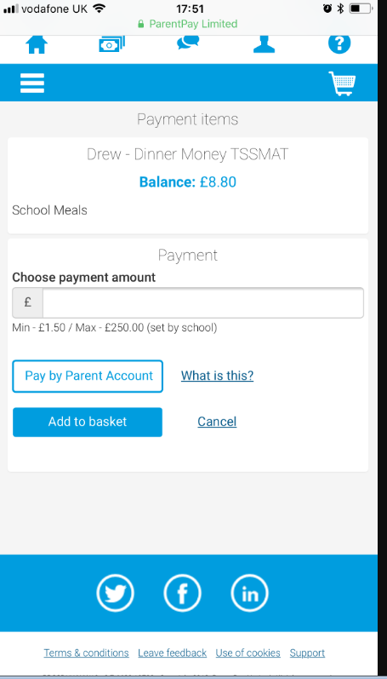
The minimum/maximum amount you can add is shown underneath the “chose payment amount” box. This is set by the school and you can pay an amount between the minimum and maximum amounts
If you have any questions regarding your parentpay account, please do not hesitate to contact the staff in the school office, who will be more than willing to help you.

Thank you

