
Cooking & Nutrition
Curriculum Overview

“Cooking with kids is not just about ingredients, recipes and cooking. It’s about harnessing imagination, empowerment and creativity.”

Guy Fieri
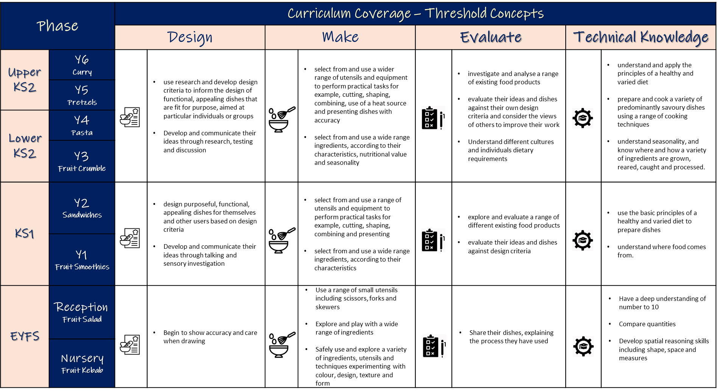
Intent
Cooking & Nutrition is an inspiring, rigorous and practical subject. Using creativity and imagination, children design and make dishes that consider their own and others’ needs, wants and values. They acquire a broad range of subject knowledge and draw on disciplines such as mathematics and science. Children learn how to take risks, becoming resourceful, innovative, enterprising and capable citizens. Through the evaluation of world cultures and cuisines, they develop a critical understanding of individuals’ dietary requirements and the environmental impact of sourcing ingredients. High-quality Cooking and Nutrition education makes an essential contribution to the health, culture, wealth and well-being of the nation.

Implementation
The threshold concepts across the Cooking & Nutrition curriculum are taught sequentially over time to develop technical knowledge, skills and understanding from EYFS to Y6 and beyond.

The curriculum aims to ensure that all children:

- Develop the creative, technical and practical expertise needed to perform everyday tasks confidently and to participate successfully in an increasingly technological world
- Build and apply a repertoire of knowledge, understanding and skills in order to design and make high-quality prototypes and products for a wide range of users
- Critique, evaluate and test their ideas and products and the work of others

Impact
The Cooking & Nutrition curriculum at BCCET allows all children:
- To develop their God given talents and gain the technical knowledge and skills needed to become confident individuals
- To understand and evaluate technical information.
- To make informed decisions that impact on their own lives and the lives of those around them.
- To develop an increasing awareness of the moral and ethical dilemmas technical discovery can bring.
- To become active citizens of the world.
- To receive regular oral and written feedback so children are aware of their position on the learning journey, their strengths and targets, which they consider when taking their next steps.

Design & Technology
Curriculum Overview
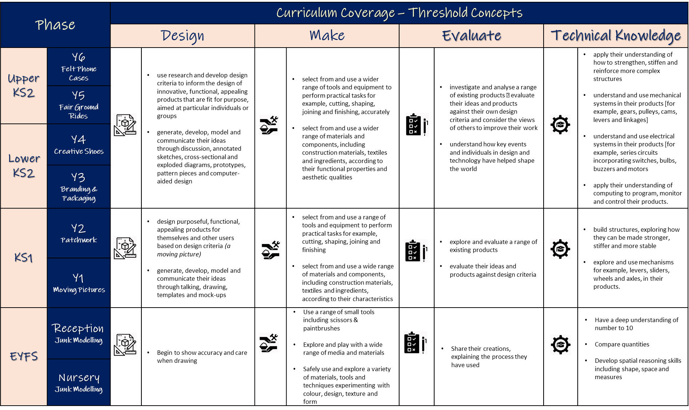
Intent
Design and Technology is an inspiring, rigorous and practical subject. Using creativity and imagination, children design and make products that solve real and relevant problems within a variety of contexts, considering their own and others’ needs, wants and values. They acquire a broad range of subject knowledge and draw on disciplines such as mathematics, science, engineering, computing and art. Children learn how to take risks, becoming resourceful, innovative, enterprising and capable citizens. Through the evaluation of past and present design and technology, they develop a critical understanding of its impact on daily life and the wider world. High-quality design and technology education makes an essential contribution to the creativity, culture, wealth and well-being of the nation.

Implementation
The threshold concepts across the Design and Technology curriculum are taught sequentially over time to develop technical knowledge, skills and understanding from EYFS to Y6 and beyond.

The curriculum aims to ensure that all children:
- Develop the creative, technical and practical expertise needed to perform everyday tasks confidently and to participate successfully in an increasingly technological world
- Build and apply a repertoire of knowledge, understanding and skills in order to design and make high-quality prototypes and products for a wide range of users
- Critique, evaluate and test their ideas and products and the work of others

Impact
The Design and Technology curriculum at BCCET allows all children:
- To develop their God given talents and gain the technical knowledge and skills needed to become confident individuals
- To understand and evaluate technical information.
- To make informed decisions that impact on their own lives and the lives of those around them.
- To develop an increasing awareness of the moral and ethical dilemmas technical discovery can bring.
- To become active citizens of the world.
- To receive regular oral and written feedback so children are aware of their position on the learning journey, their strengths and targets, which they consider when taking their next steps.

“Design and Technology should be the subject where mathematical brainboxes and science whizzkids turn their bright ideas into useful products.”
James Dyson

