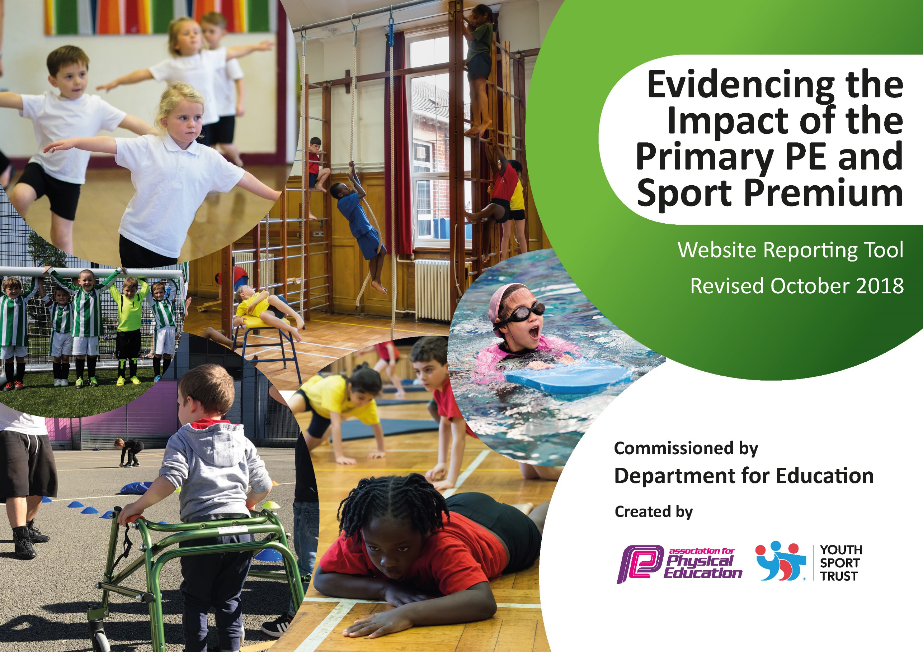
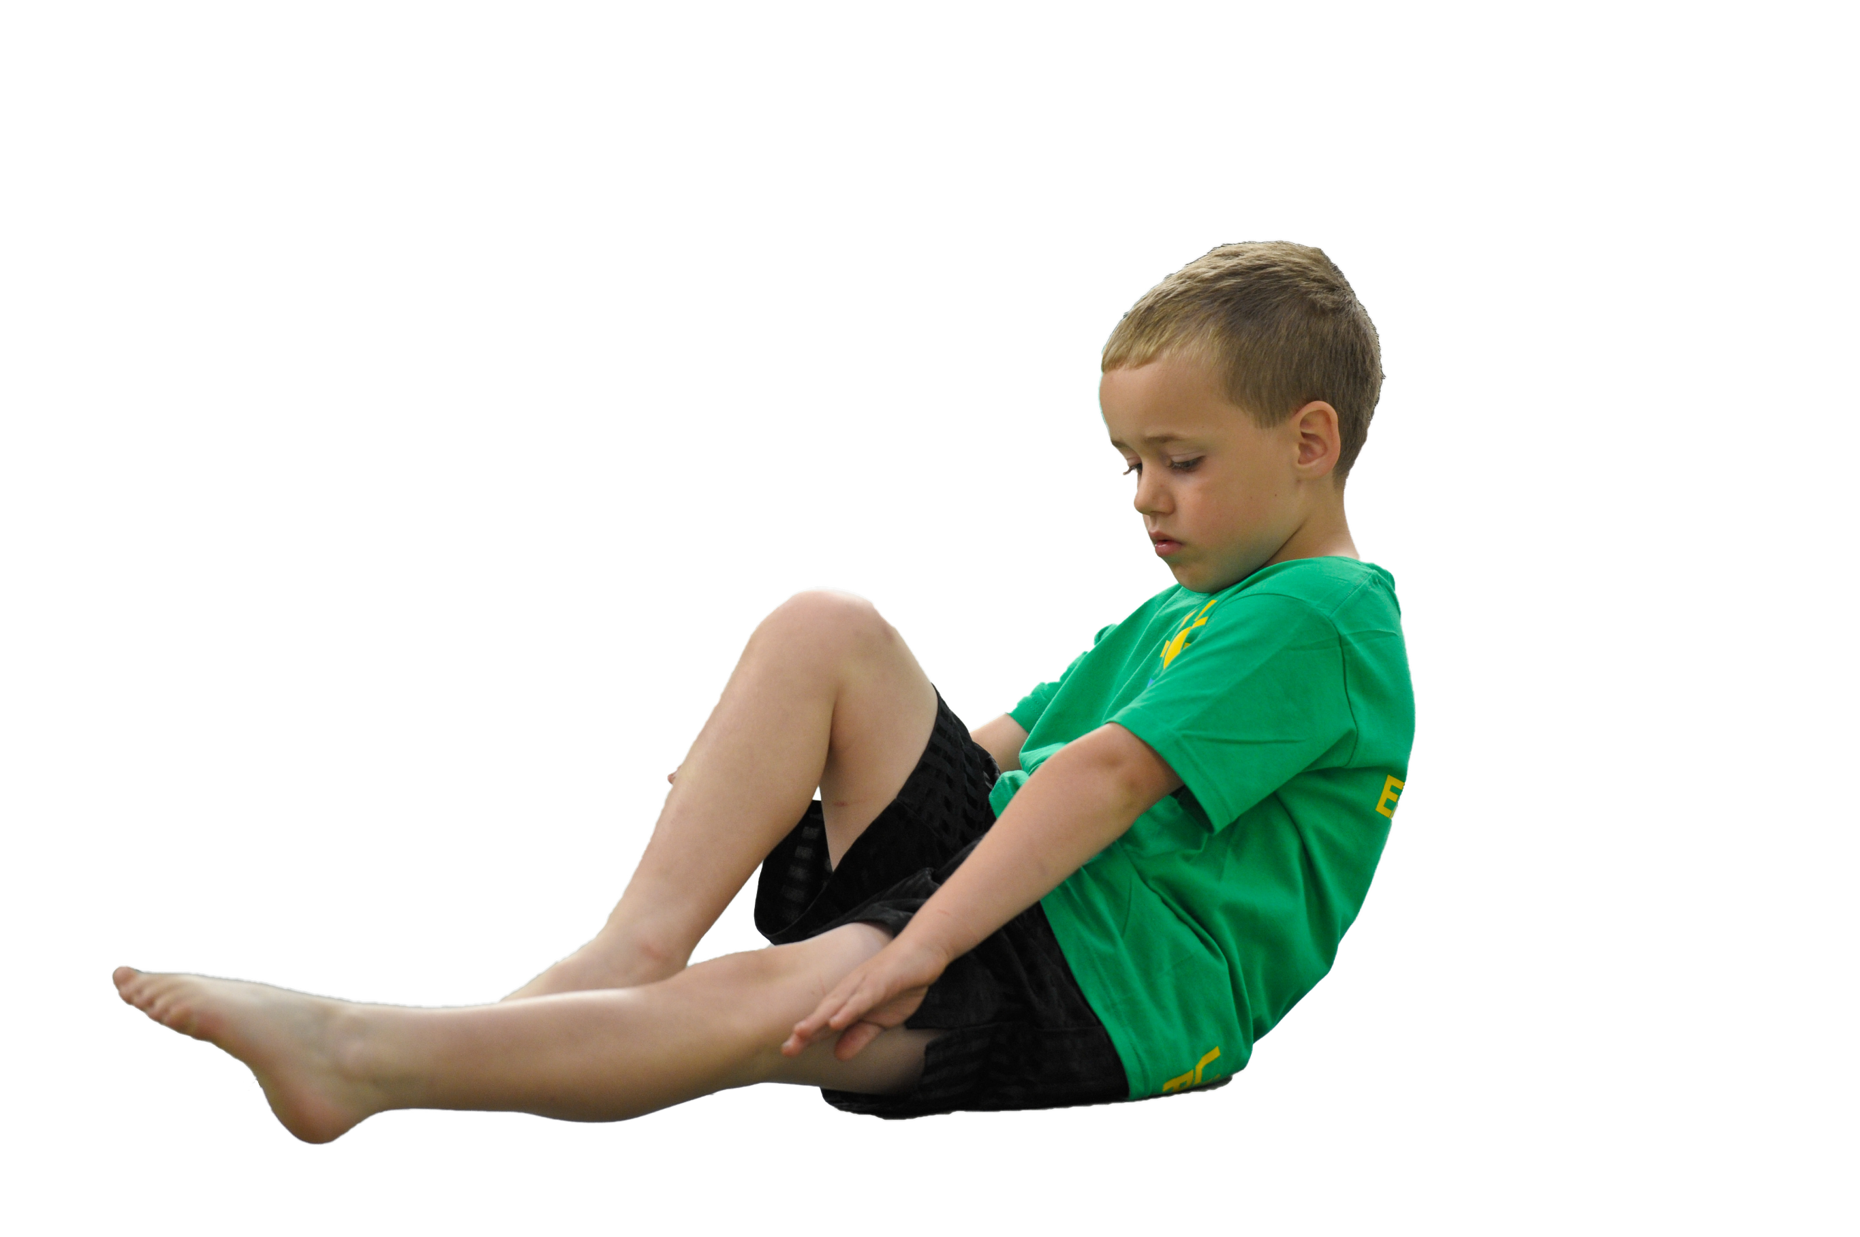
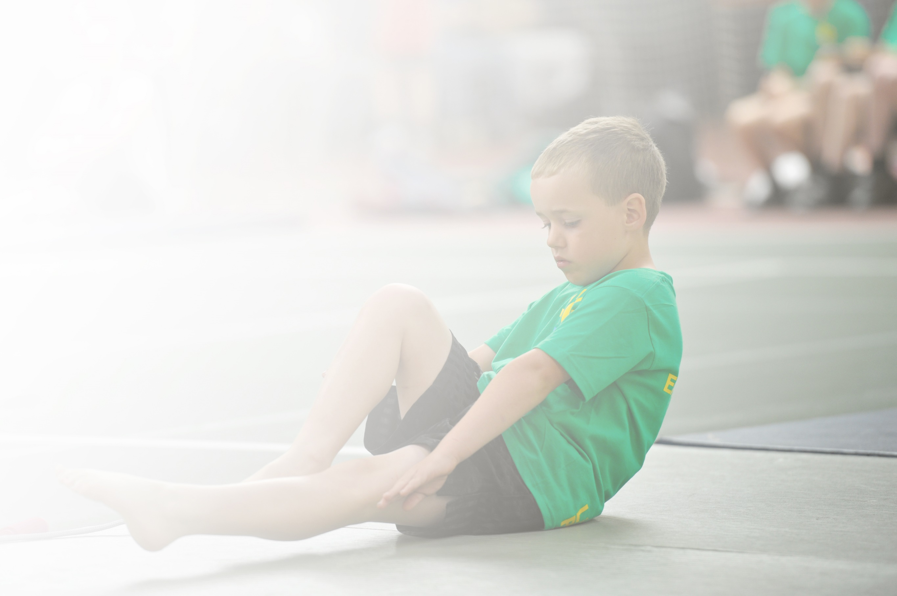
Schools must use the funding to make additional and sustainable improvements to the quality of Physical Education, Sport and Physical Activity (PESPA) they offer. This means that you should use the Primary PE and Sport Premium to:

- Develop or add to the PESPA activities that your school already offer
- Build capacity and capability within the school to ensure that improvements made now will benefit pupils joining the school in future years

Please visit gov.uk for the revised DfE guidance including the 5 key indicators across which schools should demonstrate an improvement. This document will help you to review your provision and to report
your spend. DfE encourages schools to use this template as an effective way of meeting the reporting requirements of the Primary PE and Sport Premium.

We recommend you start by reflecting on the impact of current provision and reviewing the previous
spend. Under the Ofsted Schools Inspection Framework, inspectors will assess how effectively leaders use the Primary PE and Sport Premium and measure its impact on outcomes for pupils, and how effectively governors hold them to account for this.

Schools are required to publish details of how they spend this funding as well as on the impact it has on pupils’ PE and sport participation and attainment by the end of the summer term or by 31 July 2019 at the
latest.
We recommend regularly updating the table and publishing it
on your website throughout the year, as evidence of your
ongoing review into how you are using the money to
secure maximum, sustainable impact. To see an
example of how to complete the table please
click HERE.

Support for review and reflection - considering the 5 key indicators from DfE, what development needs are a priority for your setting and your students now and why? Use the space below to reflect on previous spend, identify current need and priorities for the future.

Key achievements to date: 2019/2020 | Areas for further improvement and baseline evidence of need:
The school continues to promote a positive and inclusive view of Physical education. We have a number of children with SEN needs who participate fully in PE lessons.  We have many different sporting activities both at lunch time and after school open to all different age groups. |These were offered up until the closure of schools in March 2020. However, as a school we remained open for Key worker and vulnerable children so we continued to offer some form of fitness and skills with social distancing.  The school has sufficient resources to enable staff to deliver high quality PE lessons.  Swimming lessons are now 1 hour long for Y4 children which has made a huge impact on how many children can swim proficiently. However only half of our Y4 children received their entitlement of lessons due to school closure.  All children from Y1 to Y6 have had an Outdoor Education Experience with Hothersall Lodge in school. This is part of a rolling programme which means the children will have a different Outdoor experience each year ending with a residential in Y6.  Yoga is part of the curriculum now across both Key Stages due to Pupil Voice feedback.  We started to introduce a manageable assessment tool, the progress of this was cut short due to schools closures.  The Y3/4 gymnastics team won their category in a gymnastics competition and received a trophy.  Gifted and Talented children in Dance and Gymnastics were given opportunities to have extra sessions with our coach to work towards competitions. Dance competition was cancelled due to Covid. | More work is required on the new assessment procedure for PE. This will be done through staff sharing their experiences of what they have already done and CPD.  To focus on Early years and KS1 to try and develop basic PE skills as many come with a low starting point.  To promote more competitive sport across the whole school. This is limited to activities taking place during school time as many children do not participate in after school clubs due to Mosque  To continue to promote after school sports club. Up take can be poor as many children have Mosque commitments.  To target the now Y5 class who missed their swimming lessons.  To target non-swimmers in Y6 and give extra top up sessions to enable them to achieve the required standard before they leave KS2.

Meeting national curriculum requirements for swimming and water safety | Please complete all of the below:
What percentage of your current Year 6 cohort swim competently, confidently and proficiently over a distance of at least 25 metres?  N.B. Even though your children may swim in another year please report on their attainment on leaving  primary school. | 63%
What percentage of your current Year 6 cohort use a range of strokes effectively [for example, front crawl, backstroke and breaststroke]? | 18%
What percentage of your current Year 6 cohort perform safe self-rescue in different water-based situations? | 71.6%
Schools can choose to use the Primary PE and Sport Premium to provide additional provision for swimming but this must be for activity over and above the national curriculum requirements. Have you used it in this way? | Yes/No ( Due to school closure)

Action Plan and Budget Tracking
Capture your intended annual spend against the 5 key indicators. Clarify the success criteria and evidence of impact that you intend to measure to evaluate for students today and for the future.

Academic Year: 2019/2020 | Total fund allocated: £19,542 | Date Updated: Oct 2020
Key indicator 1: The engagement of all pupils in regular physical activity – Chief Medical Officer guidelines recommend that primary school children undertake at least 30 minutes of physical activity a day in school |  |  |  | Percentage of total allocation:
 |  |  |  | 11.77%
School focus with clarity on intended impact on pupils: | Actions to achieve: | Funding allocated: | Evidence and impact: | Sustainability and suggested next steps:
Increased activity on the playground | - Sports coach employed at lunchtimes  - Running club run by member of staff. | £2300 | Children are active during all break times either with free play or more structured activities led by staff. | Consider additional funds to be made available for replenishing break time equipment to encourage free play.
Key indicator 2: The profile PE being raised across the school as a tool for whole school improvement |  |  |  | Percentage of total allocation:
 |  |  |  | 9.31%
School focus with clarity on intended impact on pupils: | Actions to achieve: | Funding allocated: | Evidence and impact: | Sustainability and suggested next steps:
Increased opportunities to take part in inter-house sporting competitions within school.  Children will have an OOA experience at school.  To research Commando Joe programme for a whole school programme | - All children to take part in a multi activity sports day at a purpose built venue  - Purchase of certificates and stickers  Hothersall Lodge to come into school and deliver a programme of activities to Y2- Y5.  Y6 children to have a residential experience at Hothersall Lodge  Meet with the Commando Jo team and plan in a programme that suits our children and school for academic year 2020/2021 | £0  £1320  £0  £500 | This was not done due to school closure.  Children experienced orienteering, den building, team challenges. Staff saw an improvement in co-operation and self- esteem.  Only about 2/3 of our Y6 children went on the residential, the lowest uptake for a few years. The children who attended all showed improvement in confidence, social skills and resilience.  From Sept 2020 school will have a member of the Commando Jo team in on a Friday. They will work with every class in school. All activities will focus on experiences, resilience, teamwork, problem solving. They will provide mentoring, lunchtime activities and before and after school activities. | To continue with this action for the academic year 2020-21  This is now an integral part of our school PE curriculum with a planned rolling programme.  To look at how we can encourage more Y6 children to attend by offering a full day at the centre for children who do not want to stay overnight.  To monitor the impact within classes and whole school. To see if experiences and activities can link to other parts of the curriculum.

Key indicator 3: Increased confidence, knowledge and skills of all staff in teaching PE and sport |  |  |  | Percentage of total allocation:
 |  |  |  | 20%
School focus with clarity on intended  impact on pupils: | Actions to achieve: | Funding  allocated: | Evidence and impact: | Sustainability and suggested  next steps:
To focus on Yoga and Dance  Resources purchased for teachers to deliver quality lessons.  To continue to purchase a PE online planning tool to enhance teacher planning. | All classes and Teachers will have a 6 week yoga course with a qualified Yoga coach. This will then improve staff skills and knowledge  All classes will have a 6 week dance programme with a qualified dance coach delivering a choreographed dance linked to the topic the class is studying.  Resources will be purchased over the year to enhance the delivery of PE  Teachers will be able to use PE Hub to help plan differentiated lessons. | £2750.75  £808.69  £350 | All staff received Yoga training and many have reported using breathing techniques within class work.  Not all classes received the Dance CPD due to school closure.  Staff to have the correct equipment to be able to deliver the PE curriculum.  Teachers are using the planning tool to deliver quality lessons. Staff feedback says that it is easy to use, shows clear progression and can stretch the more able. | To purchase a set of Yoga mats for school. To keep Yoga part of the PE curriculum.  To reschedule dance CPD for academic year 2020/2021.  To continue to use the online planning tool.
Key indicator 4: Broader experience of a range of sports and activities offered to all pupils |  |  |  | Percentage of total allocation:
 |  |  |  | 6.75%
School focus with clarity on intended  impact on pupils: | Actions to achieve: | Funding  allocated: | Evidence and impact: | Sustainability and suggested  next steps:
Children will have an OOA experience at school.  Yoga  Increase levels of confidence and competency in swimming and start  catch-up programmes. | Hothersall Lodge to come into school and deliver a programme of activities to Y2- Y5.  Y6 children to have a residential experience at Hothersall Lodge  Before SAT’s children to be invited to Yoga sessions to support positivity and calmness.  To maintain Y4 swimming and target non-Swimmers in Y6 with intense swimming programme. | As above  £0  £0 | Children experienced orienteering, den building, team challenges. Staff saw an improvement in co-operation and self- esteem.  Did not go ahead due to school closure.  For children to have a positive and calm start to the day. Children from previous year said it really helped them focus.  Only half of Y4 went swimming and no top ups happened due to school closure. | To continue with rolling programme of activities. Do at the beginning of the year to encourage working together.  through pupil voice.  To offer same next academic year.  To target Y5 children who missed lessons due to school closure.  Target Y6 non swimmers for catch up
Key indicator 5: Increased participation in competitive sport |  |  |  | Percentage of total allocation:
 |  |  |  | 3.82%
School focus with clarity on intended  impact on pupils: | Actions to achieve: | Funding  allocated: | Evidence and impact: | Sustainability and suggested  next steps:
Gifted and Talented Gymnasts and Dancers to take part in competitions.  To purchase gymnastics equipment. | Children had extra sessions with sports coach to enhance their skills and prepare for competition.  Taxi  To practice for gymnastics | £300  £60  £387 | Gymnasts took part in a competition and won first place in their category.  The dance competition was postponed due to covid. | To continue to look at ways we can encourage competitive sport within the school day.

