Our class Prayer

Dear God,


Thank you for our families.
Thank you for our pets.
Thank you for our Pre-school.
Thank you for our friends.
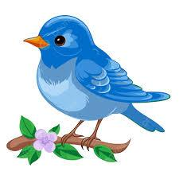

Thank you for the sun.
Thank you for the birds that sing.
Thank you God for all the lovely things in our world.
Amen

