SEND Report to Governors 2022 -2023

Date of report: 24.01.2023

SENDCO: Tracy Young
SEND Governors: Natalie Towers

SEND profile for the last 12 months

• Number of pupils on SEND register including numbers with Education Health and Care Plans School =
Number on roll 453 Total of 65 SEND = 14.35%
Lancashire 2020 – 11.3%
(Nat 15.4%)

• EHC plans 16 = 3.53% total school
28.57% of SEND have EHCPs
Boys =10/16 = %62.5
Girls = 6/16 = 37.5%

There is one EHCP request awaiting a decision

• Number of pupils according to primary need /gender/other characteristics e.g. Pupil Premium =
PP – 37/65 = 56.92%
EAL 46/65 70% (Check this with Sarah)

Boys – 35 = 54.69%
Girls - 30 = 46.15%

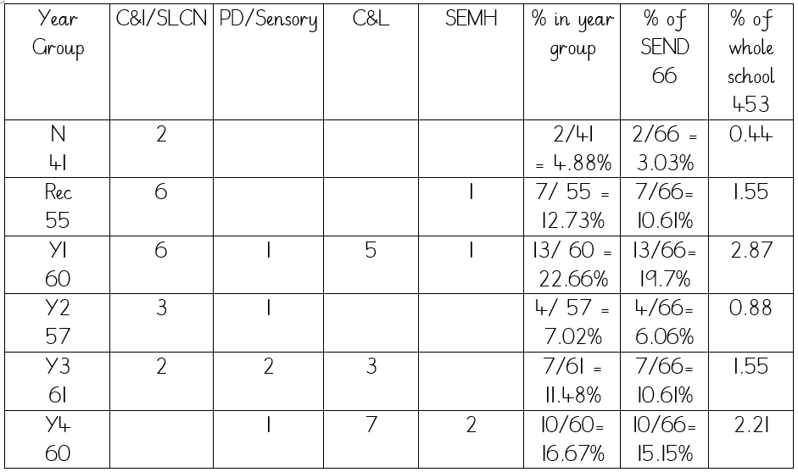
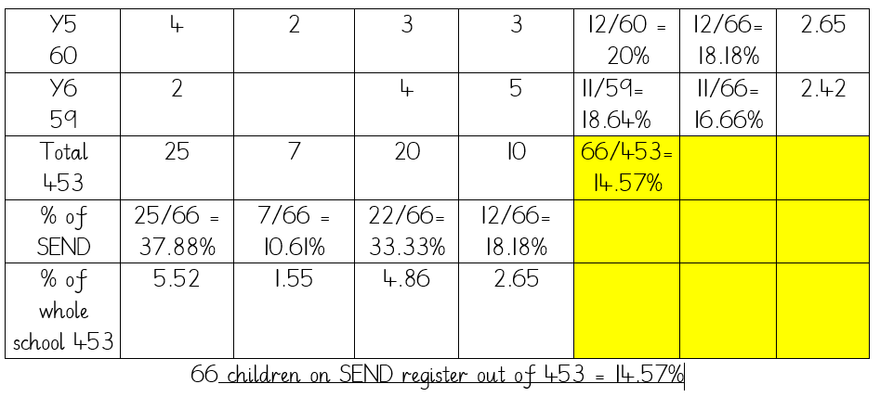
Overall quality of provision for pupils with SEND
Provision is good – every child has some 1:1 time working on their IEP targets with TA support at the direction of the class teacher. Children and TA work on Pupil Passport front sheet

Every SEND child is heard to read daily. They also have additional phonics support as well as Precision Teaching to improve sight vocabulary.

Outside agencies are referred to if additional support or interventions do not result in expected progress. Parental consent is given for specialist teacher assessment and observation.
The Inclusion Teachers we have in school provide excellent advice, support and reports needed – early identification is vital and referrals made to EY Inclusion service.

The SENDCo works closely with the SENDO – Sue Hurst.

Our Independent Speech and Language Therapist provided excellent support = group support and advice to the TAs working with language support groups. She also assesses and writes reports on individual children which are useful in identifying areas of need and are valuable in applying for EHCPs/Inclusion Funding. Half termly training is given to TAs – Colourful Semantics, Widgit program, Barrier Games and Lego Therapy and writing social stories so far covered.

We work closely with staff from our local PRU – Golden Hill who provide specialist advice and support in school and through short-stay placements.

Achievement of pupils with SEND:
- Statutory and teacher assessment data on school tracker – this was the case but now we are trying to get data on Target Tracker – most SEND children are assessed using PIVATS
- School tracking data was previously on the Google Drive/Teams – still used to get information
- Wider outcomes – the SENCO works closely with the Attendance Coordinator to target pupils with SEND who have poor attendance and punctuality. Home visits are made, meetings with parents for children with SEND are made and followed up as well as catching parents at the gates before and after school.

SEND policy Reviewed27th Sept 2022
The SEND information report is on the school website. It was reviewed 17/08/2022

The school’s Local Offer was reviewed 06/07/2022

SEND budget and spending
There is no specific budget allocation for SEND but orders have always been approved for resources for the SEND children.
Additional funding for renewing the license for IDL is given and recently we have taken a subscription to Widgit for making visuals.
VI resources have been purchased after advice from specialist teacher. Enlarged reading books are provided by the VI technicians
There are CPD opportunities for TAs and an audit of training is carried out annually.
SENDCo attended several CPD course including SLCN and Colourful Semantic – cascaded to teachers 18.01.23,
Graduated Approach for SEND, again, cascaded to teachers in a staff meeting.
Early Years SENDCo update attended

Staffing for SEND
TAs have attended in-house training and some have SaL training – Sarah Amin on Makaton and Mita Patel on ASD
The SENCo is a qualified teacher – PGCE and Master in Education Management.
The SENCo also has a Diploma in SEND.

Interventions
Precision Teaching
Paired Reading
IDL
Rapid Phonics
Bounce Back Phonics
Multiplication tables – Times Tables Rockstars
Vocab Training (Speech and Language)
Talkboost
Language support groups from Nursery to Y1.
Colourful Semantics – children with SLCN and EAL benefit from this.

CPD related to SEND
All TAs have taken part in SaL training.

Engagement with stakeholders
Pupil voice – SEND children give feedback which is recorded annually
Parent/carer voice: Parents receive a copy of the Individual Education Plans and can comment on provision. TAF meetings are held where appropriate. Parent voice is captured annually. Contact via email has increased. Termly newsletter.
Multi-agency work: SEND Inclusion Teachers work closely with the SENCo, class teachers, TAs and pupils. We are supported by the NHS Speech and Language Therapist and the school employs an Independent SaLT who liaises with Mrs A Lambat and L Slater who supports speech and language groups throughout Early Years. The school works with the local primary mental health practitioner, Lynn Wilson, who offers advice and signposts to other agencies. Referrals to other agencies are made such as CFWS and CANW.
The school has a good relationship with the outreach staff from the local PRU, GHIST.

Complaints
One complaint has been made by an ex-supply staff member.

Any other developments regarding SEND?
We have reviewed the Pupil Passports and IEPs. We discussed these in a staff-meeting following Graduated Approach training. We decided to keep the first page of the old Pupil Passport as it was important to have TA and pupil in-put. The second page reports need and next steps in each area of need. The graduated approach is reflected primarily in the SMART targets on the last page. TAs are to be encouraged to review progress against these and change HFWs/spellings/letters/number bonds etc and change as they are achieved.

Our Early Years practitioners took part in the Hanen Language Project and have cascaded these skills with TAs to improve the language and communication skills of our youngest children.

Are there any concerns regarding provision for pupils with SEND?
Some of the concerns are of a practical nature due to the building. We do not have a lift and there is a flight of steep stairs which is a barrier for some PD – we have a Stair Climber for one pupil. We need a better changing room for children who wear nappies/pull-ups – we now do have a changing bed but as children grow, this is not always safe or suitable – an SEQ1 was submitted today for a hydraulic changing bed. The toilets for KS2 children are now upstairs which makes access much easier.

GHIST outreach support is still needed for those children who need additional specialist support in school – 1 referral is in and another to be made now parental consent has been given.

