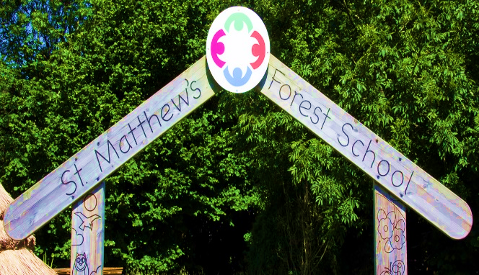

April’s Newsletter

Love Respect Friendship Creativity

Let all that you do be done in love 1 Corinthians 16:14



Dear Parents and Carers,

I would like to say a huge ‘thank you’ to the staff, children and families for making me feel so welcome at St. Matthew’s. As we begin the start of a busy and exciting summer term ahead, I look forward to getting to know everyone in the St. Matthew’s school community.

Our Year 4 & 5 classes have made an excellent start to their swimming lessons. The summer term clubs also began last week, with a variety of after-school activities available for your child to enjoy.

It has been great to see the community involvement at St. Matthew’s over the last 2 weeks. Last Friday afternoon, Mrs. Boyd held a very popular coffee and cake drop-in session for parents and carers in 1S Thank you to all those who attended – we look forward to welcoming more of our classes into school later this term.

Early years have had a busy start to the summer term, with a fantastic ‘stay and play’ session for parents and carers. It was lovely to see the children’s faces as parents and carers joined in with activities such as planting seeds, weaving, digging and reading, to name just a few!

Reception S also performed their class assembly about our Christian value of ‘generosity’ on Wednesday afternoon. Well done to you all!

I hope you enjoy the long Bank Holiday weekend – please remember school re-opens on **Tuesday 6th May.**

Mrs. Lister   
Executive Headteacher

**All Clubs & School Activities During the Day**

**Clubs are from 3pm – 4pm**

**Pick up is from the main gate**

|  |  |  |  |  |
| --- | --- | --- | --- | --- |
| **Monday** | **Tuesday** | **Wednesday** | **Thursday** | **Friday** |
|  | **Year 3**  **Football**  **Commando Joe** | **Choir** | **Year 3/4/5/6**  **Reading Club** | **Times Table Rockstars** |
|  |  | **HAF Club**  **Year 3/4** |  |  |
| **In School Activities** | | | | |
|  | **Year 4 Swimming** |  | **Year 5 Swimming** |  |

**Important Notice**

If you're driving your child to school please make sure you park safely, legally and considerately.

Please do not block the school gate as you are preventing staff from getting to school on time and do not use the garages near school to turn your vehicle around or drop off, this is for local residents.

Please don't park across household driveways near schools and always park safely. We don't want to see anyone hurt.



**Uniform**

Trousers (grey/black)

Skirts/pinafore dresses (grey/black)

Sweaters/sweatshirts/fleece/cardigans (navy blue)

Shirts/polo-necked shirts/ blouses (white)

Socks/tights (white/grey/black)

Footwear – black shoes/trainers (all black including laces, no obvious logos)

Jogging bottoms and jean style trousers are **NOT** allowed

**Children should come dressed to school in school uniform every day.**

**PE Kit for both boys and girls is as follows:**

White polo shirt or T-shirt

Dark (navy blue, black, grey) jogging bottoms, leggings or shorts

Dark (navy blue, black, grey) sweatshirt/ fleece

Black Trainers or pumps

Please check on your child’s class page to see when their P.E. days are.

**Autumn Term 2024**

**Monday 2nd September – School Closed to pupils – Staff Training Day**

**Monday 23rd September – School Closed to pupils – Staff Training Day**

Term Begins - Tuesday 3rd September 2024

Half Term - Monday 28th October to Friday 1st November 2024

Term Ends - Friday 20th December 2024 – School closes at 1pm

**Spring Term 2025**

Term Begins - Monday 6th January 2025

Half Term - Monday 17th February to Friday 21st February 2025

Term Ends - Friday 4th April 2025 – School closes at 1pm

**Summer Term 2025**

**Bank Holiday - Monday 21st April**

**Bank Holiday - Monday 5th May**

**Bank Holiday - Monday 26th May**

Term Begins - Tuesday 22nd April 2025

Half Term - Monday 2nd June to Friday 6th June 2025

Term Ends - Friday 18th July 2025 – School closes at 1pm



**Dinner Money**

School meals are provided by Bolton Council. Meals for pupils are provided for children in Reception, Year 1 and Year 2 free of charge.

For all other pupils dinners are charged at **£12.75** per week **(£2.55 per day)** unless your family is entitled to Free School Meals.

St. Matthews is a cash less school, you can pay for your children’s dinners, trip’s; special days and residential via the School Money app, please remember if you change your telephone number or email you need to inform the office. The app is set up to send out messages to 1st Contact only.

**Autumn Term 2025**

**Monday 1st September – School Closed to pupils – Staff Training Day**

Term Begins - Tuesday 2nd September 2025

Half Term - Monday 27th October to Friday 31st October 2025

Term Ends - Friday 19h December 2025 – School closes at 1pm

**Spring Term 2026**

Term Begins - Monday 5th January 2026

Half Term - Monday 16th February to Friday 20th February 2026

Term Ends - Wednesday 1st April 2026 – School closes at 1pm

**Summer Term 2026**

Term Begins - Monday 20th April 2026

**Bank Holiday - Monday 4th May**

**Bank Holiday - Monday 25th May**

Half Term- Monday 1st to Friday 5th June 2026

Half Term - Monday 2nd June to Friday 6th June 2026

Term Begins - Monday 8th June 2026

Term Ends - Friday 17th July 2026 – School closes at 1pm

**Attendance figures this week**

Rec – 91.39 %

Year 1 – 91.15%

Year 2 – 91.50%

Year 3 – 93.74 %

Year 4 - 94.84 %

Year 5 – 92.64 %

Year 6 – 94.37 %

IF your child is absent from school, please contact the school office on 01204 333005 before 9am to explain the reasons for the absence.

Please try and make any medical appointments such as dental or optometrist appointments outside of school hours to avoid disruption to learning.

