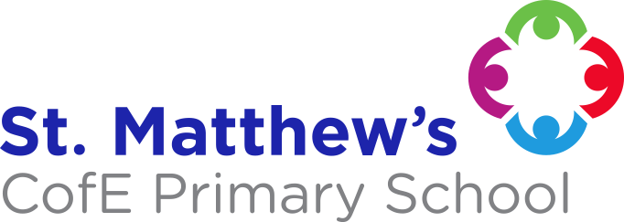
St. Matthew's
C of E Primary School Policies
Our Policy:
Art

Approval Date: September 2022
Review Date: September 2023

ART
“In the beginning God created the heaven and the Earth” Genesis 1:1

INTRODUCTION

Art is a subject within the National Curriculum. This policy is a statement of the aims, principles and strategies for the teaching and learning of Art at St. Matthew’s C.E. Primary School, Bolton.

The policy was drawn up by the Art Lead in consultation with teaching staff.

It is the responsibility of the Headteacher and Art Lead to ensure the successful implementation of the policy.

THE NATURE OF ART

Art education has been proven to have remarkable impacts of academic, social and emotional outcomes, helping us develop empathy as we learn more about societies, cultures and history.

Through Art experiences children become more able in the practical aspects of the curriculum. They develop competence in selecting, controlling and using the formal elements common to most Art processes, e.g. line, tone, colour, pattern, texture, form, space and shape. They develop knowledge of manual techniques, the properties of materials and the use of new technologies.

Through their experiences of creating and looking at Art, children become perceptive, develop powers of observation and learn to select, interpret and record what they see and feel, using Art media. Children gain an awareness of their own work and that of others, and begin to evaluate these works.

Aims

The aim of Art in the National Curriculum is to provide a rich framework in which the natural creative abilities of the children can be developed. Our aims in teaching Art are that all children will be able to:

Access various opportunities to explore different materials and develop their own ideas of how to use them effectively.
Develop their ability to express their individual creativity, working both individually and collaboratively with others.
Reflect on and discuss other worlds, cultures and times, as they explore ideas in the work of a variety of artists.
Develop their handling, moving and fine motor control skills.
Develop their language skills, social skills, decision-making and risk-taking.

IMPLEMENTATION

Art is taught through themes in our Dimensions Creative Curriculum. The children will focus on 2D, 3D and textiles, based on locality, the past and present, and a variety of cultures. A focus will be given to artists, architects and designers in history. Each theme unit contains a specific skill and there is a given task, additionally, there are skill specific lessons available for each theme unit.

SPECIAL EDUCATIONAL NEEDS AND INCLUSION

Pupils with Special Needs are able to develop confidence and express their feelings in Art and Design since it is a subject in which success is not dependent upon academic ability. These pupils include:

Pupils with learning difficulties who may find opportunities to excel.
Gifted and Talented pupils with particular ability and flair for Art who are extended through the use of more advanced techniques and materials.

MULTICULTURAL ISSUES

It is our aim for children to experience a wide variety of cultural traditions, through Art, becoming familiar with a diversity of genres and media drawn from different localities and historical times. Where possible, the cultural heritage of the children and their families is to be recognised and valued.

HEALTH AND SAFETY

Children will not be exposed to substances which are toxic. Children will be taught to respect, control and use tools safely and with regard to the safety of others. The general teaching requirement for health and safety applies to this subject.

EQUAL OPPORTUNTIES

It is the responsibility of the teacher to ensure that irrespective of race, gender or disability, all children receive their entitlement to a high quality of Art and Design experiences.

Parental Involvement: Parents can help their children with Art and Design by encouraging them to develop their practical skills at home, using a range of media. By researching with their children on the internet, in a safe manner. Also by visiting local art galleries to look at collections of art works.

ASSESSMENT AND RECORDING

Please see Assessment, Recording and Reporting Policy.

ROLE OF SUBJECT LEAD

The role of the Art Lead is to:

Support all staff in the planning and delivery of Art.
Keep up-to-date with developments in Art education and disseminate information to colleagues as appropriate.
To monitor the planning and teaching of the Art to ensure continuity and progression throughout the Key Stages.

REVIEW

This policy will be reviewed by the Headteacher and all staff on an annual basis. Amendments will be presented to the Governing Body.

Date of Policy: | September 2021
Date agreed by Governors: | September 2022
Next Review Date: | September 2023

