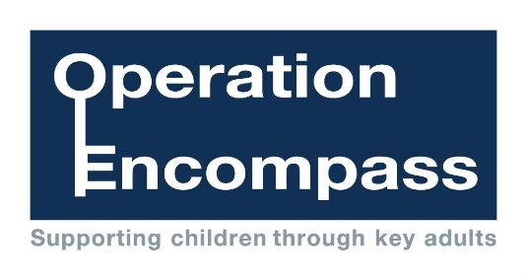

**Encompass Parents Awareness Letter**

Dear Parent/Carer,

Re: Bolton Encompass

Our school has been given the opportunity to take part in a new project that will run in partnership with Bolton Safeguarding Board and Greater Manchester Police.

The project, Bolton Encompass, has been designed to provide early reporting to schools of any domestic abuse incidents that occur outside of school but which might have an impact on a child attending school the following day. This information will be shared on school days during the school term. When incidents occur on a Friday, Saturday or a Sunday, the police will contact the relevant school the following Monday.

A nominated member of school staff, known as a Key Adult, will be trained to liaise with the police. At *insert school name* our Key Adult is *insert details*. They will be able to use information that has been shared with them, in confidence, to ensure that the school is able to support children and their families. Information will be shared where it is identified that a child or young person was present, witnessed or was involved in a domestic abuse incident.

We always endeavour to offer the best support possible to our pupils and believe that Bolton Encompass is going to be beneficial and supportive for all concerned children and families

Some information about Encompass is included in this letter but if you would like more information about this new initiative, you can contact our Key Adult at school Mrs Rebecca Rotherham.

Thank you for your continued support.

**Bolton Encompass**

The purpose of Bolton Encompass is to safeguard and support children and young people who have been involved in or witness to a domestic abuse incident. Domestic abuse impacts on children in a number of ways. Children are at increased risk of physical injury during an incident, either by accident or because they attempt to intervene. Even when not directly injured, children are greatly distressed by witnessing the physical and emotional suffering of a parent.

Encompass has been created to address this situation. It is the implementation of key partnership working between the police and schools. The aim of sharing information with local schools is to allow ‘Key Adults’ the opportunity of engaging with the child and to provide access to support that allows them to remain in a safe but secure familiar environment.

Following the report of an incident of domestic abuse, by 9.00am on the next school day the school’s Key Adult will be informed that the child or young person has been involved in a domestic incident. This knowledge, given to schools through Operation Encompass, allows the provision of immediate early intervention through silent or overt support dependent upon the needs and wishes of the child.

The purpose and procedures in Operation Encompass have been shared with all parents and governors, is detailed as part of the school’s Safeguarding Policy and published on our school website.

At St Matthews CE Primary School our Key Adult is Mrs Rebecca Rotherham.