CREATIVE CHALLENGE HOMEWORK

Our new theme is ‘Picture Our Planet’. In this theme, we look at the geography of Brazil and Scotland. Your creative challenge homework is to create a leaflet advertising Brazil as a place to visit. This can be on a double page spread (like we have done many times in English), or can be done on a device such as a computer, laptop or tablet. It should include an introduction to Brazil (basic facts) and then have sections for different places to visit. Think about both human geography and physical geography. Some ideas for things to see might be: Christ the Redeemer, Sugarloaf Mountain, Escadaria Selaron, Fiscal Island or Bandeiras Monument. There are lots of places to visit so you might find something else that you find interesting. It is up to you. For each place to visit, explain why it is worth a visit, what it is, where it is etc. Think about appropriate subheadings. There will be a prize for the best one handed in. Please hand this in by Wednesday 14th June 2023.

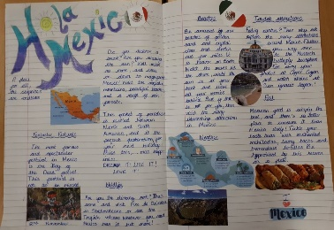
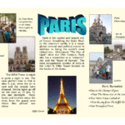
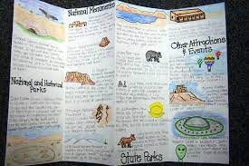
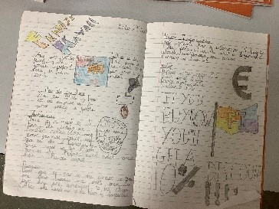

Also, please remember that the Year 4 multiplication check is taking place over the next couple weeks. Please make sure that you are practising (ideally every day for at least 10 minutes).

CREATIVE CHALLENGE HOMEWORK

Our new theme is ‘Picture Our Planet’. In this theme, we look at the geography of Brazil and Scotland. Your creative challenge homework is to create a leaflet advertising Brazil as a place to visit. This can be on a double page spread (like we have done many times in English), or can be done on a device such as a computer, laptop or tablet. It should include an introduction to Brazil (basic facts) and then have sections for different places to visit. Think about both human geography and physical geography. Some ideas for things to see might be: Christ the Redeemer, Sugarloaf Mountain, Escadaria Selaron, Fiscal Island or Bandeiras Monument. There are lots of places to visit so you might find something else that you find interesting. It is up to you. For each place to visit, explain why it is worth a visit, what it is, where it is etc. Think about appropriate subheadings. There will be a prize for the best one handed in. Please hand this in by Wednesday 14th June 2023.

Also, please remember that the Year 4 multiplication check is taking place over the next couple weeks. Please make sure that you are practising (ideally every day for at least 10 minutes).

