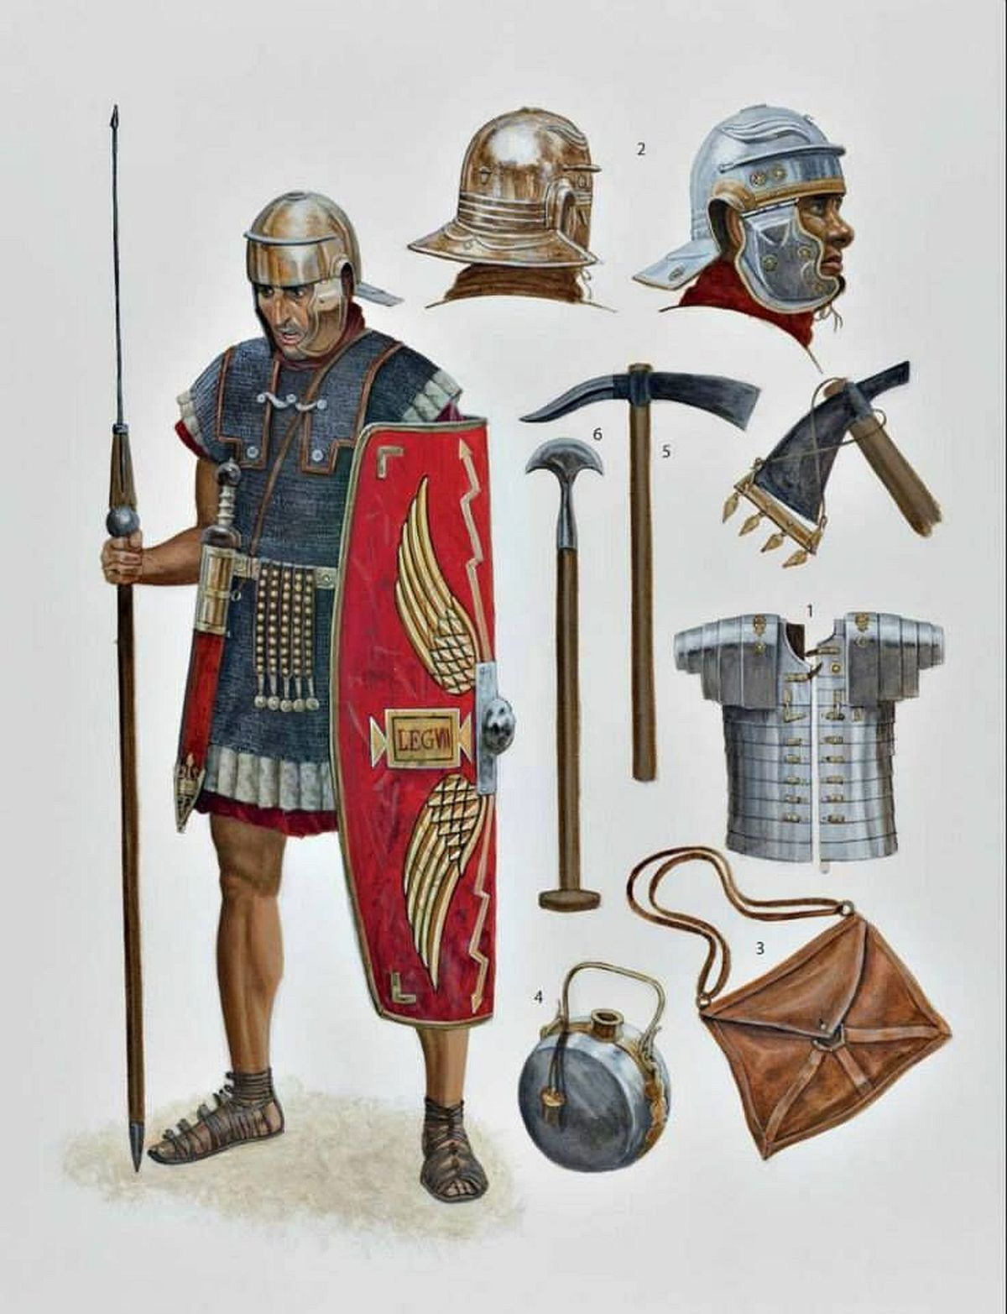

CREATIVE CHALLENGE
HOMEWORK
SUMMER TERM 1
Return on Monday 6th June
Make an item of Roman armoury
eg axe, spear, shield, helmet, breast plate

