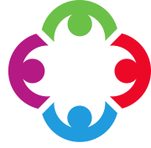
ENGLISH
Work inspired by our new novel: ‘The Fire Within’ by Chris D’Lacey. We will be writing instructions, non-chronological reports and fantasy stories. We will also be producing a whole host of other genres of writing: both fiction and non-fiction. These will be based on our novel and our Theme topics.
PLEASE ENSURE YOUR CHILD READS AT HOME AND BRINGS THEIR READING BOOK BACK TO SCHOOL EVERY DAY - THANK YOU.

MATHS
We will be revising all areas of our maths work. We will also be concentrating on Book C for Power Maths. This book focuses on: Geometry (shape), Problem Solving and Statistics.

TRANSITION WORK IN PREPARATION FOR SECONDARY SCHOOL WILL ALSO BE COMPLETED.
RE
Similarities and differences between religions and their ideas about God.

THEME Our theme for the second half term:
“AND THE BAND PLAYS ON “
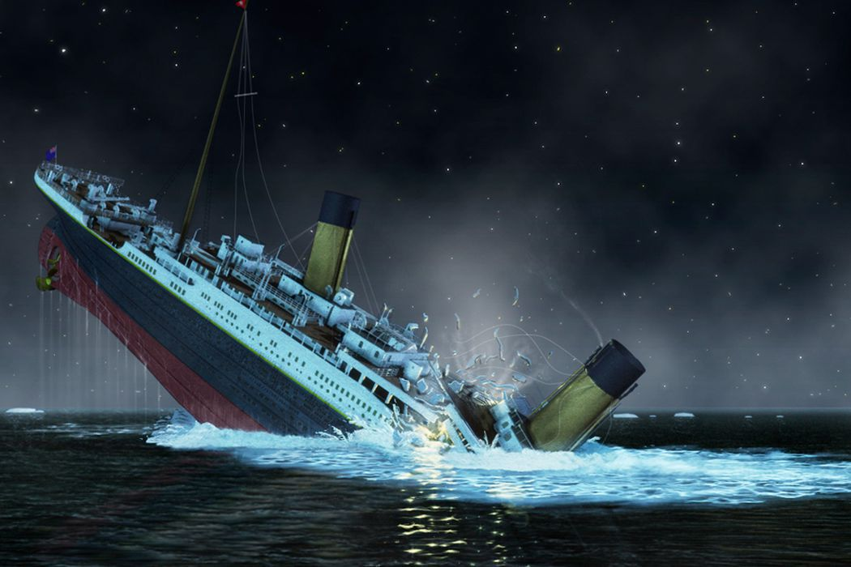
The Story of Heroes of the Titanic

THEME Our themes for the first half term:
“BRITISH BULLDOG” & “GLOBAL WARNING”
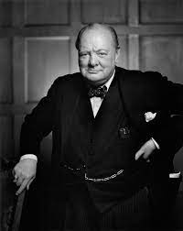
The Story of Winston Churchill Waste and Pollution
PE
Cricket, Rounders & Athletics.
PE kits must be worn on the correct PE day.
TUESDAY AND FRIDAY

SCHOOL UNIFORM REMINDERS:
JEWELLERY, APART FROM PLAIN STUD EARRINGS AND WATCHES, ARE NOT TO BE WORN IN SCHOOL. ALL BLACK SHOES.
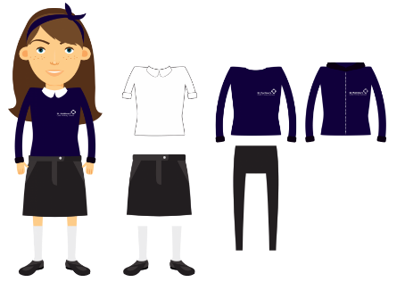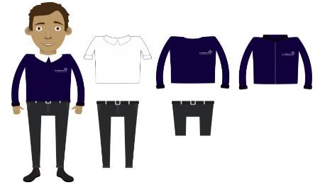

ESSENTIAL LEARNING EXPERIENCES
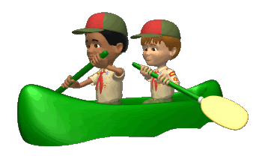
Outdoor Activities at The Anderton Centre.
Fun Day.
Year 6 Production.

YEAR 6 SUMMER TERM

