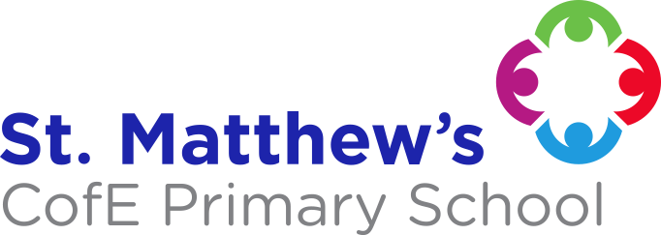
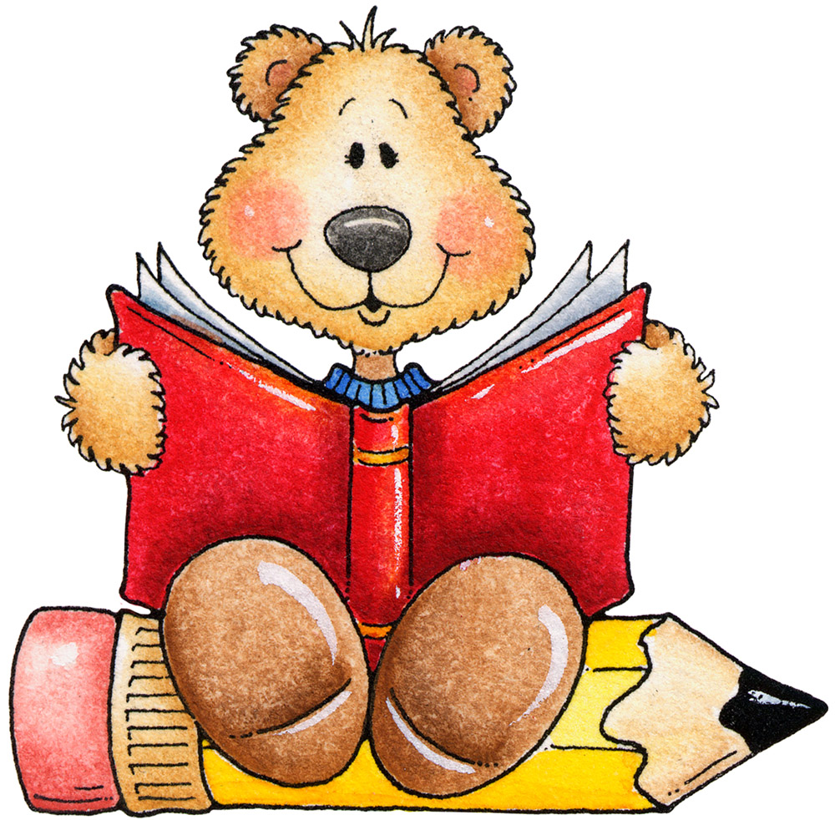
ENGLISH
We will be following the Read, Write, Ink scheme for phonics, reading and writing. We will be reading lots pirate and Arctic themed stories alongside
this.
PLEASE ENSURE YOU SIGN YOUR CHILD’S
READING RECORD WHEN THEY READ AT HOME
.

MATHS
We will be recognising number bonds to 10, counting objects up to 30 and writing the numerals up to 30, comparing numbers, finding 1 more/ 1 less than a number, count on from a number, identify longer and shorter, measure lengths and name and describe 2D shapes. Please help your child learn to count in 1s, 2s, 5s and 10s.
RE
We will be focusing on the Harvest Festival. We will also be reading different stories from the Bible about Jesus and Christmas celebrations.
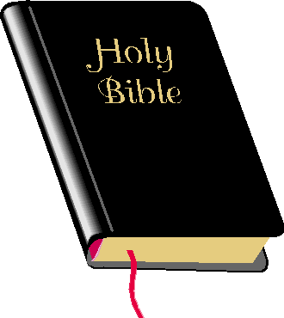

THEME Come Fly with Me - The Arctic Circle (Autumn 2)
Within this theme, we will be learning about the location, weather and climate in the Arctic. We will also look at different wildlife that lives there. Additionally, we will study the Inuit people, their traditions and way of life.
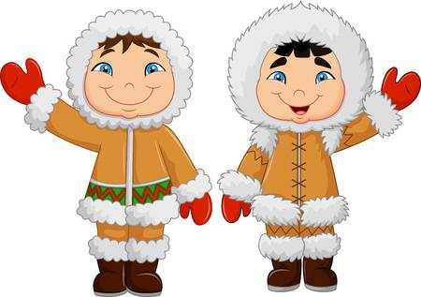

THEME Land Ahoy! (Autumn 1)
We will be learning about the continents and oceans, investigating and comparing how boats and cars move; and we will be making junk model boats to test our theories. We will learn and perform songs, before exploring sources of sound and how volume changes with distance.
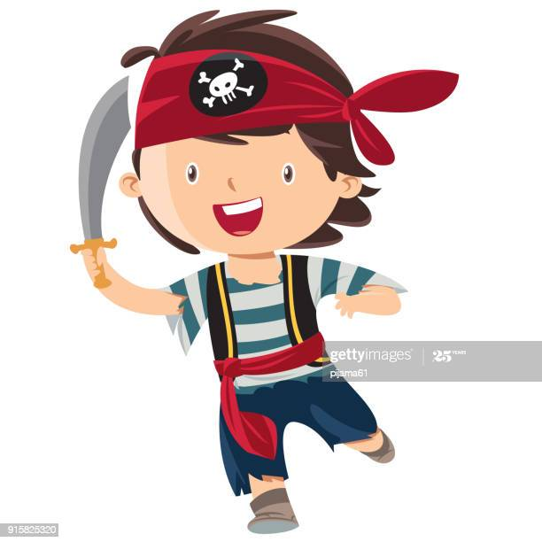

PE
Our P.E. lessons are on TUESDAY and WEDNESDAY. Please send in your child’s P.E. kit, with each item labelled clearly with their name. Long hair must be tied back.

PLEASE SEND YOUR CHILD INTO SCHOOL WITH A WATER BOTTLE EVERY DAY.

SCHOOL UNIFORM REMINDERS:
JEWELLERY, APART FROM PLAIN STUD EARRINGS AND WATCHES, IS NOT TO BE WORN IN SCHOOL.
FOOTWEAR - PLAIN BLACK SHOES.
PLEASE NAME ALL SCHOOL UNIFORM!

ESSENTIAL LEARNING EXPERIENCES
To enrich the curriculum, we will be playing out in a variety of weathers. So please ensure your child is dressed suitably, We recommend that your child has a warm, waterproof coat and a pair of wellies available to bring in if required.

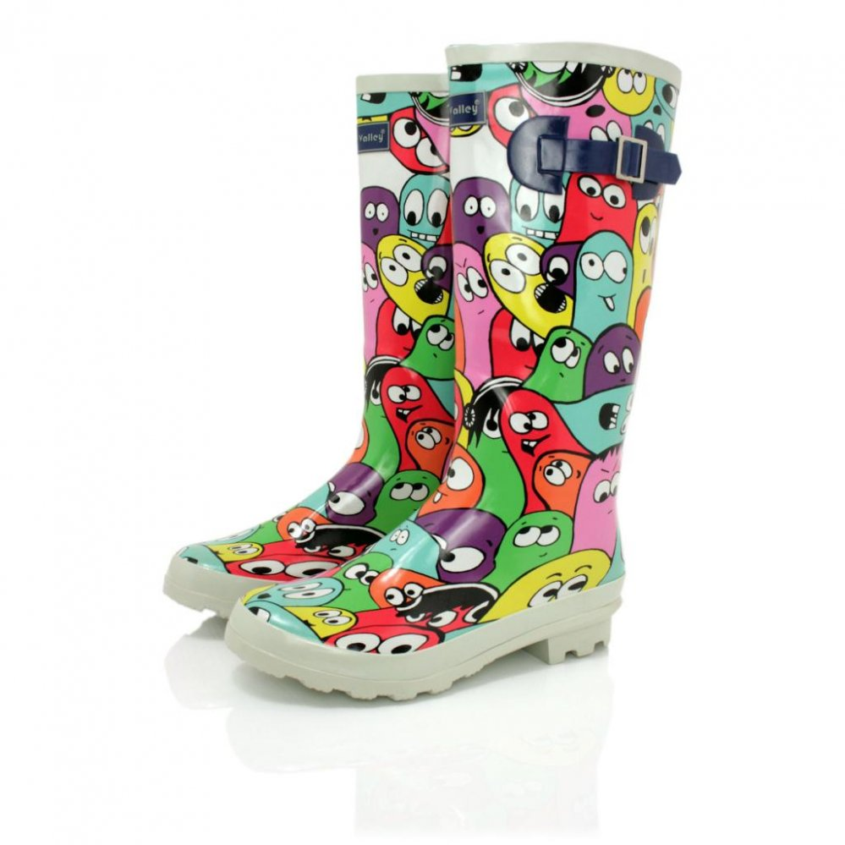

Mrs. Davidson’s Class Year One 