6th November 2024

Dear Parents/Carers,
On Friday 22nd November, we will be holding a non-uniform day where we kindly ask that in exchange for wearing their own clothes, your child brings in a donation for our chocolate tombola stall at the Christmas Fair.

We would appreciate anything from chocolate boxes, selection boxes, Christmas chocolate, multipacks of chocolate bars, large or small chocolate bars.

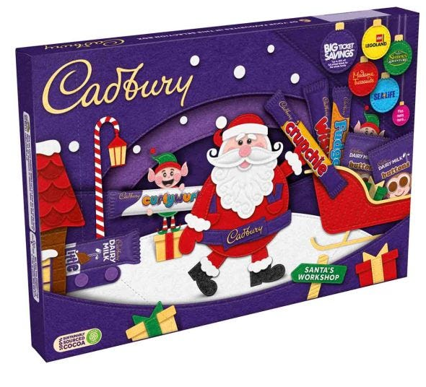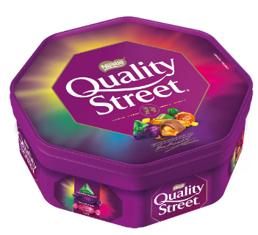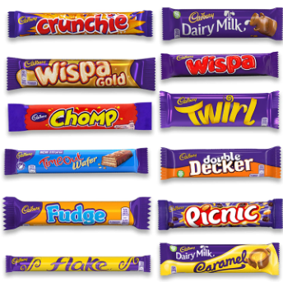

Thank you in advance for your generosity.

Mrs Hardingham
(UKS2 Phase Leader / Year 6 Teacher)

