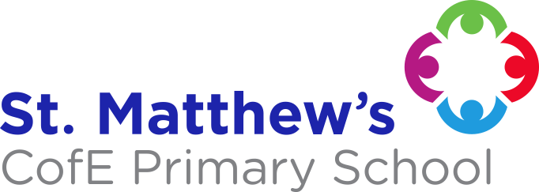
English
During the first half term the children will be using ‘George’s Marvellous Medicine’ by Roald Dahl to write extended stories and instructions. In the second half term we will be looking at ‘Mr Bunny’s Chocolate Factory’ by Elys Dolan and using this for descriptive writing, riddles and explanations. Some children will continue with RWI and guided reading will take place 4 times a week.
Your child will be given a reading book for home, bring it to school every day. Please ensure reading records are signed and are also brought into school.

Spellings will be sent home weekly for our spelling test on Wednesday.

Maths
We will be following the PowerMaths scheme of work. The topics we will be looking at this term are: Multiplication and division, Statistics, Length and height, Properties of shape and Fractions.
Please help your child learn to count in, 2s, 3s, 5s and 10s.

RE
In R.E our topic for the first half term is ‘Jesus friend to Everyone.’

In Spring 2 our topic will be ‘Easter symbols.’

Theme: Internation Media Station (Spring 2)
In this topic we will be looking at the different ways that people communicate both in the past and in the present.

Theme: Paddington’s Passport (Spring 1)
We will be completing Zero to Hero and then moving on to Paddington’s Passport. In this topic the focus is geography and we will be comparing Lima and London.

PE
In PE this term we will be focussing on fitness, dance and attacking and defending.
Our PE lessons will be on Wednesday and Friday.

Please ensure your child brings their PE kit to school on these days in a bag

School uniform reminders
Jewellery, apart from plain stud earrings and watches, is not to be worn in school.
Footwear - plain black shoes
Please name all school uniform!
Long hair must be tied back.

Essential Learning Experiences
The children will be participating in a work shop where they get to create their own radio show.

YEAR 2 Buttercups
(Miss Burkmar)
Computing
We will be looking at coding and programming. We will be using purple mash to create our own games using our coding skills.

