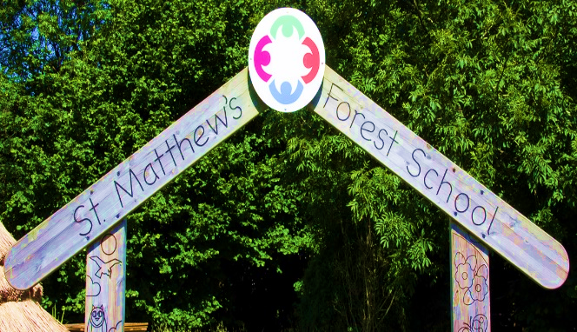

December’s Newsletter

British

Value :

Christian

Value :

Love Respect Friendship Creativity

Let all that you do be done in love 1 Corinthians 16:14



**Information for Parents / Carers**

**School Starts on 6th January 2025**

|  |  |  |  |  |
| --- | --- | --- | --- | --- |
| **Monday** | **Tuesday** | **Wednesday** | **Thursday** | **Friday** |
|  |  |  |  |  |

What a busy and wonderful month we have had!

There have been many exciting things happening this month. Year 3 have had a wonderful time learning about the Stone Age as part of the History Curriculum.

It was also great to see so many of you at Parent’s Evening and share with you how your children are getting on with their learning.

We had also had a lot of performances in school celebrating the festive season including the Year 4 Sing-along, The Year 2 Christmas Performance- ‘A Christmas Recipe’ and the Reception Nativity. All the children and teachers have worked so hard in making the performances a great success. We want to thank everyone for all their hard work. The children have thoroughly enjoyed showcasing their talent and I know that you have all really enjoyed supporting and watching our wonderful children perform.

We have also had our Christmas Fair, which a lot of you supported. We raised a fantastic amount of **£676.85**, which will help support enrichment activities in school. We also raised **£244.00** for Christmas Jumper Day to support the worthy cause ‘Save the Children’, thank you all for your generosity and donations.

All the children have had a great time at their Christmas Parties and KS1 children also enjoyed a great performance watching Lada Panto perform ‘Dick Whittington’. The children in KS2 also had a fabulous time watching, ‘The Jungle Book’ at the Octagon Theatre.

Thank you all for your continued support! I want to take this opportunity to wish you all a fantastic Christmas. I hope you have a good rest, spend time with family and enjoy the holidays. We look forward to welcoming you all back in the New Year- 2025!

**Mrs Patel**

**Club News Spring 1 Term**

**All Clubs are from 3pm – 4pm**

**Pick up is from the main gate**

|  |  |  |  |  |
| --- | --- | --- | --- | --- |
| **Monday** | **Tuesday** | **Wednesday** | **Thursday** | **Friday** |
| Y3/Y4/Y5/Y6  Choir  All Year |  | UKS2 Arts & Crafts Club  Mrs Hardingham |  |  |

**Important Notice**

If you're driving your child to school please make sure you park safely, legally and considerately.

Please do not block the school gate as you are preventing staff from getting to school on time and do not use the garages near school to turn your vehicle around or drop off, this is for local residents.

Please don't park across household driveways near schools and always park safely. We don't want to see anyone hurt.



**Uniform**

Trousers (grey/black)

Skirts/pinafore dresses (grey/black)

Sweaters/sweatshirts/fleece/cardigans (navy blue)

Shirts/polo-necked shirts/ blouses (white)

Socks/tights (white/grey/black)

Footwear – black shoes/trainers (all black including laces, no obvious logos)

Jogging bottoms and jean style trousers are **NOT** allowed

**Children should come dressed to school in school uniform every day.**

**PE Kit for both boys and girls is as follows:**

White polo shirt or T-shirt

Dark (navy blue, black, grey) jogging bottoms, leggings or shorts

Dark (navy blue, black, grey) sweatshirt/ fleece

Black Trainers or pumps

Please check on your child’s class page to see when their P.E. days are.

**Key Dates**

**Autumn Term 2024**

**Monday 2nd September – School Closed to pupils – Staff Training Day**

**Monday 23rd September – School Closed to pupils – Staff Training Day**

Term Begins - Tuesday 3rd September 2024

Half Term - Monday 28th October to Friday 1st November 2024

Term Ends - Friday 20th December 2024 – School closes at 1pm

**Spring Term 2025**

Term Begins - Monday 6th January 2025

Half Term - Monday 17th February to Friday 21st February 2025

Term Ends - Friday 4th April 2025 – School closes at 1pm

**Summer Term 2025**

**Bank Holiday - Monday 21st April**

**Bank Holiday - Monday 5th May**

**Bank Holiday - Monday 26th May**

Term Begins - Tuesday 22nd April 2025

Half Term - Monday 2nd June to Friday 6th June 2025

Term Ends - Friday 18th July 2025 – School closes at 1pm



**Dinner Money**

School meals are provided by Bolton Council. Meals for pupils are provided for children in Reception, Year 1 and Year 2 free of charge.

For all other pupils dinners are charged at **£12.75** per week **(£2.55 per day)** unless your family is entitled to Free School Meals.

St. Matthews is a cash less school, you can pay for your children’s dinners, trip’s; special days and residential via the School Money app, please remember if you change your telephone number or email you need to inform the office. The app is set up to send out messages to 1st Contact only.

**Attendance figures this week**

Rec – 95.14%

Year 1 – 90.9%

Year 2 – 93.41%

Year 3 – 93.82%

Year 4 – 92.62%

Year 5 – 89.93%

Year 6 – 90%

IF your child is absent from school, please contact the school office on 01204 333005 before 9am to explain the reasons for the absence.

Please try and make any medical appointments such as dental or optometrist appointments outside of school hours to avoid disruption to learning.

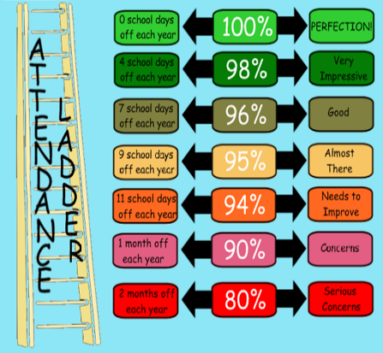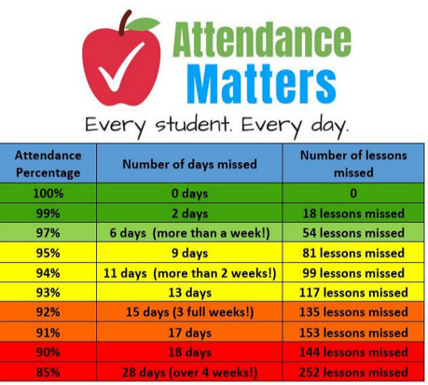



On Wednesday 18th December, 48 lucky dojo winners from Years 1 to 6 went to the Light Cinema to watch Paddington In Peru.

They all had an amazing time watching the film and eating their snack boxes.

Well done to those dojo winners.

On Tuesday 17th December the whole of Key Stage 2 (Years 3 to 6) went to see the production of the Jungle Book at the Octagon Theatre in Bolton. It was amazing to see a real live theatre performance, all of the children loved it. The actors were amazing and brought the story to life.