5th December 2024

Dear Parents / Carers,

It’s Christmas Celebrations once again. We have organised for a Pantomime to come into school and perform “Dick Whittington” for the children.

The Pantomime will take place on Monday 16th December at school during the school day.

This will be a lovely opportunity for your child to watch a theatre production the pantomime will be full of entertainment and it is sure to bring “Sleeping Beauty” alive. It is a magical production filled with colourful character, slapstick fun and lots of laughter that the children will enjoy.

The cost of the pantomime is £3.00. This once again has been subsidised by school.

Please go on the School Money app to make payments and to give consent, do not send money into school as we are a cashless school.

Yours sincerely,
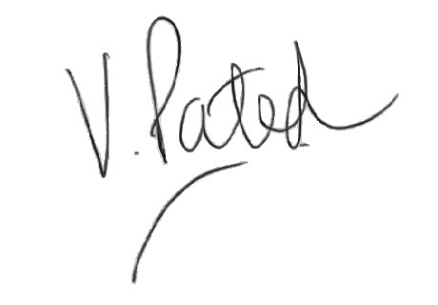
Mrs V. Patel
Headteacher

5th December 2024

Dear Parents / Carers,

It’s Christmas Celebrations once again. We have organised for a Pantomime to come into school and perform “Dick Whittington” for the children.

The Pantomime will take place on Monday 16th December at school during the school day.

This will be a lovely opportunity for your child to watch a theatre production the pantomime will be full of entertainment and it is sure to bring “Sleeping Beauty” alive. It is a magical production filled with colourful character, slapstick fun and lots of laughter that the children will enjoy.

The cost of the pantomime is £3.00. This once again has been subsidised by school.

Please go on the School Money app to make payments and to give consent, do not send money into school as we are a cashless school.

Yours sincerely,
Mrs V. Patel
Headteacher

