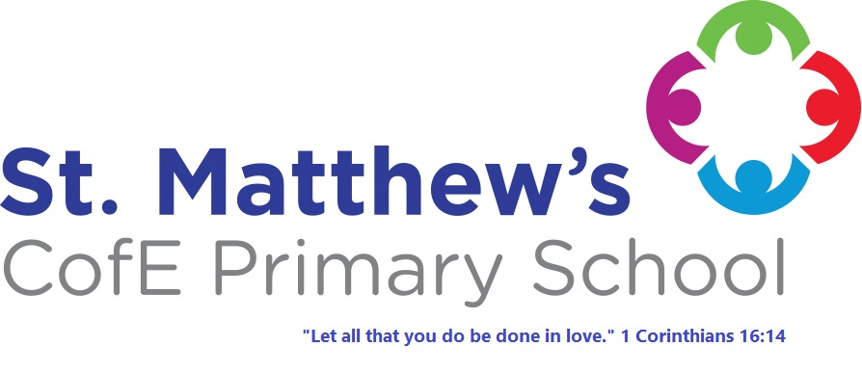
St. Matthew's
C of E Primary School Policies
Our Policy:
Homework

Approval Date: September 2023
Review Date: September 2024

POLICY STATEMENT

Homework is any work or activities which children are asked to do outside school time.

The homework programme should be manageable for everyone. Teacher feedback to homework activities may take a variety of forms e.g. formal marking, sharing work with the class, using information to support other classwork.

Our aims are to:-
1. Develop links with home and to involve parents by encouraging their support in the learning process.

2. Encourage the children to become independent learners.

3. Extend and develop work already being covered in class.

4. Develop an awareness in the children that work is not confined to a classroom but can be extended to a variety of environments using a range of information sources.

Aims into practice:-
1 All the children will be involved in the school reading programme and will be expected to read at home every night.
2. Homework will commence from Rec and continue throughout Key Stage 1 and 2.
3. Amounts and range of activities will vary according to age of children etc.
Early Years Reading nightly.
Homework related to curricular areas will be given weekly.
Key Stage 1 Reading nightly.
Homework related to curricular areas will be given weekly.
Key Stage 2 Reading nightly.
Homework related to curricular areas will be given weekly.

It is vital that teachers, parents and children apply the same high standards to this work as well as to all the work done in class. Homework is considered important to the educational development of every child.

Date of Policy: | September 2023
Date agreed by Governors: | September 2023
Next Review Date: | September 2024

