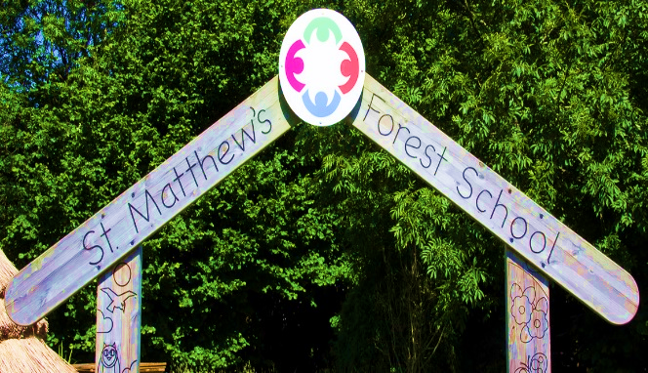

June’s Newsletter

Love Respect Friendship Creativity

Let all that you do be done in love 1 Corinthians 16:14



Dear Parents and Carers,

It has been a very busy month since returning from the half-term break! Our Year 1 children worked so hard in their Phonics Screening Check, and Year 4 were fantastic when completing the Multiplication Tables Check.

Year 6 have been busy outdoors in June, visiting Haigh Hall and walking up Winter Hill. They also had an action-packed residential at The Anderton Centre.

Year 1 had lots of fun on their visit to Imagine That! They had a great time exploring the different areas throughout the day.

On 19th June, our school choir sang at the Victoria Halls in Bolton, as part of the Bolton Music Festival. Mrs. Shaw and Mrs. Boyd were so proud of the children – a huge well done to you all!

Our Triple P Parenting course began this month – thank you to our families who attended. We hope the training has been useful for you.

This month, we have also welcomed our new Reception and Nursery families into school. We look forward to the children beginning an exciting journey with us in September.

Wednesday 2nd July is our ‘Moving Up Morning’, where the children will have the chance to spend some time with their new teacher in their new classroom.

Finally, a huge thank you to all our families who attended sports days this week. It was fantastic to see and hear the support for all of our children.

Mrs. Lister   
Executive Headteacher

**Information for Parents / Carers**

|  |  |  |  |  |
| --- | --- | --- | --- | --- |
| **Monday** | **Tuesday** | **Wednesday** | **Thursday** | **Friday** |
|  | **Year 4 Swimming** |  | **Year 5**  **Swimming** |  |

**Club News Summer Term 2025**

**All Clubs are from 3pm – 4pm**

**Pick up is from the main gate**

|  |  |  |  |  |
| --- | --- | --- | --- | --- |
| **Monday** | **Tuesday** | **Wednesday** | **Thursday** | **Friday** |
|  | **Chess Club** | **HAF Club**  **Year 3/4** |  |  |
| **KS1 Sports Club** | **Reading Club** |  |  |

**Important Notice**

If you're driving your child to school please make sure you park safely, legally and considerately.

Please do not block the school gate as you are preventing staff from getting to school on time and do not use the garages near school to turn your vehicle around or drop off, this is for local residents.

Please don't park across household driveways near schools and always park safely. We don't want to see anyone hurt.



**Uniform**

Trousers (grey/black)

Skirts/pinafore dresses (grey/black)

Sweaters/sweatshirts/fleece/cardigans (navy blue)

Shirts/polo-necked shirts/ blouses (white)

Socks/tights (white/grey/black)

Footwear – black shoes/trainers (all black including laces, no obvious logos)

Jogging bottoms and jean style trousers are **NOT** allowed

**Children should come dressed to school in school uniform every day.**

**PE Kit for both boys and girls is as follows:**

White polo shirt or T-shirt

Dark (navy blue, black, grey) jogging bottoms, leggings or shorts

Dark (navy blue, black, grey) sweatshirt/ fleece

Black Trainers or pumps

Please check on your child’s class page to see when their P.E. days are.

**Holiday List 2025/2026**

**Autumn Term 2025**

**Monday 1st September – School Closed to pupils – Staff Training Day**

Term Begins - Tuesday 2nd September 2025

Half Term - Monday 27th October to Friday 31st October 2025

Term Ends - Friday 19th December 2025 – School closes at 1pm

**Spring Term 2026**

Term Begins - Monday 5th January 2026

Half Term - Monday 16th February to Friday 20th February 2026

Term Ends - Wednesday 1st April 2026 – School closes at 1pm

**Summer Term 2026**

**Bank Holiday - Monday 4th April**

**Bank Holiday - Monday 25th May**

Term Begins - Monday 20th April 2026

Half Term - Monday 1st June to Friday 5th June 2026

Term Ends - Friday 17th July 2026– School closes at 1pm



**Dinner Money**

School meals are provided by Bolton Council. Meals for pupils are provided for children in Reception, Year 1 and Year 2 free of charge.

For all other pupils dinners are charged at **£12.75** per week **(£2.55 per day)** unless your family is entitled to Free School Meals.

St. Matthews is a cash less school, you can pay for your children’s dinners, trip’s; special days and residential via the School Money app, please remember if you change your telephone number or email you need to inform the office. The app is set up to send out messages to 1st Contact only.

**Attendance figures this week**

Rec – 93.47%

Year 1 – 92.68%

Year 2 – 97.71%

Year 3 – 97.67%

Year 4 – 95.26%

Year 5 – 94.57%

Year 6 – 93.28%

IF your child is absent from school, please contact the school office on 01204 333005 before 9am to explain the reasons for the absence.

Please try and make any medical appointments such as dental or optometrist appointments outside of school hours to avoid disruption to learning.

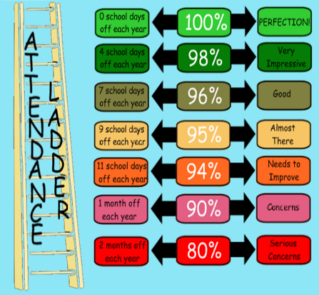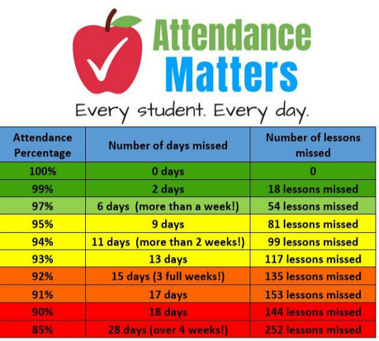



Year 1 had a great trip to Imagine That! in Liverpool. We made bath bombs, slime, snow, explored the village and painted fridge magnets. They all had a fantastic time!



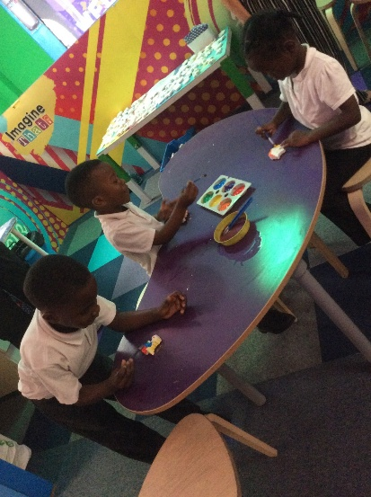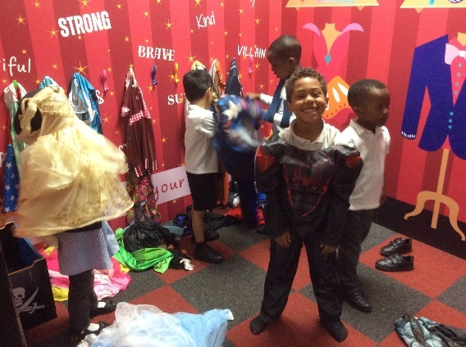

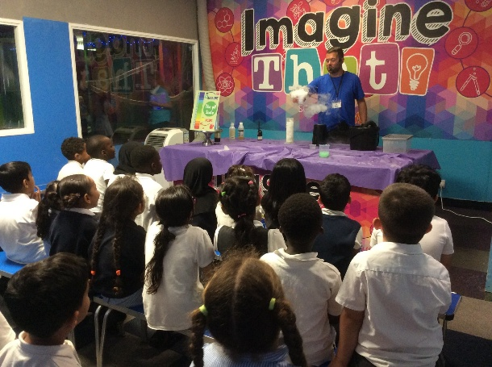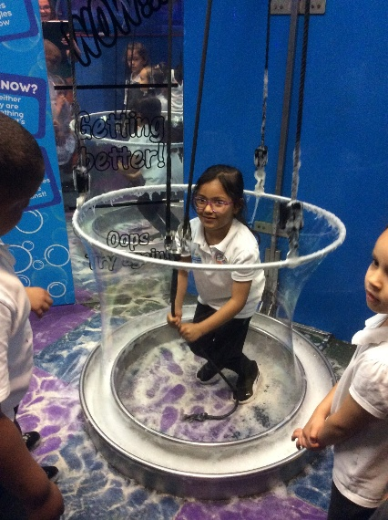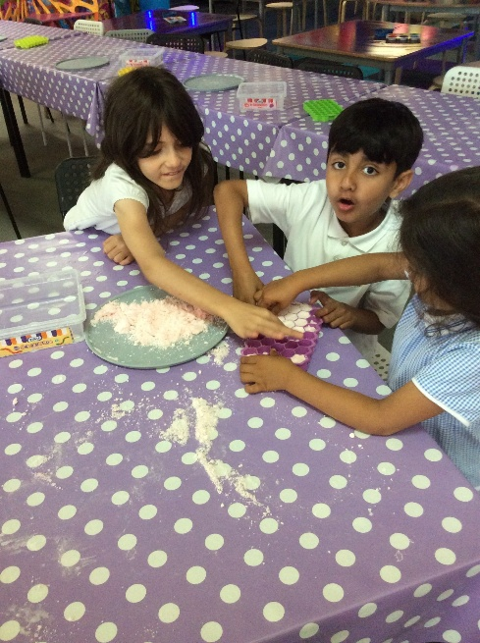

**Sports Day**

