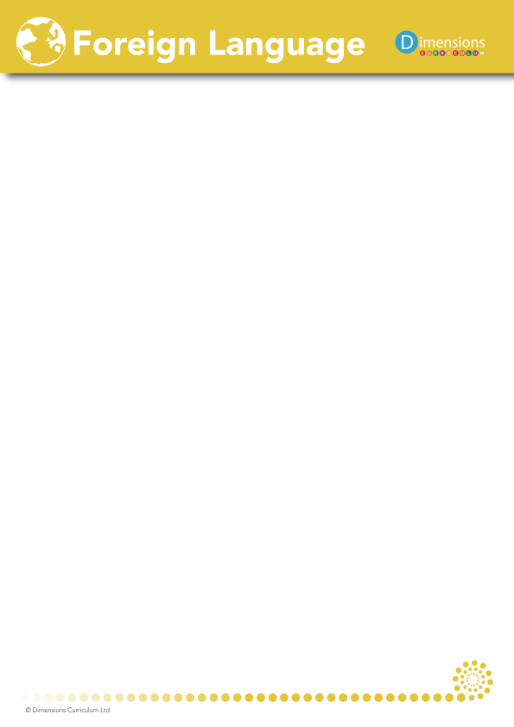

**St Matthew’s CE Primary School**

**Overview of teaching across KS2**

|  |  |  |
| --- | --- | --- |
| Year 3 | | |
| Autumn | Spring | Summer |
| Unit 1  Moi (all about me) | Unit 1  Moi (all about me)  Unit 2  Jeux et chansons (games and songs) | Unit 3  On fait la fete (celebrations) |

|  |  |  |
| --- | --- | --- |
| Year 4 | | |
| Autumn | Spring | Summer |
| Unit 4  Portraits | Unit 5  Ma famile | Unit 6  Ça pousse! (Growing things) |

|  |  |  |
| --- | --- | --- |
| Year 5 | | |
| Autumn | Spring | Summer |
| Unit 7  On y va (All aboard) | Unit 7  On y va (All aboard)  Unit 8  café | Unit 8  café |

|  |  |  |
| --- | --- | --- |
| Year 6 | | |
| Autumn | Spring | Summer |
| Unit 9  Vive le sport! (Our sporting lives) | Unit 10  Le Carnaval des animaux (‘Carnival of the Animals’) | Unit 11  Quel temps fait-il? (What’s the weather like?) |