BoltonSICT Computing Skills Prog
Computing Curriculum Long Term Overview
Digital Citizenship:  Children need to examine the consequences of their online activity–both good and bad. When teaching Digital Citizenship it is vital that we thoroughly embed the principles of staying safe online and then move onto web content and how they interact with it. Children regularly download and use material without fully understanding that it may be illegal and what the consequences might be.  *Online Safety: Safer Internet Day (2nd Tuesday in February  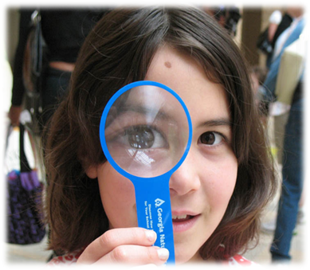 |  |  |  | Digital Literacy:  The essential component of digital literacy when it comes to the field of pedagogy is deep learning; of which there are six core skills:  Collaboration. The ability to work collaboratively with others, with strong interpersonal and team-related skills.  Creativity. Being able to weigh up opportunities in an entrepreneurial manner and ask the right questions to generate new ideas.  Critical thinking. Being able to evaluate information and arguments, identify patterns and connections, and construct meaningful knowledge and apply it in the real world.  Citizenship. The ability to consider issues and solve complex problems based on a deep understanding of diverse values and a worldview.  Character. Traits such as grit, tenacity, perseverance, and resilience; alongside a desire to make learning an integral part of living.  Communication. Being able to communicate effectively through a variety of methods and tools to a range of different audiences. |  |  | Computer Science:  Computer science teaches students design, logical reasoning, problem solving and resilience - all valuable well beyond the computer science classroom. The ability to create and adapt new technologies distinguishes computer science from computer literacy, which focuses more on using existing technologies (e.g., word processing, spreadsheets) |  |  |  | Information Technology:  This is how we interface with technology using existing software. We need to teach children how to navigate around computers, type, save work, find and move files understand the internet and the web, use search engines, understand networks and generally be efficient and independent on a computer.
 | Autumn Term  Digital Literacy / Digital Citizenship |  |  |  | Spring 1 Term  Computer Science / Information Technology |  |  |  |  | Summer Term  Computer Science / Digital Literacy
EYFS | Refer to EYFS MiniMash in Purplemash – resources to support all the seven areas of learning lots of topic resources  Lots of hands on generic skills / Mouse control  Online safety resources: Smarty Penguin / Digi Duck / Connected World |  |  |  | Refer to EYFS MiniMash in Purplemash  Use remote control toys  Introduce BeeBots  Using internet for simple searches |  |  |  |  | Refer to EYFS MiniMash in Purplemash - lots of topic links  Lots of practical learning -use 2Dos for home links  BeeBot activities, development of directional language  Debugging when things go wrong.
Year 1 | Autumn 1 | Autumn 2 |  |  | Spring 1 |  |  | Spring 2  Focus: Algorithm |  | Summer 1 |  |  | Summer 2
 | Digital Citizenship  Online Safety / PSHE  For KS1 Reference - BBC Computing | Digital Literacy with elements of Creativity  For KS1 Reference - BBC Computing |  |  | Computer Science With elements of IT  For KS1 Reference - BBC Computing  CS without a computer – Unplugged Activities |  |  |  |  | Information Technology with elements of DL  For KS1 Reference - BBC Computing |  |  | Greater Depth Project:  Digital Literacy / Computer Science
 | *Education for a Connected World / iCan Statements  Purplemash Unit1.1  Books to start conversations - Chicken Clicking, Webster's bedtime  ThinkUKnow: Hectors World | Lots of hands on generic skills  Purplemash – 2Type - *ongoing through all year groups  Purplemash -use 2Dos for home learning links  Pictograms - Purplemash Unit1.3  Animated Stories - Purplemash Unit1.6 |  |  | Lots of practical learning & unplugged activities  Development of directional language  BeeBot activities, debugging when things go wrong.  Ipad apps – BeeBot |  |  | 2Go  2Code – See year1 lessons plans & resources in teacher section of - PurpleMash Unit1.7 |  | Logging on and off  2DIY - Purplemash Unit1.2 & 1.4  Technology outside school - Purplemash Unit1.9 |  |  | PurpleMash  2Quiz / 2 publish / 2 create a story / 2sequence  Book Creator app  Possible Project:  Personal presentation – All About me
Year 2 | Autumn 1 | Autumn 2 |  |  | Spring 1 |  |  | Spring 2  Focus: Events / Program |  | Summer 1 |  |  | Summer 2
 | Digital Citizenship  Online Safety / PSHE  For KS1 Reference - BBC Computing | Digital Literacy  with elements of DC |  |  | Computer Science With elements of IT  For KS1 Reference - BBC Computing  CS without a computer – Unplugged Activities |  |  |  |  | Information Technology with elements of DL |  |  | Greater Depth Project:  Digital Literacy / Computer Science
 | *Education for a Connected World / iCan Statements  PurpleMash Unit2.2  Books to start conversations - Chicken Clicking, Webster's bedtime  ThinkUKnow: Lee & Kim | Lots of hands on generic skills  Purplemash – 2Type*  Spreadsheets - PurpleMash Unit2.3  Creating Pictures - PurpleMash Unit2.6  Making Music - PurpleMash Unit2.7  Presenting Ideas - PurpleMash Unit2.8  Purplemash -use 2Dos for home learning links |  |  | Lots of practical learning & unplugged activities  Development of directional language  BeeBot activities, debugging when things go wrong. |  |  | 2Code – See year2 lessons plans & resources in teacher section of PurpleMash Unit2.1  Online and Ipad – Scratch Junior , Daisy Dinosaur, Kodable |  | Logging on and off  Effective searching - use PurpleMash unit2.5 planning  Questioning - PurpleMash Unit2.4 |  |  | PurpleMash  2 publish / 2 create a story  Book Creator  Possible Project:  Combining sound, images and video  eg: Trailers in iMovie
Year 3 | Autumn 1 |  | Autumn 2 |  |  | Spring 1 & Spring 2  Focus: Sequence |  |  | Summer 1 |  |  | Summer 2
 | Digital Citizenship  Online Safety / PSHE  For KS2 Reference – BBC Computing |  | Digital Literacy  with elements of Creativity  For KS2 Reference – BBC Computing |  |  | Computer Science With elements of IT  For KS2 Reference – BBC Computing  CS without a computer – Unplugged Activities |  |  | Information Technology with elements of DL  For KS2 Reference – BBC Computing |  |  | Greater Depth Project:  Digital Literacy / Computer Science / STEM
 | *Education for a Connected World / iCan Statements  Books to start conversations - Chicken Clicking, Webster's bedtime  Regular digital footprint activities and use alongside www.Commonsensemedia.com  Drip feed info to parents via school newsletter, twitter, facebook  Develop E-safety champions - children to present an assembly  Awareness of popular apps such as Roblox, snapchat streaks, friend trackers in whatsapp, snapchat etc, musical.ly |  | Microsoft packages / School Blog  Touch Typing – Purplemash Unit3.4  Spreadsheets - PurpleMash Unit3.3  Branching database – Purplemash Unit3.6  Graphing - PurpleMash Unit3.8  Interviews  Book creator Photostory / iMovie  Garageband  Appropriate SICT’s STEM project loan box |  |  | Use as many platforms as you can but teach to the same level.  Vocab prompts - start using the correct vocab as soon as possible  2Code – See year3 lessons plans & resources in teacher section of PurpleMash Unit3.1  LOGO - PurpleMash Unit4.5  Online and Ipad – Scratch Junior , Daisy Dinosaur, Kodable |  |  | Use as many different platforms as possible and perform basic tasks (search the internet, input devices, saving work) look at similarities and differences.  Search engines, safe searching and copyright  Find, save and import images and information from the internet  How search works https://www.bbc.co.uk/education/clips/zwdxhyc  Email - Purplemash Unit3.5 |  |  | PurpleMash  2 publish / 2 create a story / 2animate  Photostory  Book Creator, Garage band, iMovie apps  Possible Project:  Keep fit video  Animation, Stop motion animation,  Appropriate SICT’s STEM project loan box
Year 4 | Autumn 1 |  | Autumn 2 |  |  | Spring 1 & Spring 2  Focus: Repetition |  |  | Summer 1 |  |  | Summer 2
 | Digital Citizenship  Online Safety / PSHE  For KS2 Reference – BBC Computing |  | Digital Literacy  with elements of Creativity  For KS2 Reference – BBC Computing |  |  | Computer Science With elements of IT  For KS2 Reference – BBC Computing  CS without a computer – Unplugged Activities |  |  | Information Technology with elements of DL  For KS2 Reference – BBC Computing |  |  | Greater Depth Project:  Digital Literacy / Computer Science / STEM
 | *Education for a Connected World / iCan Statements  Books to start conversations - Chicken Clicking, Webster's bedtime  Regular digital footprint activities and use alongside  www.Commonsensemedia.com  Drip feed info to parents via school newsletter, twitter, facebook  Develop E-safety champions - children to present an assembly  Awareness of popular apps such as Roblox, snapchat streaks, friend trackers in whatsapp, snapchat etc, musical.ly |  | Microsoft packages / School Blog  Purplemash – 2Type*  Book creator Photostory / iMovie  Animation  Picture collage  Spreadsheets - PurpleMash Unit4.3  Writing for Audiences - PurpleMash Unit4.4  Green screen  Creating for younger audience  Appropriate SICT’s STEM project loan box |  |  | Use as many platforms as you can but teach to the same level.  Vocab prompts - start using the correct vocab as soon as possible  LOGO - PurpleMash Unit4.5  Purplemash – 2Code chimp level (suggest up to Newton and then free code)  2Code – See year4 lessons plans & resources in teacher section - PurpleMash Unit4.1  Scratch  Online and Ipad – Kodable, Lightbot |  |  | Use as many different platforms as possible and perform basic tasks (search the internet, input devices, saving work) look at similarities and differences.  School email or purple mash 2email (talk about other ways to communicate)  How email works https://www.bbc.co.uk/education/clips/zqsg4wx  Effective searching - use PurpleMash unit4.7  How search works https://www.bbc.co.uk/education/clips/zwdxhyc  Continue with basic save, locate and retrieve skills  Purple mash |  |  | PurpleMash  2animate / iCan Animate  Book Creator app  Possible Project:  Computer generated Images (CGI)  Green screening  Eg; DoInk, iCan Animate  Digital puppetry  eg; Puppet pals app (paid version)  Appropriate SICT’s STEM project loan box
Year 5 | Autumn 1 |  | Autumn 2 |  |  | Spring 1 & Spring 2  Focus: Selection |  |  | Summer 1 |  |  | Summer 2
 | Digital Citizenship  Online Safety / PSHE  For KS2 Reference – BBC Computing |  | Digital Literacy  with elements of Creativity  For KS2 Reference – BBC Computing |  |  | Computer Science With elements of IT  For KS2 Reference – BBC Computing  CS without a computer – Unplugged Activities |  |  | Information Technology with elements of DL  For KS2 Reference – BBC Computing |  |  | Greater Depth Project:  Digital Literacy / Computer Science / STEM
 | Teach about Copyright, over sharing and self-esteem, bullying, digital footprint, inappropriate material and the impact of their actions.  *Education for a Connected World / iCan Statements  Bullying and impact of actions - a whole host of videos to use  Over sharing and self esteem - Think You Know resource  Books to start conversations –Troll Stinks, Chicken Clicking, Webster's Books  What is Copyright video- https://www.youtube.com/watch?v=suMza6Q8J08 |  | Microsoft packages / School Blog – becoming more aware of their audience.  Purplemash – 2Type*  Excel/ Spreadsheets - PurpleMash Unit5.3  Database - PurpleMash Unit5.4  Book creator Photostory / iMovie  Garageband Animation  Picture collage Interactive quiz  Green screen, Interviews  Appropriate SICT’s STEM project loan box |  |  | Teach Variables, programming and game creation on different software  Vocab prompts – continue to use correct vocab  Purplemash – 2DIY & 2DIY3D  2Code – See year5 lessons plans & resources in teacher section - PurpleMash Unit5.1  https://scratch.mit.edu/ - maths quiz variables  Kodu – free game developing software from Microsoft with teachers pack  Online and Ipad – Kodable, Lightbot, ALEX (app), Hopscotch  After school club resource: CodeClub  (free to register and lots of resources) |  |  | Reinforce the basics of using technology in our everyday lives. Teach the difference between the internet and the web, viruses and digital crimes.  Use as many different platforms as possible and perform basic tasks (search the internet, input devices, saving work) look at similarities and differences.  School email, search engines, safe searching and copyright  Digital crimes PowerPoint  How does the internet work? http://www.bbc.co.uk/guides/z3tbgk7  What is the World Wide Web? http://www.bbc.co.uk/guides/z2nbgk7 |  |  | PurpleMash  2DIY, 2DIY 3D, 2Quiz, 2Code  Book Creator app  Possible Project:  Game Creator  Scratch, Kodu  Creating for younger audience – ScratchJr  Appropriate SICT’s STEM project loan box
Year 6 | Autumn 1 |  | Autumn 2 |  |  | Spring 1 & Spring 2  Focus: Variables |  |  | Summer 1 |  |  | Summer 2
 | Digital Citizenship  Online Safety / PSHE  For KS2 Reference – BBC Computing |  | Digital Literacy  with elements of Creativity  For KS2 Reference – BBC Computing |  |  | Computer Science With elements of IT  For KS2 Reference – BBC Computing  CS without a computer – Unplugged Activities |  |  | Information Technology with elements of DL  For KS2 Reference – BBC Computing |  |  | Greater Depth Project:  Digital Literacy / Computer Science / STEM
 | Teach about social networking sites, online gaming and different types of attention through debates and key questions.  *Education for a Connected World / iCan Statements  Books to start conversations –Troll Stinks, Chicken Clicking, Webster's Books  Exploring positive and negative attention – Jigsaw / Tom’s Story videos  Digital footprint activity and https://www.commonsensemedia.org/  E-safety debating help sheet and ideas  PEGI activity – PowerPoint, PEGI info and cards |  | Microsoft packages School Blog – becoming more aware of their audience.  Excel/ Spreadsheets - PurpleMash Unit6.3  Book creator Photostory / iMovie  Garageband Animation  Picture collage  Interactive quiz - PurpleMash Unit6.7  App building, Keep fit videos  Green screen, Interviews  Creating for younger audience  Appropriate SICT’s STEM project loan box |  |  | Recap on Variables and develop critical thinking skills; children need to produce programs for given scenarios.  Vocab prompts – continue to use correct vocab  Purplemash – 2DIY & 2DIY3D  2Code – See year6 lessons plans & resources in teacher section - PurpleMash Unit6.1 & 6.5  2Code – Gibbon level  https://scratch.mit.edu/ - use in conjunction with problems  Kodu – Imaged based programming  Online and Ipad – Kodable, Lightbot, ALEX (app), Hopscotch  After school club resource: CodeClub  (free to register and lots of resources) |  |  | Teach the history of computers and it’s pioneers. Also look at the future of technology – what would the children like to see?  Networks - PurpleMash Unit6.6  Database - PurpleMash Unit5.4  Computer History timeline - http://www.bbc.co.uk/timelines/zxsrcdm  Computing Pioneers biographies - https://www.thocp.net/biographies/biographies.htm#B  Watch your day in the future – see video |  |  | Possible Projects:  Memory Book of time in school  Children given the opportunity to plan and create using any software/app appropriately to combine  Create their own app – thunkable  (will need a school Google account)  This project would be an example of real world application of programming skills  Appropriate SICT’s STEM project loan box
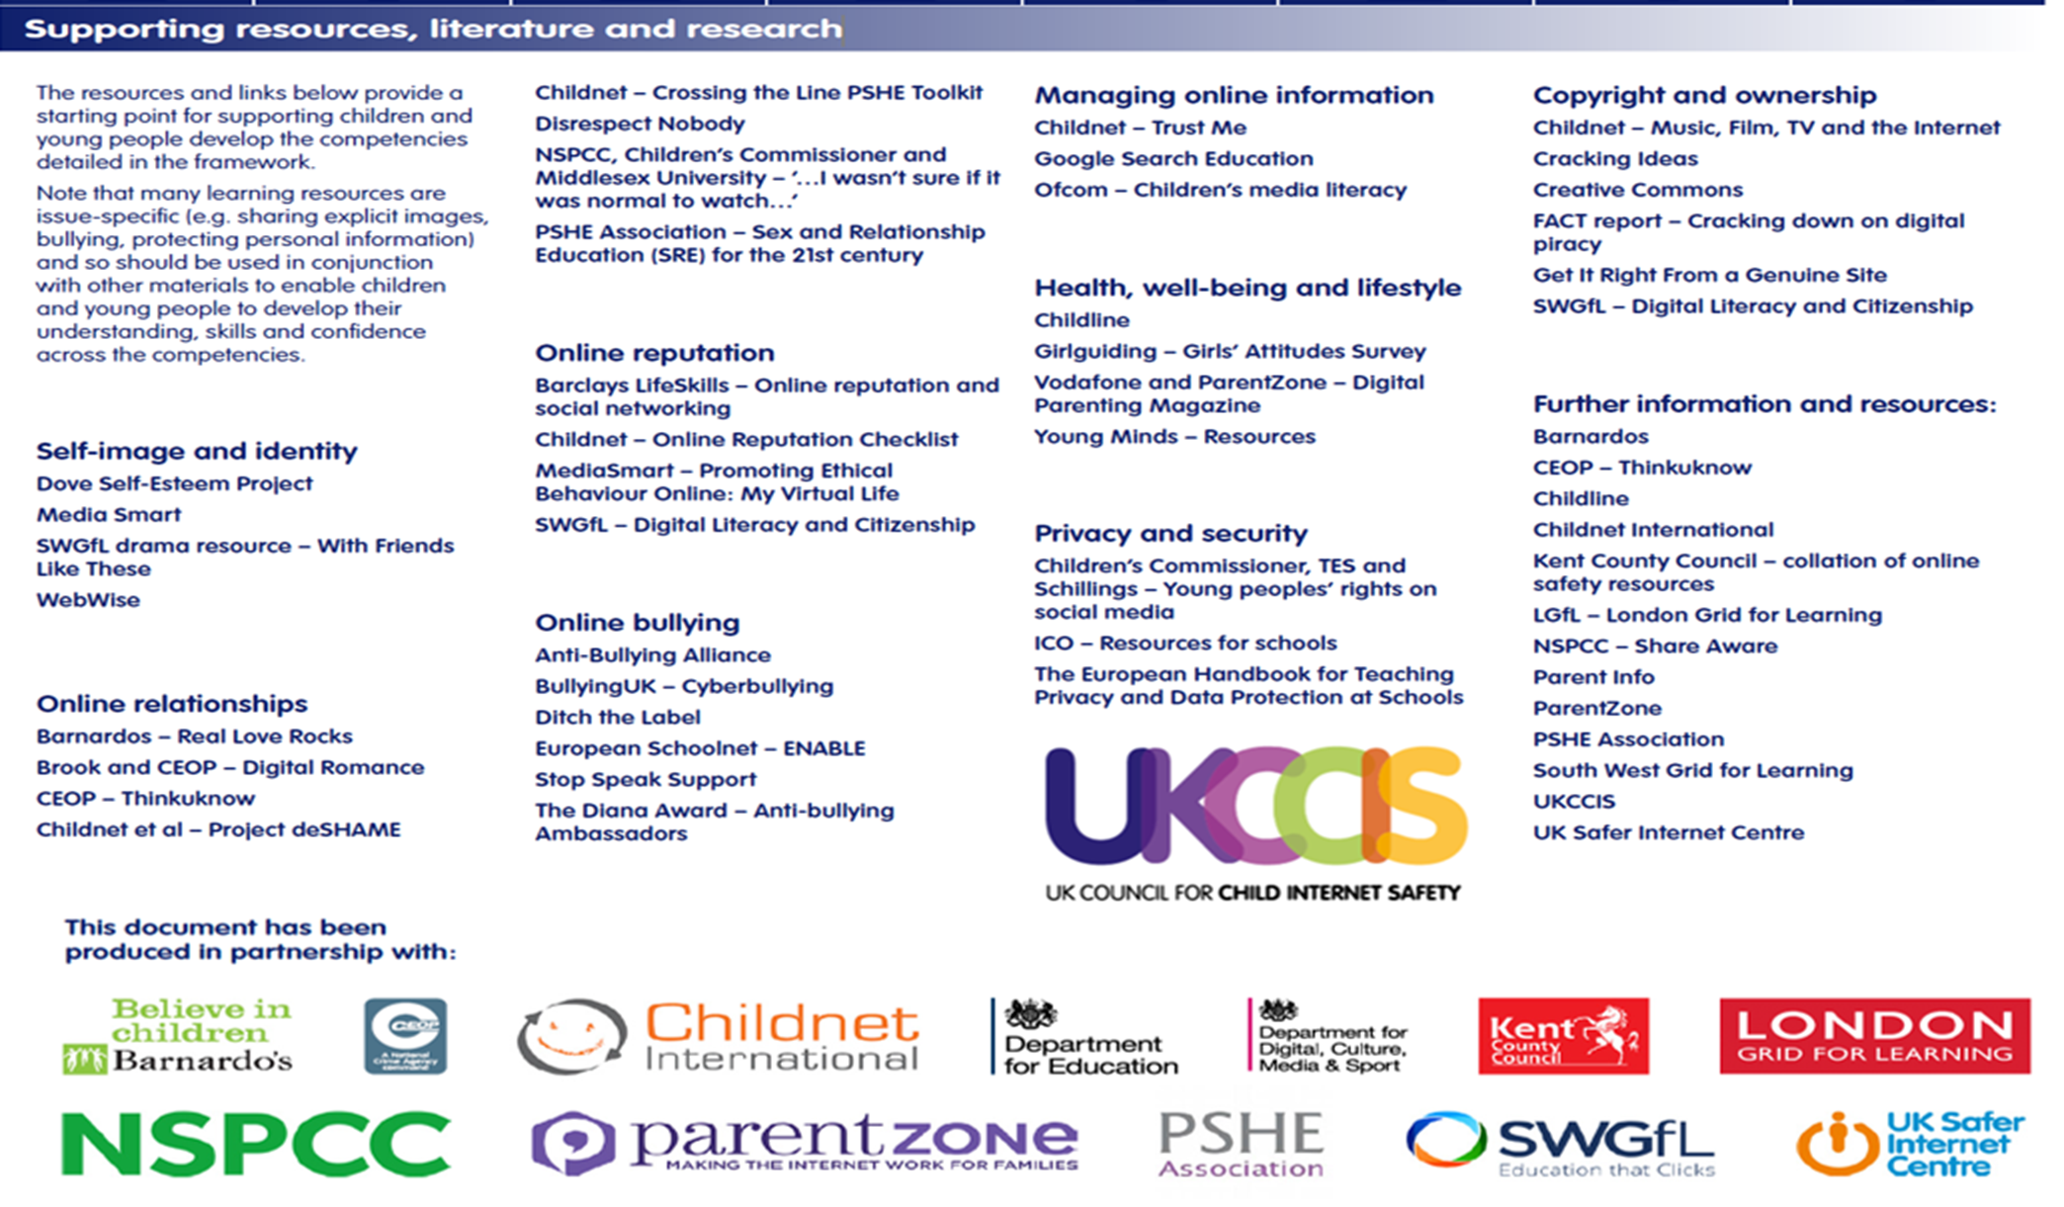
BoltonSICT has developed this document.
Updated: June2018

These iCan statements have been developed using resources from the National Curriculum, Education for a Connected World, NAACE and CAS.

This overview is designed to be a flexible working document to support staff when planning computing lessons, giving them a clear overview of learning objectives and progression.

