Y3 CREATIVE HOMEWORK
May The Force Be With You
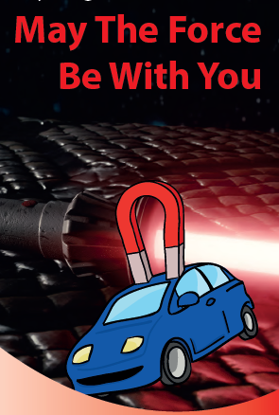

Given out: Thursday 10th February 2022
Due in: Thursday 24th February 2022

Choose one of the following to complete:
- Blow through straws to create pictures that are affected by wind. Also, add water drops to paint to create watermarked effects.
- Design and make a marble run with various surfaces to test effect of friction on the marbles.
- Make a game that works using magnets.
- Make and fly a paper aeroplane that travels really far.
- Compose and perform a dance that demonstrates repel and attract.
- Write a list of negative and positive forces (influences) in our lives. Make a poster showing which qualities attract people e.g. kindness and which repel e.g. bullying?
- Design a pop bottle rocket and launcher and make it fly the furthest distance possible.
- North and South Poles – Find out where they are, what’s the difference between them and why are they called the North and South Poles?

You can present this in any way you want. Be as creative as you want!

Good luck! We look forward to seeing them!

