
St. Matthew's
C of E Primary School Policies
Our Policy:
Physical Education

Approval Date: September 2024
Review Date: September 2025

PHYSCIAL EDUCATION CURRICULUM POLICY

St. Matthew’s Church of England Primary School fosters a caring environment where we come together as a loving family to share, learn, pray, and flourish. Our school's ethos is underpinned by our four key Christian Values: respect, friendship, love, and creativity. We firmly believe that these values empower every member of our community to thrive.

Our children engage in a supportive and purposeful curriculum closely aligned with national curriculum objectives, promoting our overarching vision: "Let all that you do be done in love."
(1 Corinthians 16:14)

INTENT
PE is instrumental in promoting health and wellbeing in young children. At St Matthew’s Primary School, we believe that PE should promote development of key skills and participation in a variety of games, activities and sports. At our school, PE is used to give children an opportunity to work as a team, develop leadership skills and foster an enthusiasm for sport. We provide a safe and supportive environment for children to flourish in a range of different physical activities and encourage their physical, emotional, social and moral development. Competitions are used across school which allow children to compete individually and as part of a team, allowing the opportunity to develop communication and leadership skills. No child is left behind and all children are involved in competitive competition, giving them the opportunity to develop their skills and showcase their talents.
IMPLEMENTATION
At St Matthew’s all staff follow the Key PE Sports Scheme. Key PE provide a high-quality scheme of work in line with the PE National Curriculum. The scheme provides teachers with lessons that are progressive, challenging and planned but also give teachers the opportunity to be creative. The scheme provides children with the essential development of agility, balance and co-ordination, inclusive healthy competition and co-operative learning by using fun and engaging games that build up a range of transferable skills. These can be used in a variety of sports and encourages creativity, cooperation and teamwork. Basic skills such as running, jumping and throwing, cooperative and collaborative learning are all covered throughout the scheme. Challenge is encouraged through group and individual challenges.
Through the Key PE Sports Scheme our aims in the teaching of PE are:
- Foster a love for and enjoyment of being active.
- Develop ‘fitness for life’ through promoting the health benefits of regular exercise.
- To develop an understanding in children of how to succeed in a range of physical activities, and how to evaluate their own success.
- Identify talents.
- Develop self-esteem, confidence and social skills.
- Contribute to the physical development of every child.
- Give children a way of expressing themselves and an opportunity to be creative.
- Develop a range of skills that can be applied in other contexts.

ADAPTATIVE TEACHING

Leaders within school ensure the highest ambition for all pupils and create opportunities to experience success. Drawing from research by Mould (2020) from the Education Endowment Foundation, educators are encouraged to employ various teaching strategies to support pupils’ learning. These strategies include: scaffolding, explicit instruction, cognitive and metacognitive approaches, flexible groupings and the integration of technology into the learning process.

LONG TERM MEMORY

Learning is a long-term process and teachers utilise four main strategies to support pupils in being successful and confident learners.

The agreed strategies are:

• Knowledge organisers
• New content in small, manageable steps.
• Images to support new learning.
• Spaced retrieval practice.

TEACHING AND LEARNING MODEL

Teachers are responsible for effectively balancing the introduction of new physical education content to enable pupils to grasp important concepts successfully. At St. Matthew’s, we employ a 5-part teaching model that guarantees a thorough impartation of a physical education knowledge. These principles and strategies contribute to a vibrant and captivating physical curriculum, enabling our children to develop a passion for learning and exploring Sport and physical education.

 | Activate- teachers activate the appropriate schema and make long term links to learning that occurred in the past.
 | Vocabulary – teachers explicitly teach vocabulary that pupils need a deep understanding of to support their learning.
 | Retrieve – pupils complete a retrieval task relating to more recent learning such as self-testing key information from their knowledge organisers.
 | Teach – The teacher presents new information clearly and in manageable chunks.
 | Apply – pupils apply their learning by demonstrating their skills gained.

ASSESSMENT

Teachers use formal assessments, as well as regular ongoing teacher assessments, to adapt their planning to meet the needs of all pupils appropriately. End-of-unit attainment is tracked using Insight tracking system so that leaders can ensure pupils are making at least good progress throughout their learning.

EYFS
We encourage the physical development of our children in the Early Years as an integral part of their work. As the Nursery and Reception class is part of the Foundation Stage of the National Curriculum, we relate the physical development of the children to the objectives set out in the Early Learning Goals, which underpin the curriculum planning for children aged three to five years of age. We encourage the children to develop confidence, control of the way they move, and care in the handling of tools and equipment. We give all children the opportunity to undertake activities that offer appropriate physical challenge, both indoors and outdoors, using a wide range of resources to support specific skills. We prioritise the learning of fundamental movement skills as we know they are essential for students to be competent in accessing our ambitious PE curriculum.
Curriculum overview for EYFS
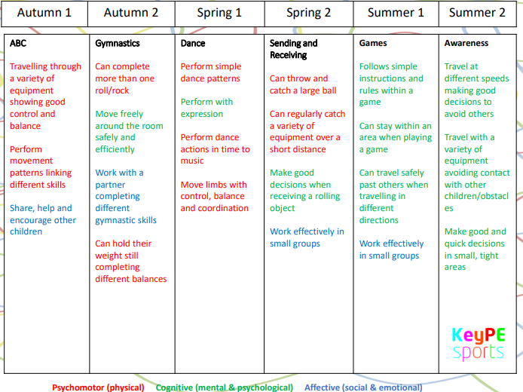

Key Stages 1
Key stage 1 Pupils will develop fundamental movement skills, become increasingly competent and confident and access a broad range of opportunities to extend their agility, balance and coordination, individually and with others. They should be able to engage in competitive (both against self and against others) and co-operative physical activities, in a range of increasingly challenging situations.
Pupils will be taught to:
- Master basic movements including running, jumping, throwing and catching, as well as developing balance, agility and co-ordination, and begin to apply these in a range of activities.
- Participate in team games, developing simple tactics for attacking and defending.
- Perform dances using simple movement patterns.
Curriculum overview for Year 1
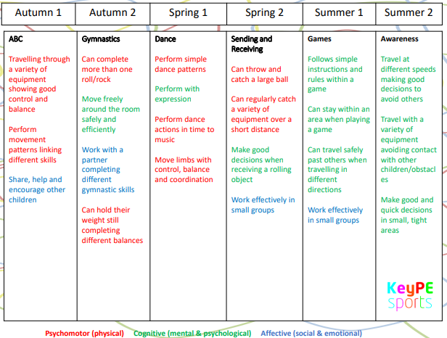
Curriculum overview for Year 2
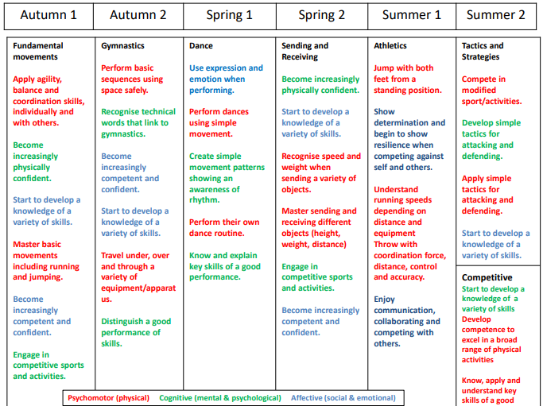

KS2
Pupils will apply and develop a broader range of skills, learning how to use them in different ways and to link them to make actions and sequences of movement. They should enjoy communicating, collaborating and competing with each other. They will develop an understanding of how to improve in different physical activities and sports and learn how to evaluate and recognise their own success.
Pupils should be taught to:
- Use running, jumping, throwing and catching in isolation and in combination.
- Play competitive games, modified where appropriate [for example, badminton, basketball, cricket, football, hockey, netball, rounder’s and tennis], and apply basic principles suitable for attacking and defending.
- Develop flexibility, strength, technique, control and balance [for example, through athletics and gymnastics].
- Perform dances using a range of movement patterns.
- Take part in outdoor and adventurous activity challenges both individually and within a team.
- Compare their performances with previous ones and demonstrate improvement to achieve their personal best.

Curriculum overview for Year 3
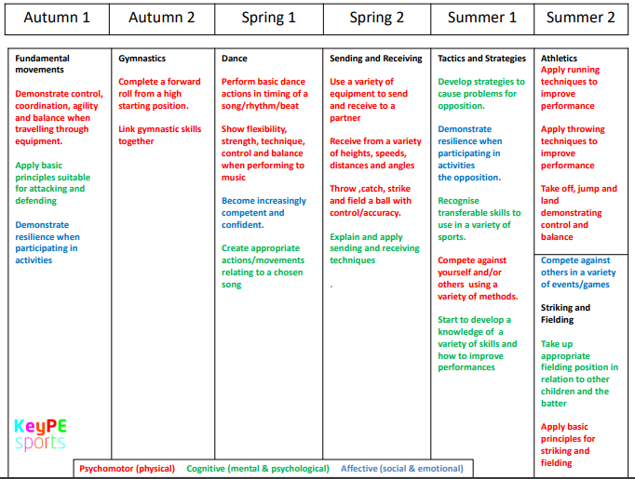

Curriculum overview for Year 4
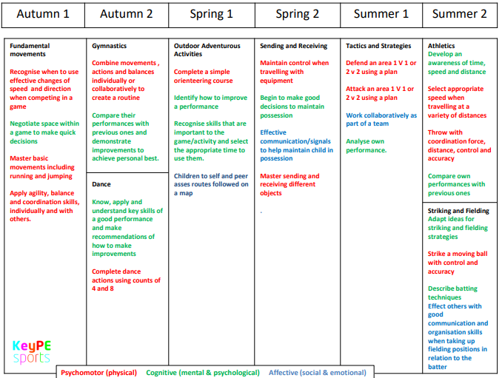
Curriculum overview for Year 5
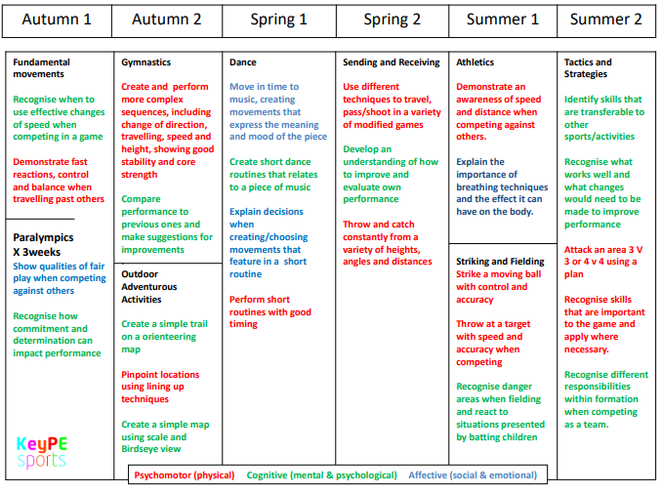
Curriculum overview for Year 6
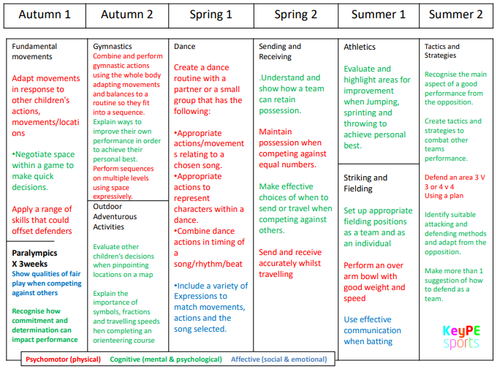

INCLUSION
At St Matthew’s Primary School inclusion in physical activities means that all children have access to learning opportunities regardless of race, gender and ability. We aim to create an environment in which all children learn to respect and value each other and each other's interests. This is achieved by employing the following strategies:
- Having equal expectations of boys and girls.
- Teaching mixed gender/ability groups and pairs.
- Structuring activities so that all are fully involved.
- Providing opportunities for children to present their work to others.
- Recognising the need to extend more able children and targeting them for school clubs/signposting to borough clubs.
- Anticipate needs and provide support as required. This could be the provision of specialist equipment, adult support or modified teaching programmes.
- Targeting particular children during playtimes and supporting them in physical play.

SAFETY
To ensure our pupils are safe in PE lessons children and staff must ensure the following:
- No head scarfs should be worn when participating in PE.
- All hair should be tied up when participating in PE.
- All children should participate in PE with or without a kit.
- Children should not be wearing earrings during PE. If a child wears earrings to school, it is their responsibility to remove their own earrings before PE. If they are unable to remove their earrings by themselves, they should not be wearing earrings on PE days.
- If a child does not have their PE kit the class teacher will phone home and remind their parents / careers. If in the following lesson the same child is not wearing a PE kit, then the class teacher will make another phone call home. If the child, again, does not bring their PE kit to the third lesson after 2 phone calls home, then the child will wear a kit provided by school. The child will need to leave this kit at school.
PE KITS
At St Matthews we expect all children to be in the correct PE kit at all times participating in PE lessons. To help ensure children are in the correct PE kit the following is in place for all children.
- Children at St Matthew’s are expected to bring their PE kits into school at the start of the week and then can take them home at the end of the week to be cleaned.
EQUAL OPPORTUNITIES
It is the teacher’s responsibility to ensure that, irrespective of race, gender or disability, all children receive their entitlement to Physical Education and be part of representing their school in competitive competition.
ROLE OF SUBJECT LEADER
It is the role of the Subject Lead to:-
Offer support to all staff in the planning and delivery of PE.
Monitor progress in PE and advise the Head teacher on any action needed.
Be responsible for the purchase and organisation of resources.
Co-ordinate extra-curricular activities involving PE.
Keep up-to-date with developments in Physical education and disseminate information to colleagues as appropriate
REVIEW
This policy will be reviewed annually by the Headteacher, Subject Leader and staff.

Date of Policy: | SEPTEMBER 2024
Date agreed by Governors:

Next Review Date: | September 2025

