Number of pupils and pupil premium grant (PPG) received

Total number of pupils on roll | 420 (inc Nur) 393
Total number of pupils eligible for PPG | 204 FSM + 1 FSM + 5 LAC
Amount of PPG received per pupil | £1,345 + £2,345
Total amount of PPG received | £ 287,450 (£274,380 +£1,345 + £11,725)
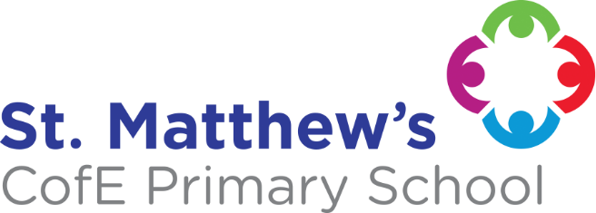
Barriers to learning

Key barriers | A summary of the main barriers to educational achievement faced by eligible pupils at are:  - Passive learning behaviour (poor levels of resilience/have a go attitude to learning)  - Minimal first hand experiences (particularly cultural enrichment opportunities)  - Poor parental engagement/support  - Mobility (including in year admissions)  - English as an additional language (EAL)  - Special Educational Needs (SEND)  - International New Arrival (INA)  - Poor attendance

Key Principles
Intention: | - Evidence-informed strategy linked with the Education Endowment Foundation’s research (EEF Guide to Pupil Premium)  - Whole-school commitment to narrowing the gap between disadvantaged children and their peers  - Recognition that excellent teaching is the most important lever to improve outcomes for disadvantaged children  - Identification of key priorities by the Senior Leadership Team/Pupil Premium Lead  - Acknowledgement that disadvantaged children are not a homogenous group, and therefore their needs must be individually specified and addressed appropriately  - The Pupil Premium Strategy sits within the broader, whole-school Teaching & Learning strategy  - Ensuring highest quality teaching at all times  - Ensuring interventions and extra-curricular activities are run by ‘St. Matthew’s staff’
Implementation – a tiered approach
Quality of Teaching | - Pupil Premium CPD  - Whole-school Development programme (lesson studies; peer observations; book sharing; collaborative planning; staff training (teachers and teaching assistants)  - Mastery Mathematics Programme (curriculum development linked with staff training; resources)  - English Hub phonics Programme (in collaboration with Read/ Write/ Inc)  - Reading Focus and Language Acquisition (NELI programme in EYFS)  - Teaching Assistants targeted support during lessons  - Robust Assessment and Data Evaluation leading to intervention (Data tracking, Pupil Progress Reviews, Book sharing, Learning Walks, External reviews  - Curriculum enrichment: specialist events; workshops; instrumental music lessons in KS1 and Y3; Nurture/ behavioural mentor;  - Intensive catch up programme to support learning delivered by school staff
Targeted Academic Support | - Additional phonics sessions with school teachers  - Small group tutoring led by school teachers, using additional resources  - Intensive catch up programme to support learning delivered by school staff  - Targeted intervention groups led by HLTAs
Wider strategies (to remove non-academic barriers) | - Emotional and Mental Health: nurture support led by pastoral mentors and trained staff; support from Educational Psychologist when appropriate; parental support provided by the school nurse (e.g. on sleeping, eating issues)  - PSHCE enrichment activities  - An active breakfast club, free of charge, ensuring children receive a good breakfast at the start of the school day  - All school lunchtime and afterschool clubs run at no charge to parents ensuring access for all pupils to a wide range of high quality enrichment activities  - Enrichment trips and activities financially supported  - Rewards: whole school ethos of excellence and success  - Financial support with swimming lessons  - Pastoral mentor  - Attendance awards, rewards and support by SEND and Inclusion Leader  - Funding to external clubs as appropriate
Progress
How progress will be measured | - Tracking pupil progress is an integral part of our teaching.  - In addition to tracking individual pupil progress we monitor groups of children such as FSM, CLA, girls and boys, spring and summer term born children, pupils with special educational needs, pupils from ethnic minority backgrounds, INA’s and pupils for whom English is an additional language etc.  - The data we collect is analysed during our half termly pupil progress meetings and drives processes for closing the gap.  - At these meetings, class teachers meet with the Assessment Leaders and the Special Educational Needs Coordinator to discuss pupil progress and the impact of interventions.  - Where pupils are not on track to reach their targets, staff look at changes that can be made to help the pupils make the required progress. This may mean modifying teaching, providing the pupil with an intervention programme, or moving the child to the special educational needs list and providing additional support.  - The focus of pupil progress meetings is about diminishing the difference between groups of pupils, so that every child makes progress and reaches their full potential.
Review of strategy
- Termly within pupil progress meetings
- At the end of specific interventions
- Annually with a report to the governors

