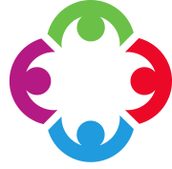
LITERACY
Work based on the significant children’s author Michael Morpurgo, Dragon Slayer, and Newspaper Reports. We will be focusing in the issues of animals in captivity. 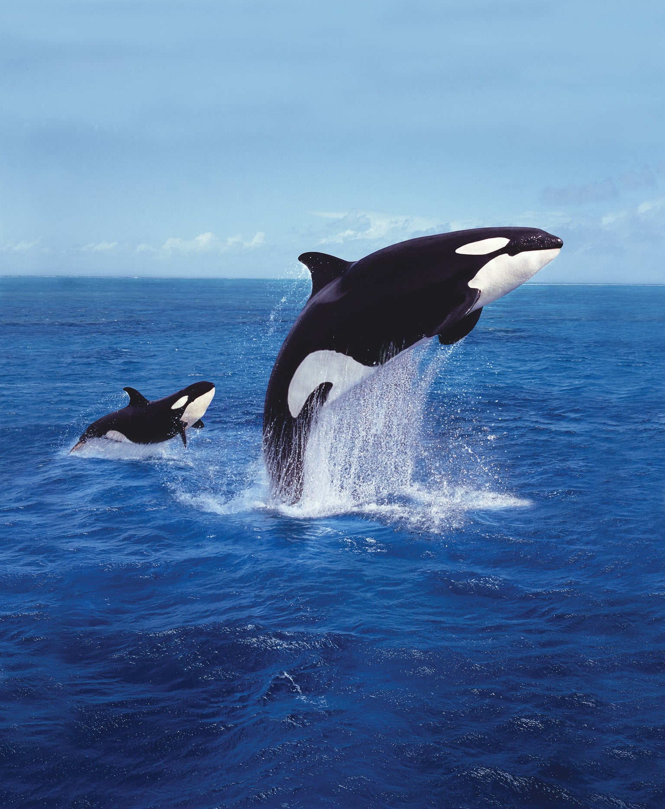 PLEASE ENSURE YOUR CHILD READS AT HOME AND BRINGS THEIR READING BOOK BACK TO SCHOOL EVERY DAY-THANK YOU.

NUMERACY
We will be revising the basic skills of addition, subtraction, multiplication and division. We will also be concentrating on fractions, decimals and percentages.

Transition work in preparation for High School will also be completed.
RE
Similarities and differences between religions and their ideas about God.
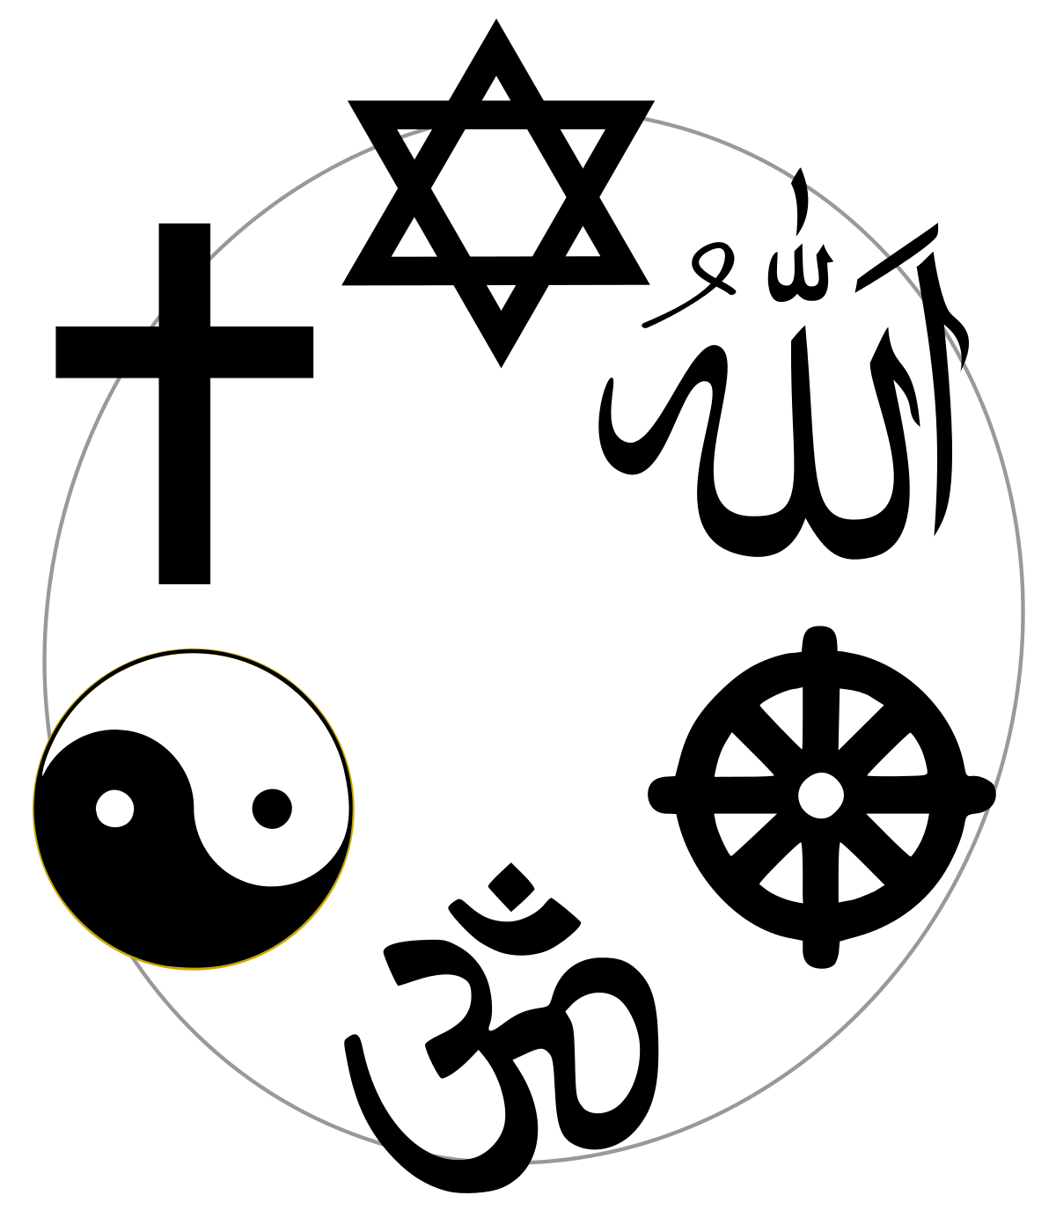
THEME Our theme for the second half term:
“AND THE BAND PLAYS ON “
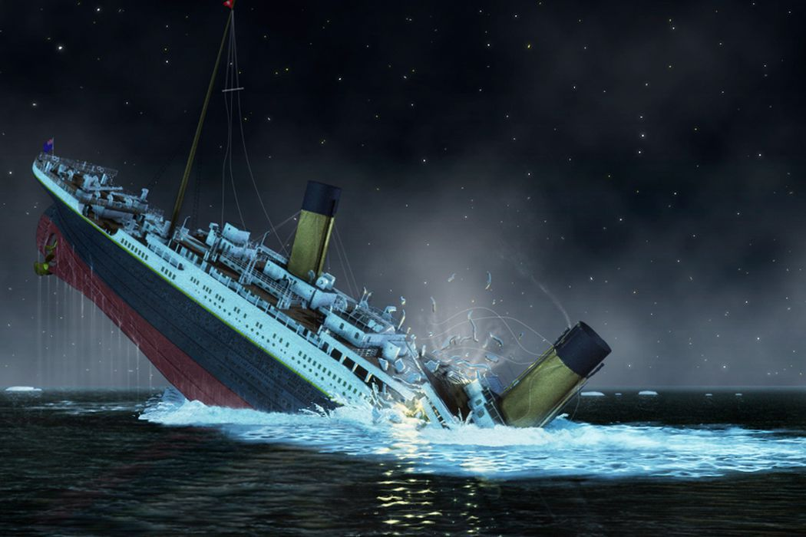
THEME Our theme for the first half term:
“GLOBAL WARNING”

PE
Cricket, rounders & athletics.
PE kits must be worn on the correct PE day.
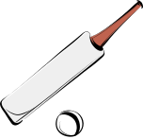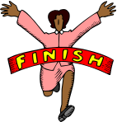
6P – Tuesday and Thursday
6C – Wednesday and Friday
SCHOOL UNIFORM REMINDERS:
JEWELLERY, APART FROM PLAIN STUD EARRINGS AND WATCHES, ARE NOT TO BE WORN IN SCHOOL. ALL BLACK SHOES.
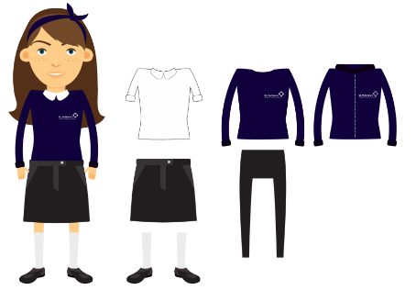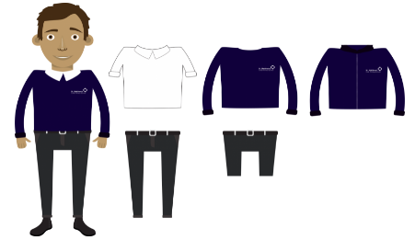

ESSENTIAL LEARNING EXPERIENCES
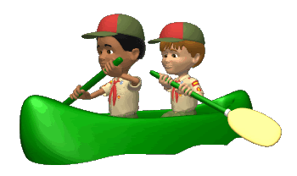
Outdoor Activities at Anderton Centre.

YEAR 6 SUMMER TERM

