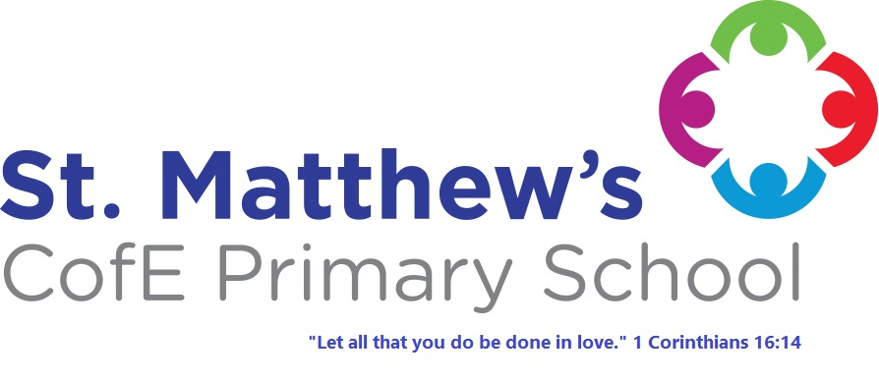
St. Matthew's
C of E Primary School Policies
Our Policy:
School Uniform

Approval Date: June 2025
Review Date: June 2026

At St Matthew’s CE Primary School, we believe that a simple and straightforward school uniform policy is important for a number of reasons.

• promotes a sense of pride in our school;

• helps to create a sense of community and belonging towards the school;

• identifies the children with the school;

• supports our commitment to inclusion;

• prevents children from wearing ‘fashion clothes’ that could be distracting in class;

• is practical and smart;

Expectations

We expect all pupils to comply with this uniform policy, which will be monitored. Any pupil who falls short of these requirements will be spoken to by their class teacher and given the opportunity to improve. Teachers may contact parents at the end of the day or by phone call about their child’s uniform.

The Role of Parents/Carers

We believe that one of the responsibilities of parents/carers is to ensure that their child has the correct uniform and PE kit, and that it is clean, in good condition and that the child’s name is written on all items.

The Role of Governors

The governing body supports the Headteacher in implementing the School Uniform Policy. It considers all representations from parents regarding the uniform policy and liaises with the Headteacher to ensure that the policy is implemented fairly and with sensitivity. It is the governors’ responsibility to ensure that the school uniform meets all regulations concerning equal opportunities. Governors ensure that the school Uniform Policy enables children to dress sensibly, in clothing that is hardwearing, safe and practical.

Where to buy our uniform

All items are stocked by Harrisons, 467a Blackburn Rd, Bolton, BL1 8NN or Whittakers Schoolwear, 106 Deansgate, Bolton, BL1 1BD both stock the navy blue sweatshirts/cardigans with the school logo.

Uniform can also be bought from elsewhere; Asda, Matalan, Sainsbury’s etc on the condition that garments comply with the list below.

Our Uniform

- skirts/pinafore dresses (grey/black)
- trousers/shorts (grey/black)
- sweaters/sweatshirts/cardigans (navy blue) – not hoodies
- blouses/shirts/polo shirts (white)
- socks/tights/leggings (white/grey/black)
- cotton dress/playsuit (white/blue check)
- Footwear – plain black shoes or plain black trainers (no logos)
- Head scarves (White/blue/black) plain, short in length with no embellishments

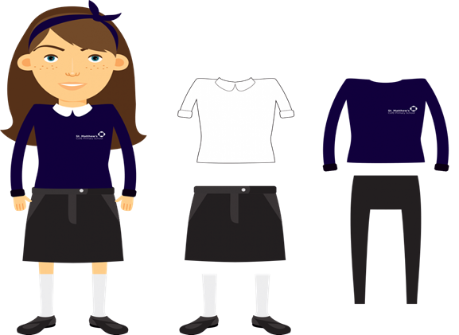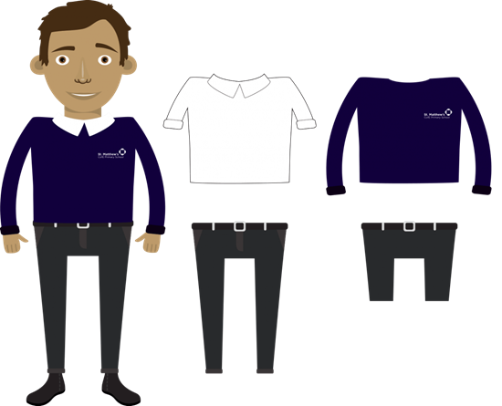

Hoodies, hats and baseball caps are not part of the uniform and must not be worn in school

P.E.

White T-shirt/polo shirt and Blue/black shorts/leggings,
Footwear – black pumps (indoor) and trainers (outdoor)
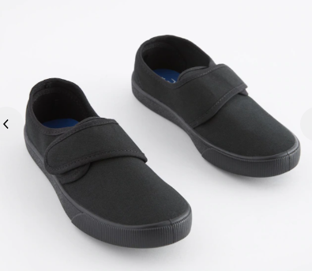

These items should be put into a draw string bag and hung up on the child’s coat peg in the class corridor. The P.E. kit should be brought into school at the start of each term and taken home to be washed at the end of each half term.

Children will attend swimming lessons in Years 4 & 5.
A letter will come out to parents nearer the time explaining what your child will need.

School Bags

There is no reason for children to bring large bags into school.
There is a great shortage of space in the cloakrooms and large bags exacerbate the problem.
Lunch boxes can be carried and stored on trolleys.

Jewellery

No jewellery should be worn at school apart from a pair of small plain studs earrings (large or hoop earrings are not allowed for health and safety reasons) and a simple watch (no smart watches)
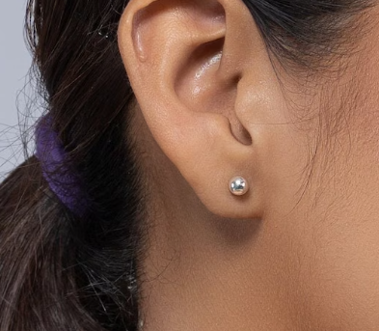

Hairstyles
Hairstyles must be appropriate for primary school, coloured hair is not permitted – natural hair colours only. Children must also have their hair tied back. Headbands, bobbles, beads and hair accessories should be in school colours (blue/black) and not oversized.

Make up

All make up (which includes false eye lashes, false nails, nail varnish, temporary tattoos and false tan) is not permitted.

Please be aware that St Matthew’s also has pre-loved uniform items which are available directly from the school. Please get in touch for more information.

Date of Policy: | June 2025
Date agreed by Governors: | June 2025
Next Review Date: | June 2026

