September newsletter
Thank you for making the start of term so smooth. The children have settled into their new classes and have been having lots of fun both inside and outside the classroom. Read on to see what has been going on.
Ethos Team
Our value for this term is ‘Friendship’. Here is a prayer that our Ethos team would like to share.
Thank you, God, for all that we have.
Thank you for our food, our family, our friends and all that you give us.
We are sorry that sometimes we forget to say thank you.
Help us to always thank other people for the things they do for us,
and to thank you for all that we have.
Amen

Ethos Team Challenge
Make a treasure box with your family. Add in post it notes for what you are thankful for such as your friends and family. This will remind you of all the precious things you have.

Y1M - Snowdrops
Year 1 had a visit to Rivington Pike. The children had the opportunity to explore the natural surroundings while also working as a team and supporting each other.

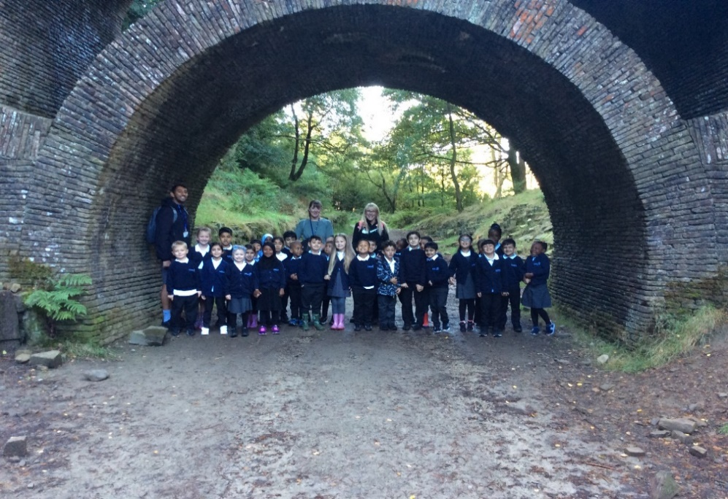

Y6K - Honeybees - Music Project

Y6K were lucky enough to be part of a music project led by Chetham's School of Music Outreach Team. Sarah led our three sessions and we wrote three varied songs, which were performed in front of the whole school.
The first was about small pox. The second about an invention from the last 50 years and the third was about one of our own inventions. We thoroughly enjoyed this project.
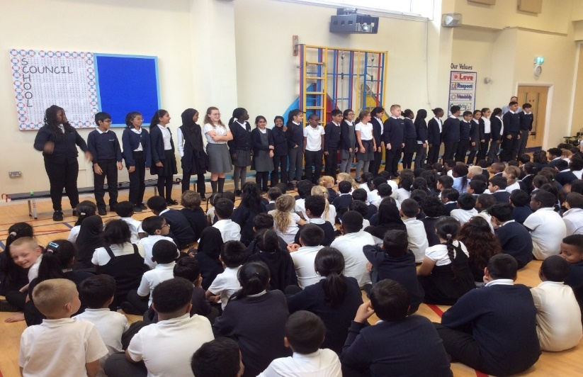

Y2M - Poppies
In theme, year 2M have been exploring the local area and learning about how and why our school building has changed.
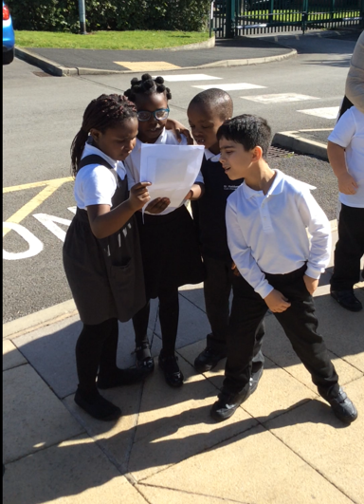

Y3J - Sparrows
Y3 Sparrows had a fabulous time at the Anderton Centre. We climbed trees, did archery and paddled our boats. We were very brave.

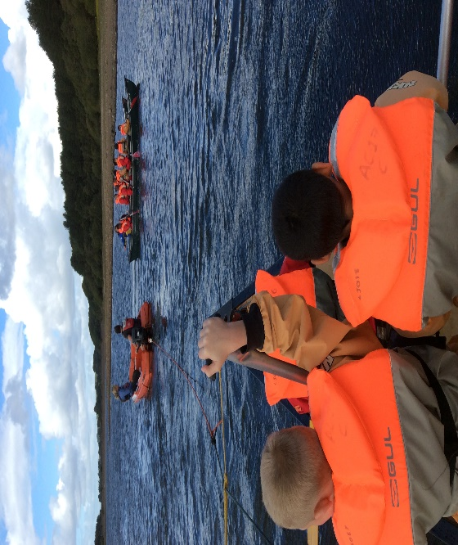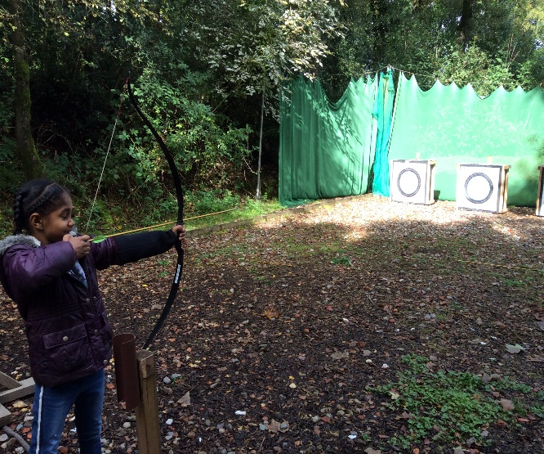

Reception Owls
On Wednesday this week Sue Tinker from the Road Safety Team visited us in our Reception classes. She talked to us about keeping safe when we are out and about near roads and how important it is to always hold a grown-ups hand. We also learnt about where it is safest to cross a road and the role of the lollipop person. It was great fun and we will be practising stopping the traffic and crossing the road next week in our play outside.
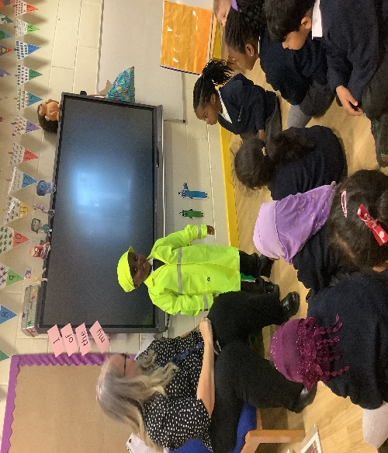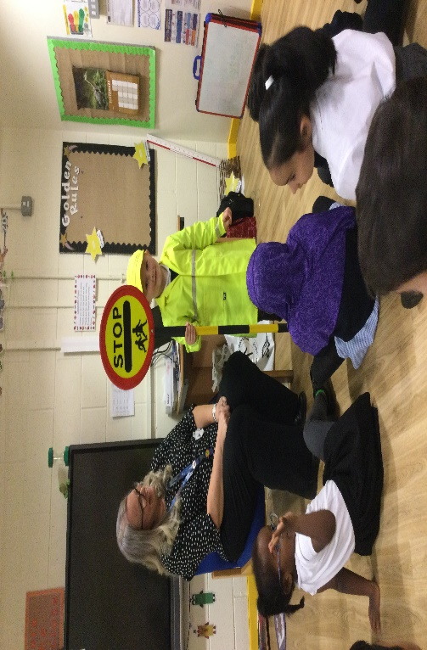

Y1S - Bluebells
Year 1 Bluebells have been exploring push and pull forces in our science lessons.
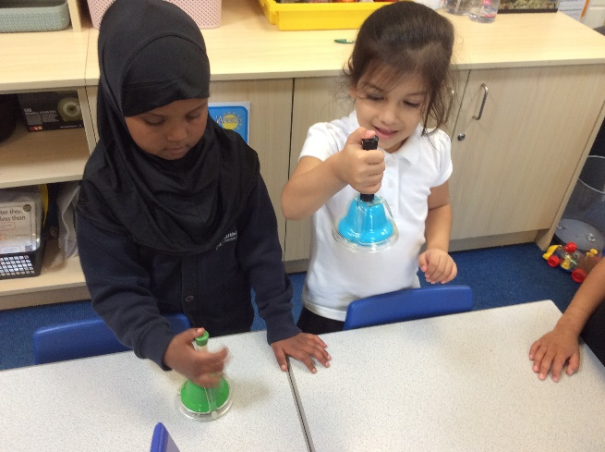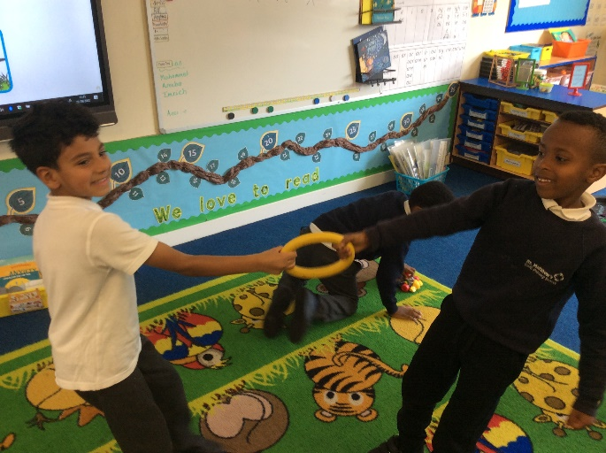

Y5
At the start of the Autumn Term, Year 5 enjoyed a trip to Roman Chester. We were given a guided tour of the museum, with the soldier (Maximus), who explained every aspect of Roman life.
After the museum, Maximus taught us how to march like the Roman infantry and defend ourselves as a unit. Finally, we marched our way to the amphitheatre to watch a gladiator battle.
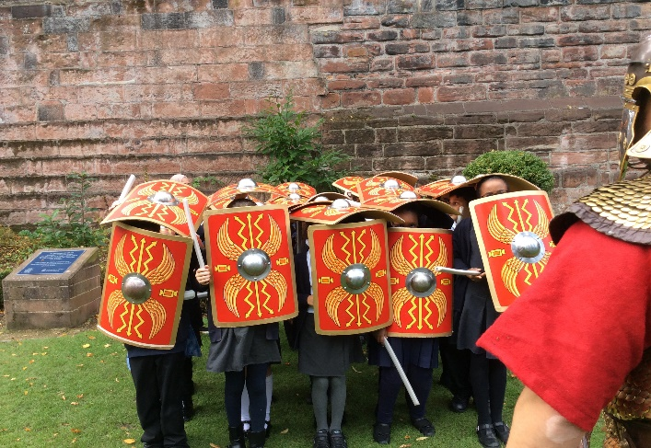
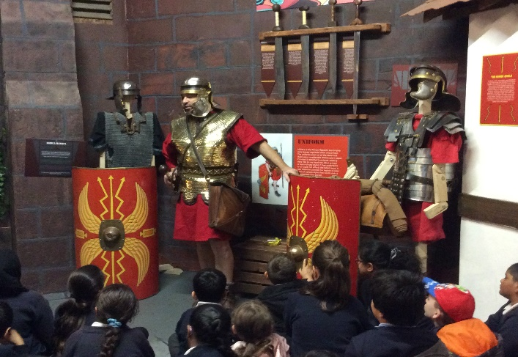

SEND
Some Y5 children had a great morning horse-riding.
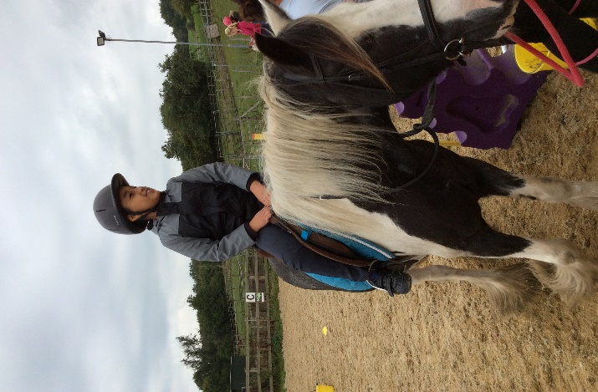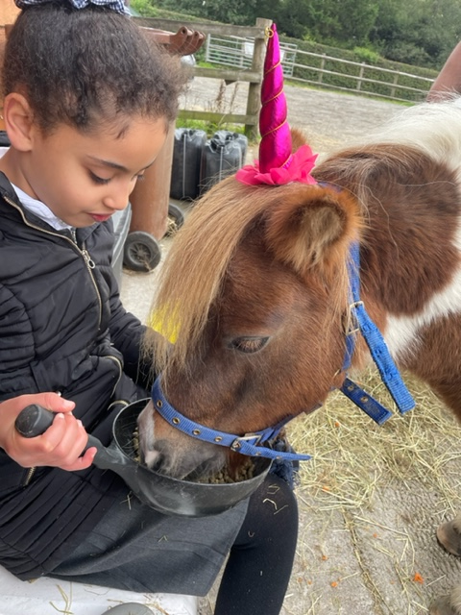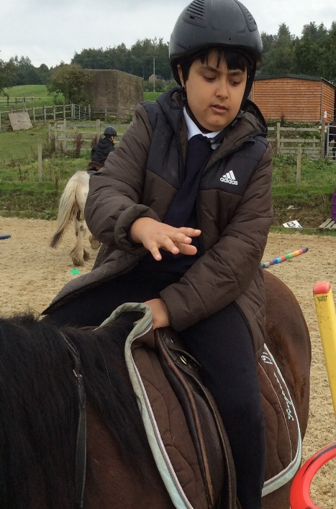
For more information about Bolton’s SEND local offer please visit:
www.boltotn.gov.uk/sendlocaloffer

