Hedgehogs and Owls - Reception
Spring Overview – ‘Come Fly With Me’, ‘Animal Crackers’ and ‘Tell Me A Story’
Miss Smith and Miss Russell
Read Write Inc Phonics |  | Maths |  | Theme |  | Writing
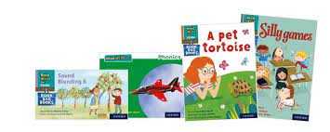  We continue to teach exciting and engaging phonics every day. The children access differentiated phonics groups matched to their ability and identified next steps. We continue to practise our oral blending, Fred Talk to read CVC words and all children are taught how to use their Fred Fingers for spelling. Please remember to use the QR codes and follow the phonics links on your child’s class page; these will help improve your child’s confidence and phonic skill.  Your child will bring home a reading book or activity matched to their phonic knowledge – this needs to be returned to school every day so your child can read with an adult. |  | We are busy mathematicians in Reception! We take part in a ‘Mastering Number’ session and a Power Maths session every day. We have weekly mathematics group works and we explore number, numerical pattern, shape and measure throughout our continuous provision!  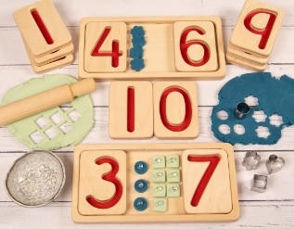  This term we will be continuing to build upon our knowledge of ordinality, cardinality, composition of number and ability to subitise. We continue to develop our knowledge of number bonds. Every day we practise our reasoning skills. |  | This term we will first begin by continuing our theme ‘Come Fly With Me’. We will recap and develop our understanding of  - Chinese culture  - Indian culture  - Pakistan culture and traditions  Our next theme will be ‘Animal Crackers!’ We will be developing  Our knowledge of the animal kingdom and we will find out about  - Big and small animals  - Baby animals  - Animals on the farm  We will also be continuing to support the children’s understanding of seasonal change as we notice signs of Spring. Our third theme in Spring will be a traditional tales focus where we will learn key stories including ‘The Gingerbread Man’ and ‘Jack and the Beanstalk’. |  | Your child will develop their writing in a number of ways this term. We continue to provide lots of opportunities to strengthen our fine motor skills with fun and exciting activities in the provision. The children will take part in differentiated writing activities and every child will practise writing their sounds daily in phonics.  How can I help at home?  Young children needs lots of opportunities to develop their confidence, fine motor skills and knowledge of letters before they are ready to become capable writers! You can help your child by helping them write simple shopping lists with words such as ‘jam’ or ‘milk’. You can encourage them to write their name, messages or sign birthday cards! Remember, in Reception it is more important to ‘sound out’ the words, rather than spell them correctly.
Tapestry |  | Stay and Play |  | Forest School |  | P.E
Please make sure to check your child’s tapestry learning journal so that you can see all the exciting things they have been getting up to! |  | This term we will be running ‘Stay and Play’ sessions in Reception. This will be an opportunity for you to see Reception in action! Staff will be available to provide ideas around how you can support your child’s learning at home. You will receive a letter to inform you of the dates. |  | If your child is taking part in forest school this half term, a letter will have been sent home.  Hedgehogs Forest School is Tuesday.  Owls Forest School is Thursday. |  | Owls PE day is Thursday.  Hedgehogs PE day is Friday.  Please send your child’s PE kit into school on their PE day - white t-shirt, black/navy shorts or legging and PE pumps.

