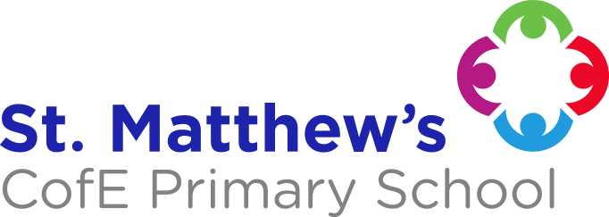
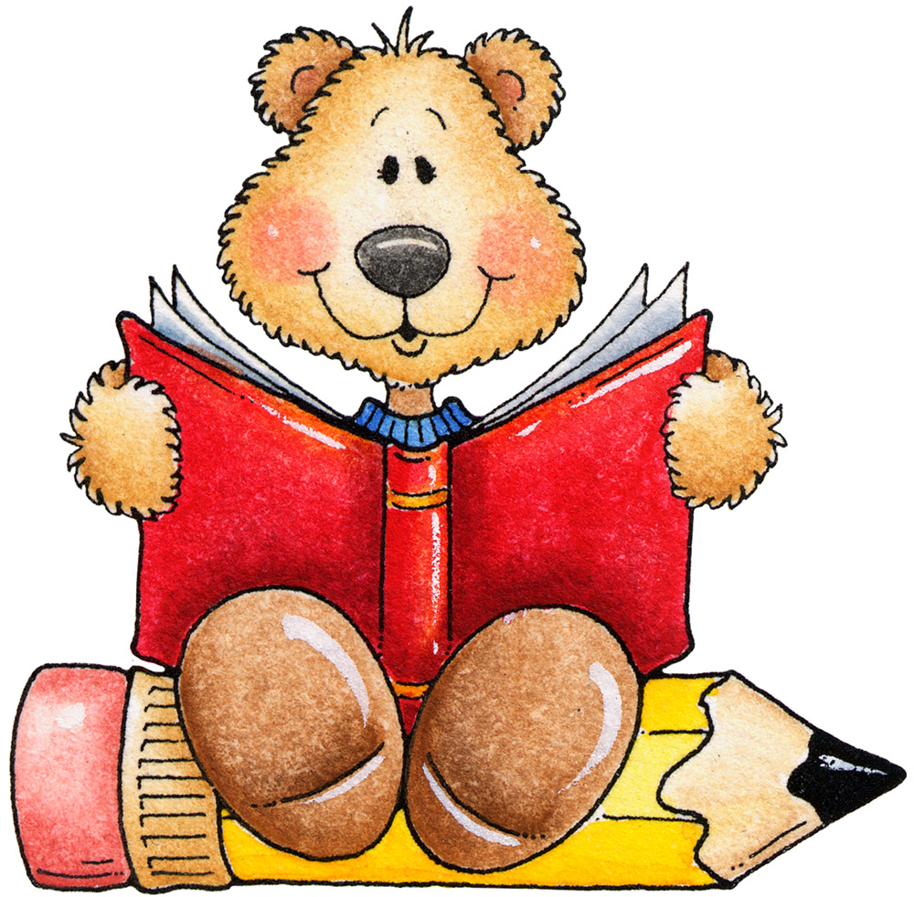
ENGLISH
We will be following the Read, Write, Ink scheme for phonics, reading and writing. We will be reading lots of light and dark themed stories alongside
this. PLEASE ENSURE YOU SIGN YOUR CHILD’S
READING RECORD WHEN THEY READ AT HOME
AND IT IS IN SCHOOL ON FRIDAYS.

MATHS
Due to the pandemic we will be having a focus on number and fraction work. We will be recognising number bonds to 10, counting objects up to 100 and writing the numerals up to 100, comparing numbers, finding 1 more/ 1 less than a number, count on from a number, partitioning numbers into tens and ones and adding and subtracting. .Please help your child learn to count in 1s, 2s, 5s and 10s.
RE
We will be looking at Baptism and about the Story of Joseph.
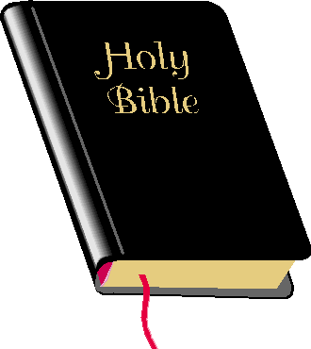

THEME - The Famous Five (Summer 2)
This theme will have a History focus, looking at some famous figures and events from the past who have helped to shape the future that we know. The children will learn about the Great Fire of London / Samuel Pepys, the Moon Landing / Neil Armstrong and Christopher Columbus.
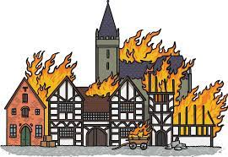

THEME - Light up the World! (Summer 1)
The children will be learning about the sun, light and darkness. They will learn about different light sources and what objects reflect the light. We will also be focusing a lot on PSHE, thinking about dark emotions and light emotions and how we can bring light to the world.


PE
OUR PE LESSONS ARE ON WEDNESDAYS AND FRIDAYS.
PLEASE ENSURE YOUR CHILD COMES INTO SCHOOL WEARING THEIR P.E. KIT.

PLEASE SEND YOUR CHILD INTO SCHOOL WITH A WATER BOTTLE EVERY DAY.

SCHOOL UNIFORM REMINDERS:
JEWELLERY, APART FROM PLAIN STUD EARRINGS AND WATCHES, IS NOT TO BE WORN IN SCHOOL.
FOOTWEAR - PLAIN BLACK SHOES.
PLEASE NAME ALL SCHOOL UNIFORM!

ESSENTIAL LEARNING EXPERIENCES
To enrich the curriculum, we will be playing out in a variety of weathers. Please ensure your child has suitable clothing for all weather, for example a coat for rainy days, sun hat and sun cream already applied for when it is hot,

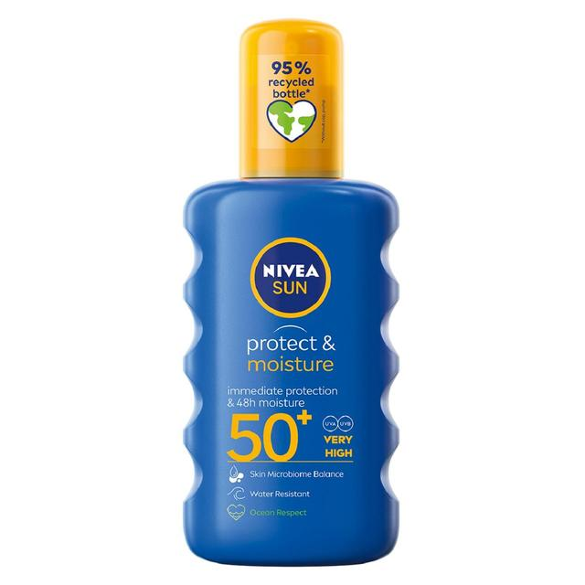
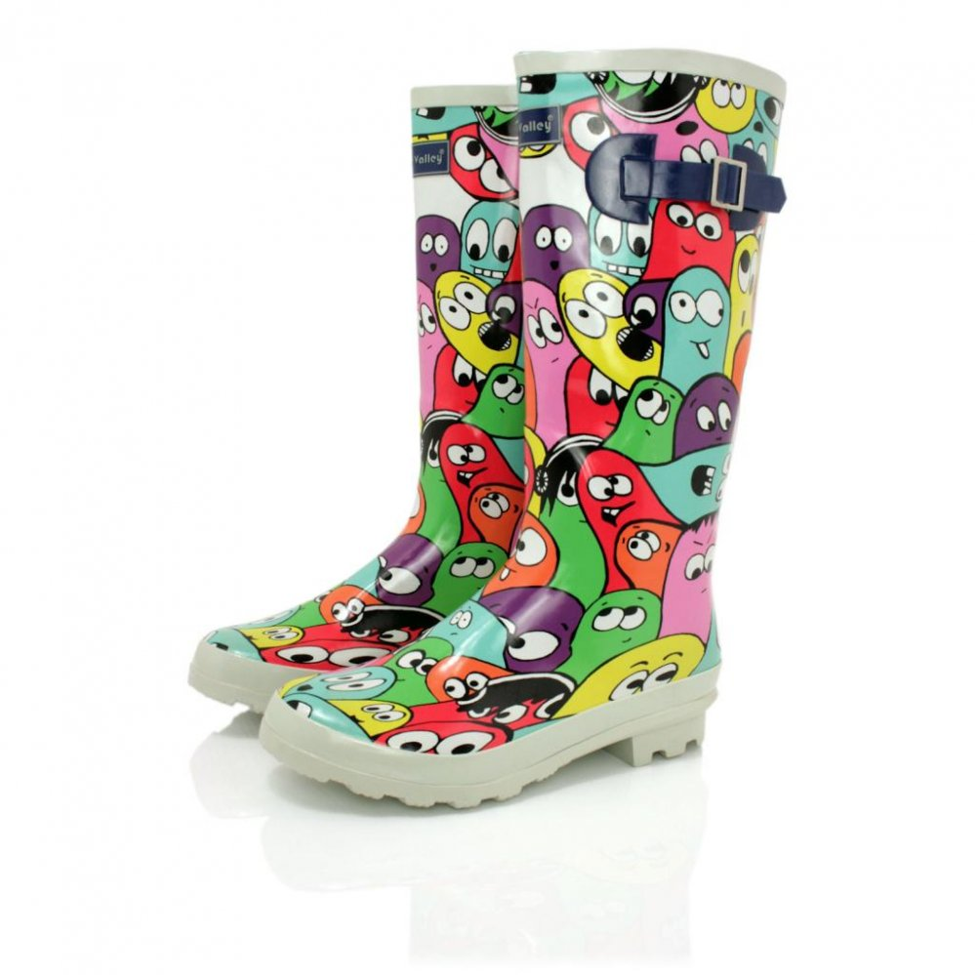

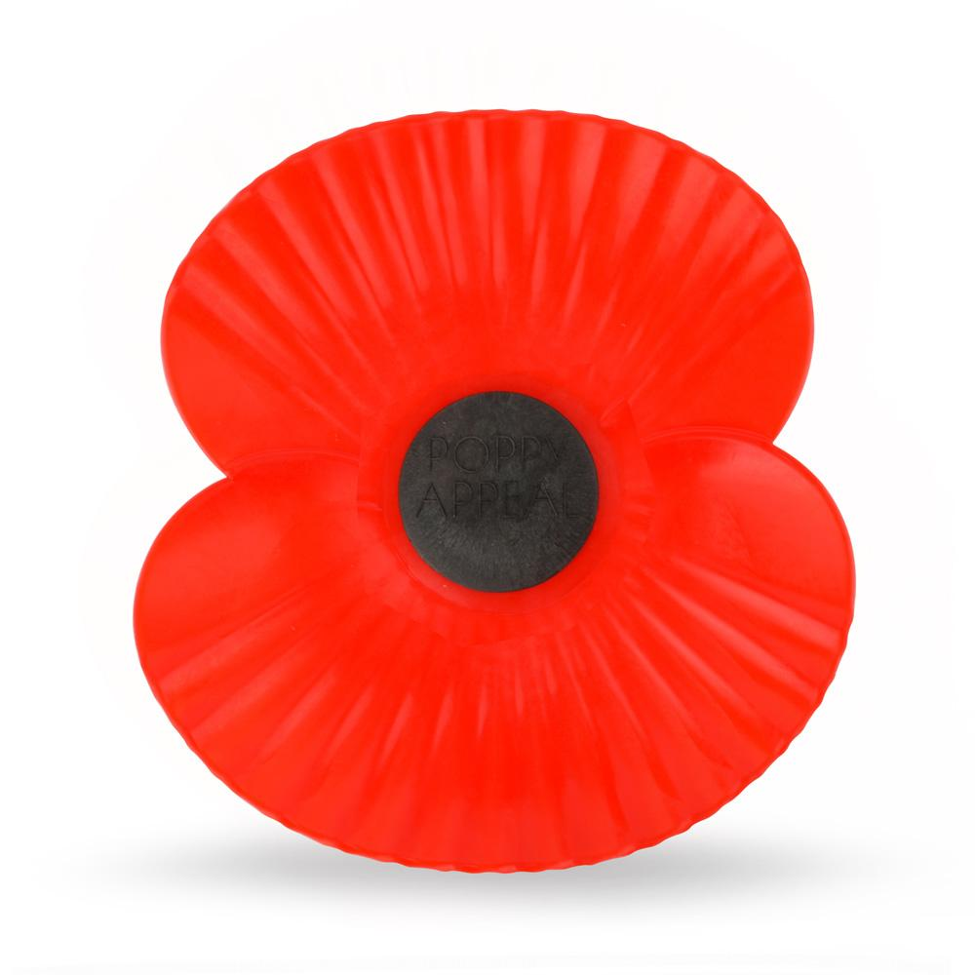Year One 

