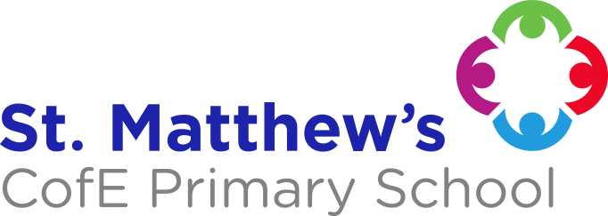
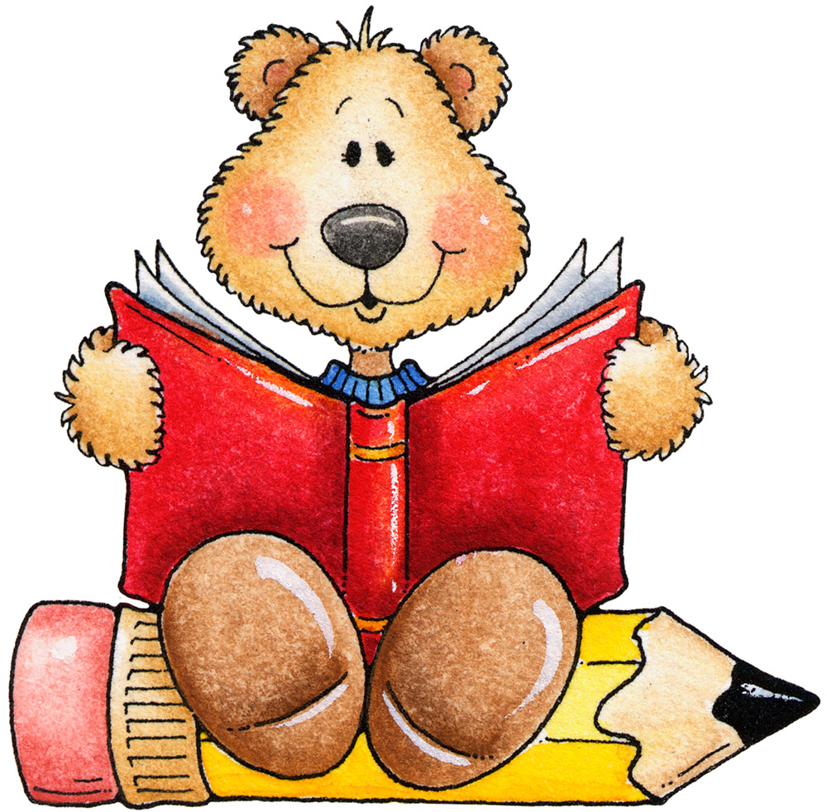
ENGLISH
We will be following the Read, Write, Inc. scheme for phonics, reading and writing. We will be reading lots of light and dark themed stories alongside
this. This year’s Phonics Screening Test will be in the week commencing 6/7/22, If you have any questions about
this please speak to the class teacher.
MATHS
We are continuing to follow the Power Maths scheme of work. This term will entail counting, reading and writing numbers up to 100, multiplication, division, fractions (halves and quarters), position and direction, money and time.
Please help your child by counting forwards and backwards 0-100 or in 2s,5s and 10s.
RE
We will be looking at Baptism and about the Story of Joseph.
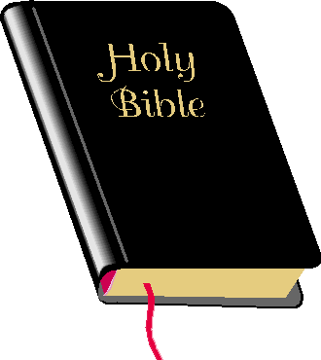

THEME - The Famous Five (Summer 2)
This theme will have a History focus, looking at some famous figures and events from the past who have helped to shape the future that we know. The children will learn about the Great Fire of London / Samuel Pepys, the Moon Landing / Neil Armstrong and Christopher Columbus.
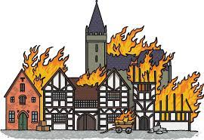

THEME - Light up the World! (Summer 1)
The children will be learning about the sun, light and darkness. They will learn about different light sources and what objects reflect the light. We will also be focusing a lot on PSHE, thinking about dark emotions and light emotions and how we can bring light to the world.
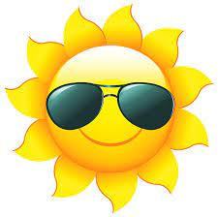

PE
Our PE lessons are now on TUESDAYS AND THURSDAYS
.
Please ensure that your child brings a FULL PE kit to get changed into.

PLEASE SEND YOUR CHILD INTO SCHOOL WITH A WATER BOTTLE EVERY DAY.

SCHOOL UNIFORM REMINDERS:
JEWELLERY, APART FROM PLAIN STUD EARRINGS AND WATCHES, IS NOT TO BE WORN IN SCHOOL.
FOOTWEAR - PLAIN BLACK SHOES.
PLEASE NAME ALL SCHOOL UNIFORM!

ESSENTIAL LEARNING EXPERIENCES
To enrich the curriculum, we will be playing out in a variety of weathers. Please ensure your child has suitable clothing for all weather, for example a coat for rainy days, sun hat and sun cream already applied for when it is hot.

Your child will receive a letter to tell them which half term they will be participating in Forest School. Please ensure that they bring appropriate clothing for this also.

Please also look out for letters regarding trips.

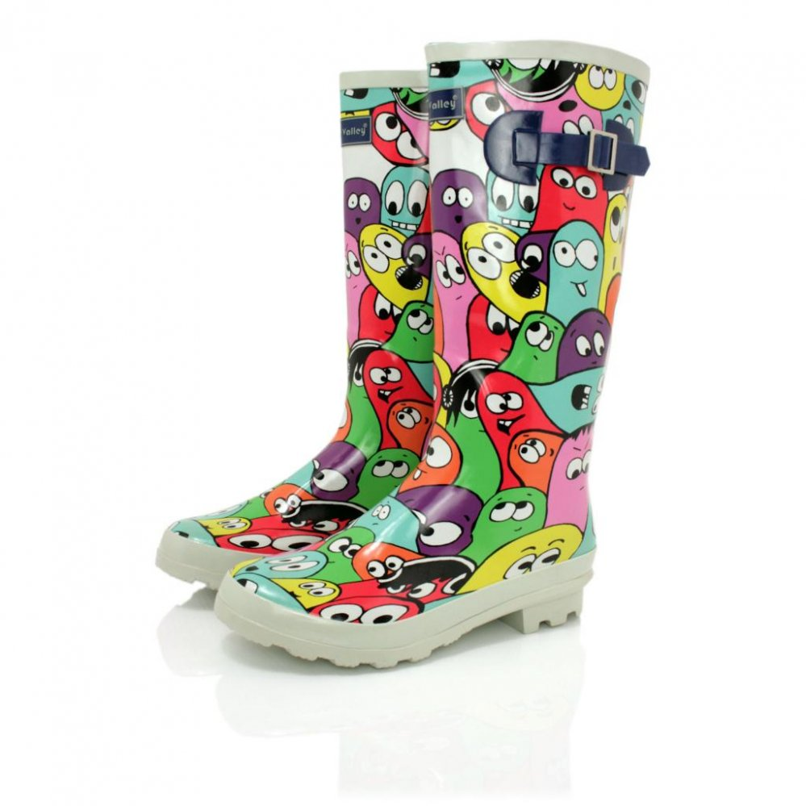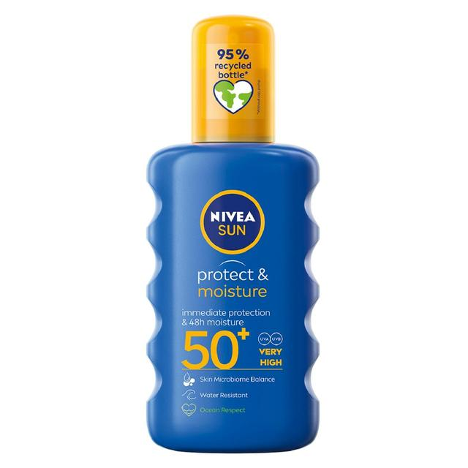

Year One 

