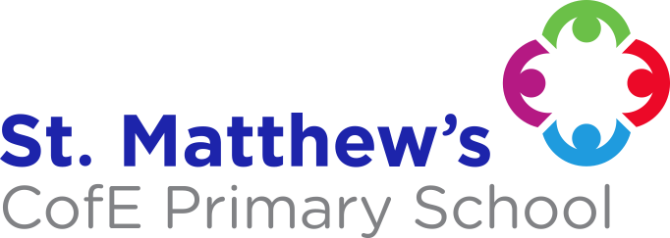

**RE**

Ideas about God

People of Faith

**MATHS**

This half term we will be completing our unit on position on direction. Then, we will be revising all previously taught unit in preparation for the SATs. Following this, we will be completing problem solving units and preparing the children for secondary school.

**YEAR 6**

**SUMMER TERM**

**NOTICES**

PE is on a Wednesday. PE kit is a plain white t-shirt and navy blue shorts or leggings. Children should come to school in their school uniform and bring their PE kit in a bag. Kits should be taken home after every session and washed. No earrings.

Homework is due in every Monday. They will have a maths and English piece weekly and they must choose 3 pieces of creative homework over the half term linked to our theme. On Friday, maths scrapbooks will be handed out with a task to be completed with the family. These must be returned on Wednesdays.

**If you would like any further information about our curriculum, please do not hesitate to contact us.**

**SCIENCE**

**The Circulatory System**

Pupils will identify and name the main parts of the human circulatory system and explain the functions of the heart, blood vessels and blood.

**Reversible and Irreversible Changes**

This unit will look at comparing and grouping everyday materials on their properties, know that some materials will dissolve in liquid to form a solution and describe how to recover a substance from a solution, and use knowledge of solids, liquids and gases to decide how mixtures might be separated.

**Go With The Flow**

This is a thematic unit which focuses on the biology of humans and animals. Pupils will learn about the changes humans develop to old age. They will recognise the impact of diet, exercise, drugs and lifestyle on the way their bodies function. Pupils will describe the ways in which nutrients and water are transported within animals including humans.

**Global Warning**

This Is a thematic unit which is geography-focused with sustainability and eco literacy at its heart. This project-based theme involves pupils applying their learning about the global environmental issues of waste and pollution by creating a board game, which is both educational and fun. The pupils will work in groups to research, design and produce their board game, after which they will present and demonstrate it to the class.

**ENGLISH**

**Summer 1:** Kensuke’s Kingdom

**Summer 2:** Black Fish

Your spelling test will be every Wednesday.

**PLEASE ENSURE YOUR CHILD BRINGS THEIR READING BOOK BACK TO SCHOOL EVERY DAY.**