Y3 CREATIVE HOMEWORK
Under the Canopy
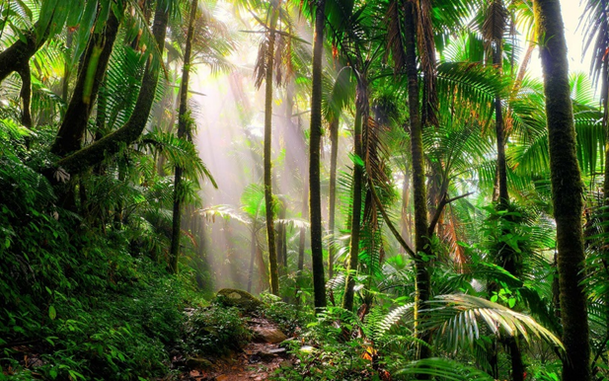
Given out: Thursday 26th May 2022
Due in: Friday 10th June 2022

Choose one of the following to complete:
- Produce a shoebox model (diorama) of a rainforest scene.
- Write a poem about saving the rainforest.
- Write an imaginary story about the life of a child living in the rainforest.
- Make a set of Did you know? cards about the rainforest.
- Compose and perform a rainforest dance.
- Write a poster about how to protect the rainforest.
- Write a poster about checking a product’s label for palm oil.

You can present this in any way you want. Be as creative as you want!

Good luck! We look forward to seeing them!

