5th February 2025
Dear Parents / Carers,
World Book Day is on Thursday 6th March 2025. We would love the children to dress up for World Book Day, the children can dress up as any book character. Here are some examples of costumes.
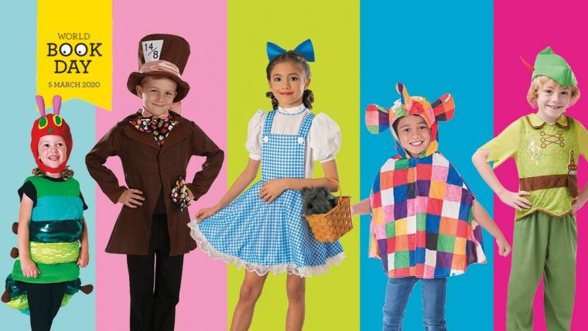

Before World Book Day, we will be doing an extreme readers competition.
Take a photo of yourself reading one of your favourite books in a crazy or unusual place. Be as creative as you like. You could even photoshop or draw yourself into a crazy place.
Our school council will decide the winners for each year group on 5th March 2025, so make sure it is ready for the deadline. Here are some examples of extreme readers entries below to help inspire you!
We cannot wait to see what fantastic costumes the children will wear and their amazing extreme readers entries! Good luck.
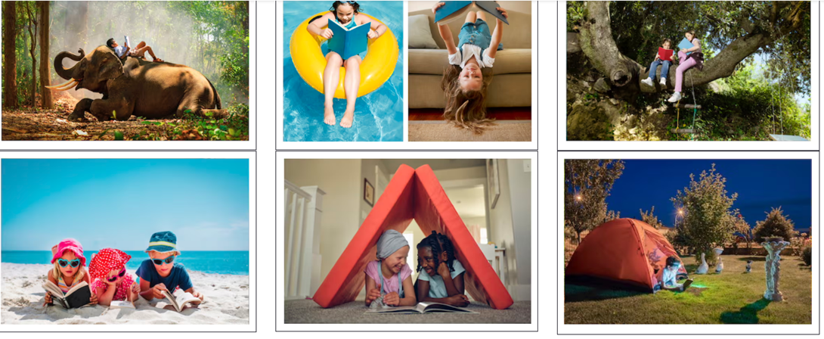

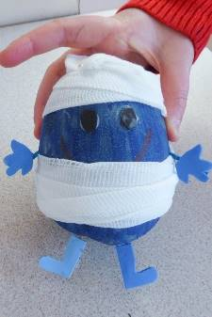
Yours sincerely
Miss Foster / Mrs Lightfoot
Y4 Teacher and Y6 English Coordinator

