Term/ Theme: | Autumn 1 | Autumn 2 | Spring 1 | Spring 2 | Summer 1 | Summer 2
 | AU1 – Land Ahoy! - Pirates  AU1/2 – Never Eat Shredded Wheat - Geography  AU2/SP1 – Come Fly With Me! Arctic Circle |  | SP1 – Record Breaker – The Story of Sir Rapulph Fiennes  SP1/2 – Happily Ever After – Fairy Tales |  | SU1 – Royal Patron – The Story of Elizabeth II and Victoria  SU1/2 – Going Wild – All About Animals  SU2 – Powhatan People – The Story of Pocahontas
Class novels  Supporting texts  May link to Theme (where possible). | 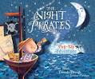  The Night Pirates By Peter Harris  The Pirates Next Door By Johnny Duddle / Peace at Last By Jill Murphy | 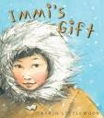  Immi’s Gift By Karin Littewood  Handa’s Surprise By Eileen Brown | 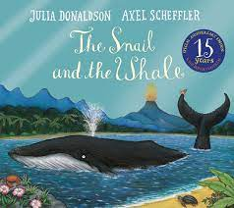  The snail and the whale – Julia Donaldson  Stickman – Julia Donaldson | 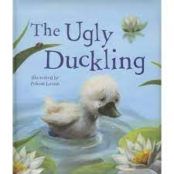  The Ugly Duckling By Hans Christian Anderson  Little Red Riding Hood By Charles Perrault | 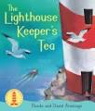  The Lighthouse Keeper’ Lunch By David and Ronda Armitage  The Very Hungry Caterpillar By Eric Carle | 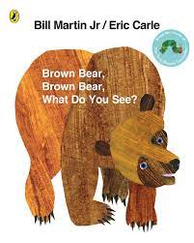  Brown Bear, Brown Bear what do you see? By Bill Martin Jr. and Eric Carle
Genre: | Fiction  Fantasy stories  Non- fiction  Lists, labels and captions  Recount | Fiction  Stories from other cultures  Non-fiction  Explanation texts | Fiction  Author study (Julia Donaldson)  Poetry (pattern and rhyme)  Non-fiction  Biography | Fiction  Fairy tales / traditional stories  Poetry – traditional nursery rhymes  Non-fiction  Letters | Fiction  Stories with familiar settings  Non-fiction  Instructions | Fiction  Stories with patterned language  Poetry - senses  Non-fiction  Fact files
Outcomes: | Fiction  Non-fiction  Recount from the pirate day | Fiction  Non-fiction | Fiction  Non-fiction  Biography on Julia Donaldson  Autobiography - all about ‘me’ | Fiction  Non-fiction | Fiction  Non-fiction  Instructions on how to make a sandwich | Fiction  Stories with familiar settings  Non-fiction  Animal fact file
Skills Covered: | Fiction  Create short narratives  Adjectives to describe  -ed suffix  Non-fiction  adjectives | Fiction  Non-fiction | Fiction  -ing endings  Proper nouns – places  -er/est adjectives  And to link ideas  Non-fiction | Fiction  Create short narratives  Adjectives to describe  Un prefix  Non-fiction | Fiction  Proper Nouns for names  Days of the week  Question marks  And to link ideas  Story language  Non-fiction | Fiction  Exclamation marks  Non-fiction

