Term/ Theme: | Autumn 1 | Autumn 2 | Spring 1 | Spring 2 | Summer 1 | Summer 2
 | AU1 – Unity and the Community – Where I Belong  AU1/2 – Children’s Champion Thomas Barnardo  AU2/SP1 – Zero to Hero Inspirational Figures, Past & Present |  | SP1 – Paddington’s Passport - Geography  SP1/2 – Inter-Nation Media Station – Media/Broadcasting |  | SU1 – Medicine Woman – The Story of Elizabeth Blackwell  SU1/2 – Light up the World – The Sun: Light and Heat  SU2 – Dancing Spy – The Story of Josephine Baker
Class novels  Supporting texts  May link to Theme (where possible). | 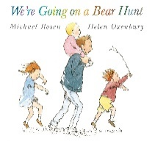  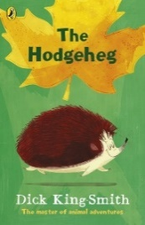  The Hodgeheg by Dick King Smith  We’re Going On A Bear Hunt – Michael Rosen | 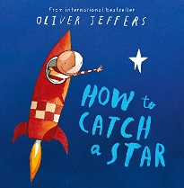  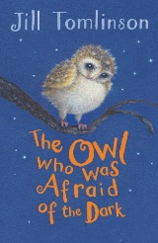  The Owl Who Was Afraid of the Dark – Jill Tomlinson  How to Catch a Star – Oliver Jeffers | 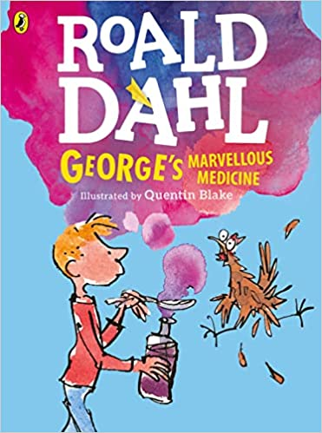  George’s Marvellous Medicine - Roald Dahl | 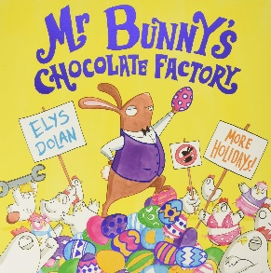  Mr. Bunny’s Chocolate Factory by Elys Dolan | 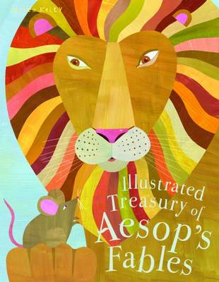  The Illustrated Treasury of Aesop’s Fables by Kelly Miles | 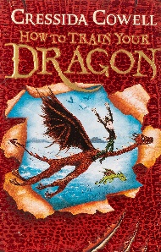  How to Train Your Dragon - Cressida Cowell
Genre: | Fiction:  - Stories with patterned language  - Stories with familiar settings  Non-Fiction:  - Non-chronological reports  - Letters | Fiction:  - Descriptive writing  Non-Fiction:  - Diaries | Fiction:  - Extended stories  Non-Fiction:  - Instructions | Fiction:  - Riddles  - Descriptive writing  Non-Fiction:  - Explanation texts | Fiction:  - Traditional stories - fables  Non-Fiction:  - Letters | Fiction:  - Fantasy stories  Non-Fiction:  - Recount – fact and fiction
Outcomes: | Fiction:  - Story with a repeated pattern (based on We’re going on a bear hunt)  - Story with a familiar setting based on The Hodgeheg ( also setting and character descriptions)  Non-Fiction:  - Informative letter as Max in The Hodgeheg  - Non-chronological report on hedgehogs | Fiction:  - Sensory description of fireworks from Plop’s point of view (in Tomlinson’s novel)  Non-Fiction:  - Write diary entries from different characters views including Plop, the Boy Scout and Mr/Mrs. Barn Owl (in Tomlinson’s novel) | Fiction:  - Extended stories with George’s Marvellous Medicine (setting and character descriptions, summaries, alternative endings)  Non-Fiction:  - Instructions for your own potion (based on George’s Marvellous Medicine) | Fiction:  - Write an animal riddle  - Descriptions of characters in Mr. Bunny’s Chocolate Factory  Non-Fiction:  - Write explanation texts on the life cycle of a human and the water cycle | Fiction:  - Explore the features of a range of traditional tales (fables) and rewrite our own versions  - Write our own story in the style of a fable  Non-Fiction:  - Write an invitation to a summer party  - Write a letter proposing a new school activity | Fiction:  - Write character descriptions (dragon, Stoik, Sea dragon)  - Write a monologue for a character  Non-Fiction:  - Write recounts of school trips (zoo/beach)  - Write recount of events in school
Skills Covered:

