Y3 CREATIVE HOMEWORK
A World of Difference: Showing Understanding
Faiths and Beliefs
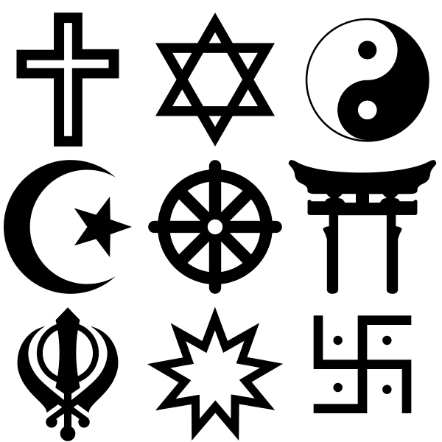

Given out: Friday 17th December 2021
Due in: Monday 10th January 2022

Choose one of the following to complete:
• Create a poster showing the symbols of all five religions studied.
• Design your own Muslim prayer mat.
• Create a Buddha statue using plasticine or playdoh.
• Adapt a Bible story so it is suitable for a young audience, with illustrations.
• Write a poem about creation.
- Make an elephant sculpture.
- Make and play the Dreidel game.

You can present this in any way you want. Be as creative as you want!

Good luck! We look forward to seeing them!

