Y3 CREATIVE HOMEWORK
Law and Order:
Keeping the Peace
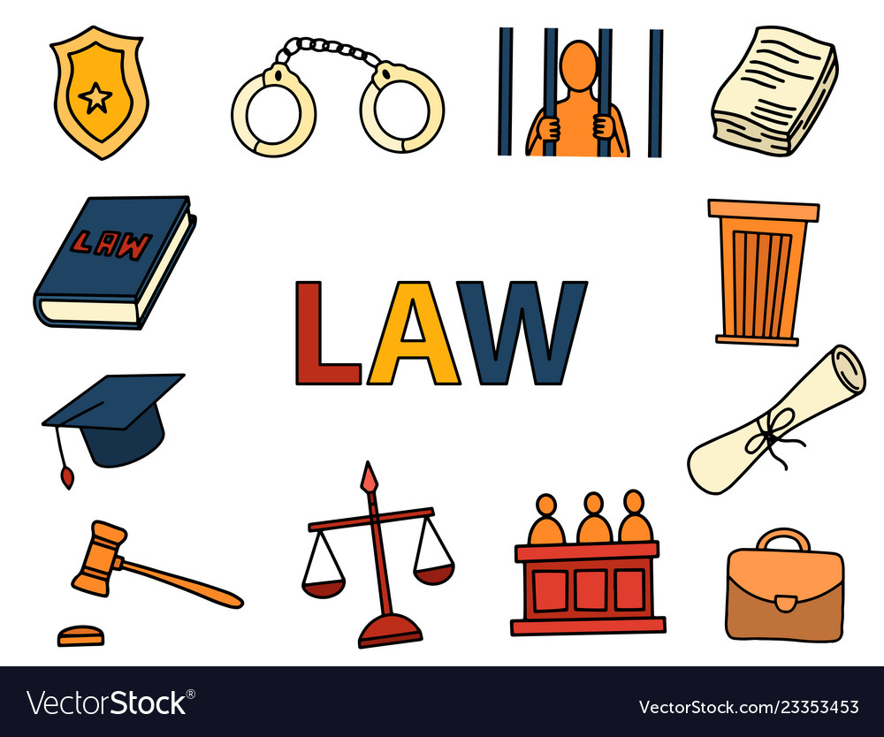

Given out: Friday 22nd October 2021
Due in: Friday 5th November 2021
Choose one of the following to complete:
• Design a new peace symbol.
• Research the history behind the Nobel Peace Prize and make a presentation to tell its story.
• Create a survey and ask people to vote. Produce a report about the results of your survey.
• Create an illustrated acrostic using the word DEMOCRACY.
• Write a vivid description of a scene you would describe as peaceful. Then, draw that scene.
• Make a poster to get across a message linked to a cause e.g. child poverty.

You can present this in any way you want. Be as creative as you want!

Good luck! We look forward to seeing them!

