Term/ Theme: | Autumn 1 | Autumn 2 | Spring 1 | Spring 2 | Summer 1 | Summer 2
 | AU1 – Law and Order: Rules and Rights  AU2 – May the Force Be With You  AU2/SP1 – A World of Difference: World Religions |  | SP1 – Three Giant Steps: Geography  SP2 – Lightning Speed: The World Wide Web |  | SU1 – Out and About: Geography  SU1/2 – Under the Canopy: Rainforests  SU2 – Lindon Man: The Story of Prehistoric Man
Class novels  Supporting texts  May link to Theme (where possible). | 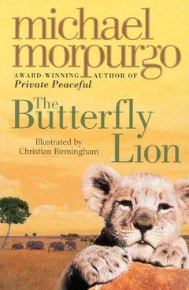  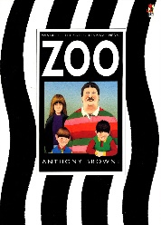  The Butterfly Lion – Michael Morpurgo  Zoo – Anthony Browne | 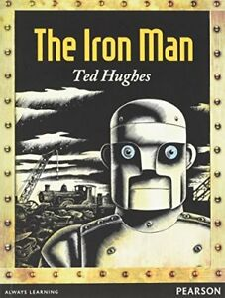  The Iron Man – Ted Hughes | 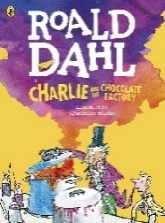  Charlie and the Chocolate Factory – Roald Dahl | 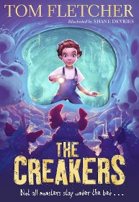  The Creakers – Tom Fletcher | 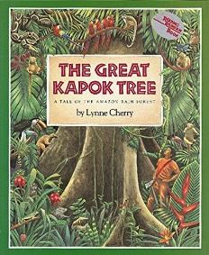  The Great Kapok Tree – Lynne Cherry | 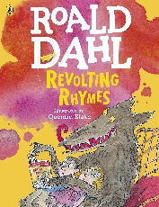  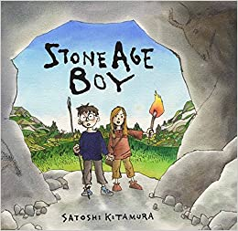  Stone Age Boy –  Satoshi Kitamura  Revolting Rhymes – Roald Dahl
Genre: | Fiction:  - Performance Poetry  - Descriptive writing around The Butterfly Lion  Non-Fiction:  - Letters (Points of View / Persuasion) | Fiction:  - Science fiction stories  Non-Fiction:  - Newspaper reports | Fiction:  - Play scripts  Non-Fiction:  - Instructions | Fiction:  - Mystery stories  Non-Fiction:  - Formal/informal writing | Fiction:  - Adventure stories  Non-Fiction:  - Letters (persuasive)  - Non-chronological reports  - Explanation texts | Fiction:  - Narrative poems  - Stories with historical settings  Non-Fiction:  - Author study (Biographies)
Outcomes: | Fiction:  - A performance poem inspired by If I Were King by A. A. Milne (using repetition/rhyme)  - Setting descriptions of Timbavati  Non-Fiction:  - Persuasive letter as Bertie asking to keep the lion  - Points of view letter to the Prime Minister on zoos | Fiction:  - Science fiction (descriptions of characters/ settings)  - Science fiction story loosely based on The Iron Man  Non-Fiction:  - A newspaper report on the Space Bat | Fiction:  - A play script inspired by ‘Charlie and the Chocolate Factory’ book and scenes from the 1971 film (comparing dialogue in stories and scripts, stage directions)  Non-Fiction:  - Instructions on how to make chocolate rice krispie cakes | Fiction:  - Exploring mystery stories (identifying features, suspense writing, varying sentence lengths)  - Write a mystery story loosely based on The Creakers  Non-Fiction:  - Compare and write a formal letter as the parents and an informal letter as Lucy to the children | Fiction:  - An adventure story set in the rainforest  Non-Fiction:  - A persuasive letter to stop the man cutting down the kapok tree.  - A non-chronological report on an animal  - An explanation text on the life cycle of a plant | Fiction:  - A narrative poem inspired by changing a nursery rhyme into a ‘revolting rhyme’ (using adjectives, similes, alliteration, rhyming couplets)  - Write a setting description of the Stone Age  - Write a story set in the Iron Age  Non-Fiction:  - Author study and biographies on Roald Dahl
Skills Covered:

