Term/ Theme: | Autumn 1 | Autumn 2 | Spring 1 | Spring 2 | Summer 1 | Summer 2
 | AU1 - Athens v Sparta  AU1/2 - Rocky the Findosaur  AU2 /SP1- Come Fly with Me! Africa |  | SP1 – Saxon King. Harold Godwinson  SP2 – That’s All Folks! – Film and Animation |  | SU1 – Window on the World  SU1/2 – Picture our Planet  SU2 – Viking Warrior, Ragnar Lothbrok
Class novels  Supporting texts  May link to Theme (where possible). | 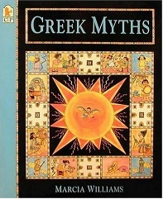  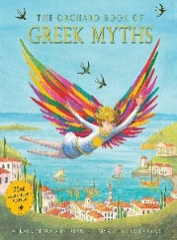  The Orchard Book of Greek Myths – Geraldine McCaughrean  Greek Myths – Marcia Williams | 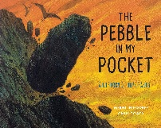  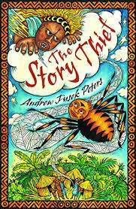  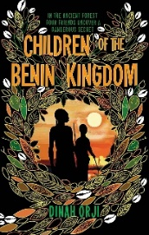  Children of the Benin Kingdom – Dinah Orji  The Story Thief – Andrew Fusek Peters  The Pebble in My Pocket: A History of Our Earth by Meredith Hooper | 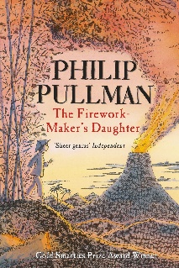  The Firework Maker’s Daughter – Philip Pullman | 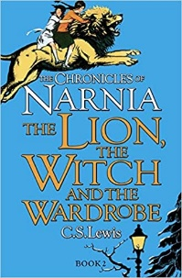  The Lion, The Witch and The Wardrobe –  C. S. Lewis | 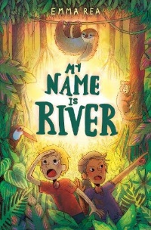  My Name is River – Emma Rea | 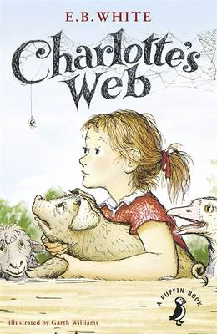  Charlotte’s Web – E. B. White
Genre: | Fiction:  - Myths and Legends  - Poetry – exploring form  Non-Fiction:  - Non-chronological reports | Fiction:  - African Folklore  - Choral and Performance Poetry  Non-Fiction:  - Explanation text | Fiction:  - Stories from Other Cultures  Non-Fiction:  - Advertisements | Fiction:  - Stories set in Imaginary Worlds  - Play scripts  Non-Fiction:  - Informative letter  - Leaflets | Fiction:  - Adventure/Character-driven stories  Non-Fiction:  - Persuasive writing  - Newspaper reports | Fiction:  - Stories which raise issues and dilemmas  Non-Fiction:  - Diary entries
Outcomes: | Fiction:  - Explore a range of myths and legends (focused on Ancient Greece)  - Write your own myth with a moral  - Compare, explore and write haikus, cinquains and tankas  Non-Fiction:  - Write non-chronological reports on a Greek God and a mythical creature | Fiction:  - Read a range of African folklore and identify morals  - Write their own folktale about Anansi the Spider  - Explore, write and perform their own poem based on Walking With My Iguana by Brian Moses  Non-Fiction:  - Write an explanation text on the rock cycle | Fiction:  - Setting descriptions and 1st person experience of another culture  - Explore stories set in other cultures and write their own set in Africa or Greece  Non-Fiction:  - A persuasive advert on Lila’s firework show | Fiction:  - 1st person description of an imaginary world (Narnia)  - Write a story set in their own imaginary world  - Play script of a scene in Narnia based on the 2005 film  Non-Fiction:  - An informative letter as one of the evacuees to their parents  - Create a leaflet all about Narnia | Fiction:  - Re-write My Name is River from an alternative character perspective  Non-Fiction:  - Write and perform a persuasive speech as Dylan about his farm  - Write a newspaper report about Miss. Crassy’s secret project | Fiction:  - Write a story which raises and explores an important issue  Non-Fiction:  - Write a range of diary entries that explores thoughts and feelings from contrasting viewpoints of characters and points in time
Skills Covered:

