MARCH 2025

Dear Parent/Carer
Parents’ Evening this term will be held over two nights; Monday 24th March and Thursday 27th March 2025.
Parents’ Evening is an important time for you to discuss your child’s progress and achievements at school. I hope all parents can find the time to attend.
Please find below your date and time and the teachers you will need to see.
Yours sincerely
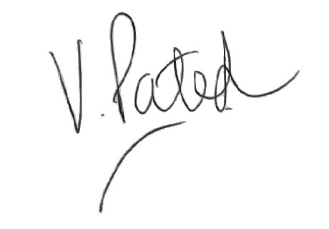
Mrs V Patel
Headteacher

----------------------------------------------------------------------------------------------------------------------
PARENTS’ EVENING – MARCH 2025

Name of child: ..............................................................................................................................

Date: .................................................................... Time: .................................................

Teacher to see: Mrs Clarkson

MARCH 2025

Dear Parent/Carer
Parents’ Evening this term will be held over two nights; Monday 24th March and Thursday 27th March 2025.
Parents’ Evening is an important time for you to discuss your child’s progress and achievements at school. I hope all parents can find the time to attend.
Please find below your date and time and the teachers you will need to see.
Yours sincerely
Mrs V Patel
Headteacher

----------------------------------------------------------------------------------------------------------------------
PARENTS’ EVENING – MARCH 2025

Name of child: ..............................................................................................................................

Date: .................................................................... Time: .................................................

Teacher to see: Mrs Clarkson

