Term/ Theme: | Autumn 1 | Autumn 2 | Spring 1 | Spring 2 | Summer 1 | Summer 2
 | AU1 – You’re Not Invited – Invaders and Settlers  AU1/2 – In your Element - Geography  AU2/SP1 - Come Fly with Me! America |  | SP1 – Been Around The World - Geography  SP2 – Mission Control – Earth and Beyond |  | SU1 – Pharaoh Queen – The Story of Hatshepsut  SU1/2 – Full of Beans - Energy  SU2 – True Crime? The Pendle Witches
Class novels  Supporting texts  May link to Theme (where possible). | 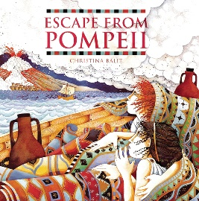  Escape from Pompeii – Christina Balit | 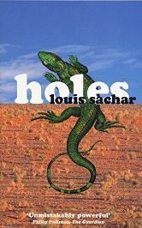  Holes - Louis Sachar | There’s A Boy In The Girls’ Bathroom – Louis Sachar | 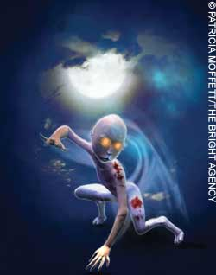  The Star Beast – Nicholas Stuart Gray | 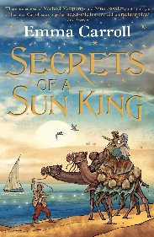  Secrets of a Sun King by Emma Carroll | 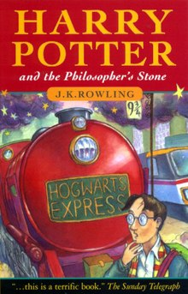  Harry Potter and the Philosopher’s Stone by J. K. Rowling
Genre: | Fiction:  - Stories with historical settings  Non-Fiction:  - Explanation texts  - Leaflets and brochures | Fiction:  - Descriptive writing  - 1st person narrative  Non-Fiction:  - Non-chronological reports | Fiction:  - Stories with issues and dilemmas  Non-Fiction:  - Discussion/balanced arguments  - Letters expressing points of view | Fiction:  - Science Fiction  Non-Fiction:  - Newspaper Reports | Fiction:  - Poetry - power of imagery  - Myths and Legends  Non-Fiction:  - Diary entries | Fiction:  - Novels and stories by significant authors  - Classic poetry (exploring form)  Non-Fiction:  - Persuasive writing  - Explanation texts
Outcomes: | Fiction:  - Write a story about a historical natural disaster  Non-Fiction:  - An explanation text about volcanoes around the world  - Leaflets about __________. | Fiction:  - Descriptive writing inspired by Holes (setting – Camp Green Lake)  - 1st person narrative inspired by a character in Holes  Non-Fiction:  - A non-chronological report about their chosen reptile | Fiction:  - Character descriptions that explore contrasting characters  - Write a story about the animals in Bradley’s bedroom  Non-Fiction:  - Write a balanced argument surrounding issues raised in the novel.  - Write a letter of advice to a character experiencing issues. | Fiction:  - A science fiction story about their own beast’s journey to earth  Non-Fiction:  - A newspaper report about the first moon landing | Fiction:  - Explore and write poetic techniques including personification, similes, metaphors, alliteration and onomatopoeia  - Write a poem about ‘the vase’ in Carroll’s novel  - Write their own Egyptian legend after exploring the legend of Isis and Osiris  Non-Fiction:  - Diary entries from various characters’ perspectives. | Fiction:  - Descriptive and story writing based on the events in the novel.  - Write a ghost story based around Hogwarts.  - Recreate a classic poem in relation to their class novel.  Non-Fiction:  - Persuasive writing inviting Harry Potter to join Hogwarts.
Skills Covered:

