Term/ Theme: | Autumn 1 | Autumn 2 | Spring 1 | Spring 2 | Summer 1 | Summer 2
 | AU1 – Wars of the World – Wars, Past and Present  AU1/2 – Time Team – History / Geography  AU2/SP1 – ‘I Have a Dream…’ – Discrimination & Prejudice |  | SP1 – Go With the Flow - Science  SP1/2 – A World of Bright Ideas – Inventions and Developments |  | SU1 – British Bulldog – The Story of Winston Churchill  SU1/2 – Global Warning – Waste and Pollution  SU2 – The Rescuers – The Story of Heroes of the Titanic
Class novels  Supporting texts  May link to Theme (where possible). | 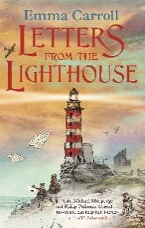  Letters from the Lighthouse – Emma Carroll | 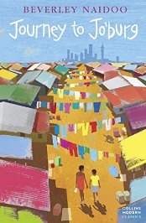  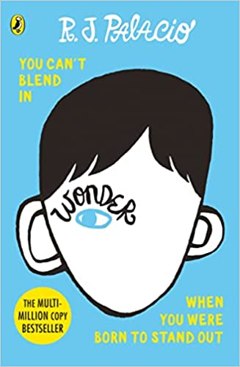  Wonder – R. J. Palacio  Journey to Jo’burg – Beverley Naidoo | 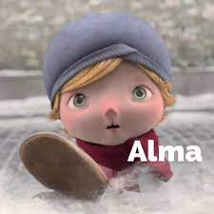  Alma – Literacy Shed Video | 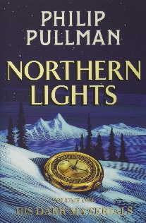  Northern Lights by Philip Pullman | 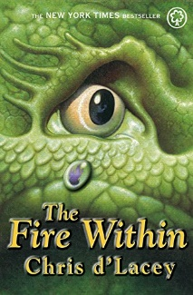  The Fire Within by Chris d’Lacey | 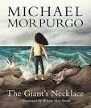  The Giant’s Necklace by Michael Morpurgo
Genre: | Fiction:  - Historical fiction  - Classical and narrative Poetry  Non-Fiction:  - Explanation texts | Fiction:  - Stories and poetry that explore issues and dilemmas  Non-Fiction:  - Biographies & Autobiographies | Fiction:  - Horror/scary stories and spooky tales  Non-Fiction:  - Newspaper Reports | Fiction:  - Film narratives (The Present)  Non-Fiction:  - Advertisements | Fiction:  - Fantasy stories  Non-Fiction:  - Instructions  - Non-chronological reports | Fiction:  Short stories  Non-Fiction:  - Formal/informal letter writing
Outcomes: | Fiction:  - Historical setting description of an air raid  - Narrative poetry  Non-Fiction:  - Write an explanation text | Fiction:  - Write a short story about Journey to Jo’Burg  - Write a poem exploring racism  Non-Fiction:  - Write a biography on a chosen famous person  - Write their own autobiographies | Fiction:  - Write a horror story based around Alma  Non-Fiction:  - Newspaper about missing children (based on Alma) | Fiction:  - Write a story from an alternative perspective (based on film narrative)  Non-Fiction:  - Create an advert for a car of the future | Fiction:  - Explore the fantasy genre and produce their own fantasy settings, characters and story  Non-Fiction:  - Instructions on a craft they’ve experienced  - Non-chronological reports on the world and nature | Fiction:  - Descriptive writing inspired by a short story  Non-Fiction:  - Letter writing for a range of audiences and purposes (including letters to parents and post cards)
Skills Covered:

