End of term newsletter
Happy Christmas to you all!
We have had a wonderful end to this very busy term. The children loved performing their Christmas plays and I was very proud of everyone. It was lovely to see so many of you watching your children perform. Some year 5 and year 6 children were lucky enough to go roller-skating on the rink in town and everyone enjoyed a pantomime. The Christmas parties were great fun and unbelievably the children have still been working hard.
We wish you a very Merry Christmas and look forward to seeing everyone at 8:40 am on Monday 9th January for the start of term.
Staffing
We are sorry to be saying goodbye to Mr Currid and Mrs Robson and wish them all the best in their new challenges. We would like to welcome Mrs Sutton to the year 6 team and Miss Hodson to the EYFS team.
Ethos Team
Our value for this half term.
Love
“Let all that you do be done in love” 1 Corinthians 16:14
Prayer, by Fiza
Dear God,
Thank you for everything you have given us. Help us to create love at St Matthew’s. We are all working on respecting others, being creative and showing friendship. Help us to serve by looking after one another. Amen.
Our New Vision
On Friday 9th December, Ethos Team delivered worship to the whole school, launching our new Christian Vision 'Let all that you do be done in love' 1 Corinthians 16:14. We had met before to prepare our worship, choose the songs, write prayers and talk about how we would share our new school vision with the whole school. We talked about Paul's letter to the Corinthians, and how we would use this teaching to inform how we were going to live out our new vision at school.

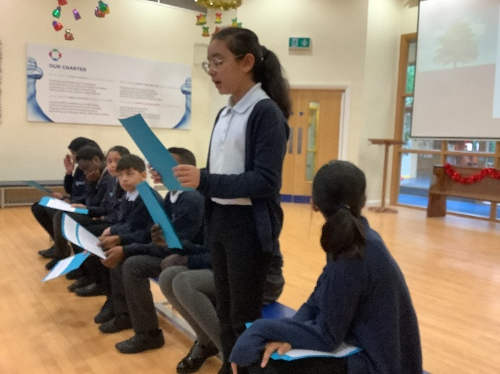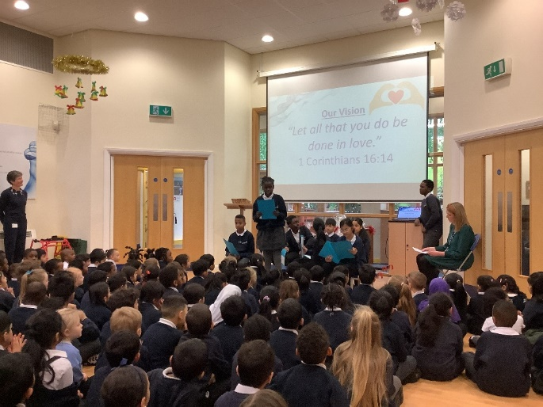

Here are some of our reflections on our new vision.

"With love, our diverse school community can have friendship and respect for everyone. This vision shows how hard we are all working to include everybody and be an inclusive place." Khalid

"Love in our school community makes us complete. This is a true gift. We are a team and we can do anything. With this love, we share. We reach any goal. We can make our school a better place. Love is the key to life, and the key for our school." Haleemah

"With love we have everything. By showing love, we make our world a better place. If we showed no love it this school it wouldn't be a fun or safe place to go to. With love, our school has potential, friendships are made and people trust each other. Together, we can do anything and everything. Love unlocks all doors and helps us to achieve anything!" Sakina

"Without love we have nothing. With love, our school has potential. With love we have a safe, nurturing place to learn and have fun. Together we can all make our school an inspiring place to be! We can learn to help care and love as our school family." Eshaal

"If you have love, you feel like a million colours. If we have love, our school will be nurturing and inspiring. Without love, everything would be dull. Love helps us to set all our goals and dreams." Azza

Eco-Warriors
The Eco Warriors would like to remind everyone of the 3 R’s. Reduce, Reuse and Recycle. Reduce means to cut back on the amount of rubbish we generate. Reuse means to find new ways to use things that would have been thrown in the bin. Recycle means to turn something old and useless into something new and useful.

Y1M - Snowdrops
Library visit - 1M had a visit to Bolton Library. 1M walked to the library and saw some familiar places / people on the way. During the visit the children learned how to borrow books while also having a story read to them and the opportunity to explore the books in the library.

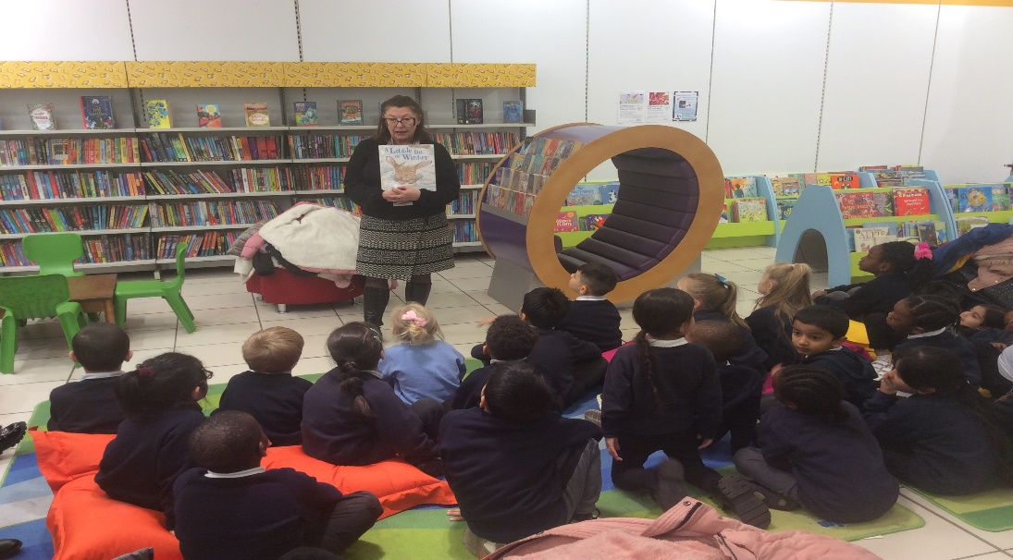

Reception Nativity

On Tuesday 13th December, Reception class performed their wonderful nativity 'A Little Bird Told Me'. They had all worked incredibly hard learning the songs and actions as well as their lines for the performance. All the staff were absolutely amazed by how confident everyone was and how far we have come this term! The children loved it, and they were even singing the songs again after the performance. We enjoyed a lovely treat of hot chocolate the next day, as a big 'well done' for our amazing and confident nativity.

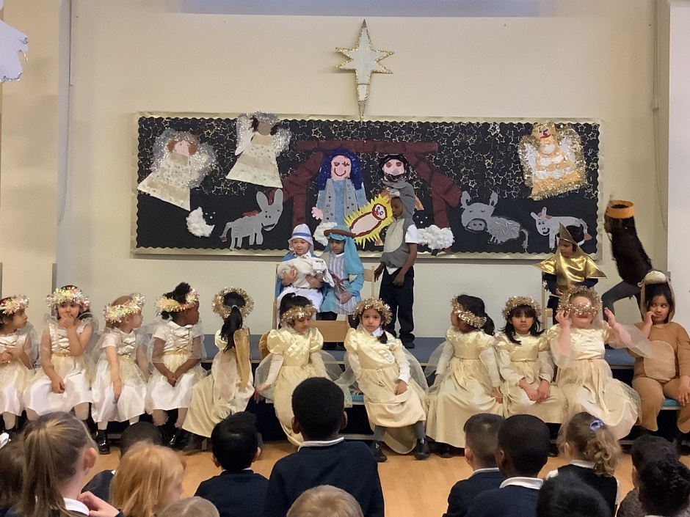
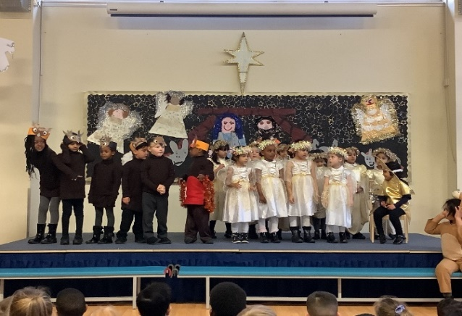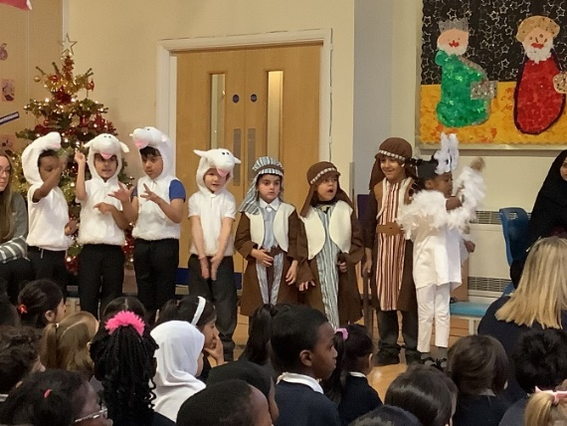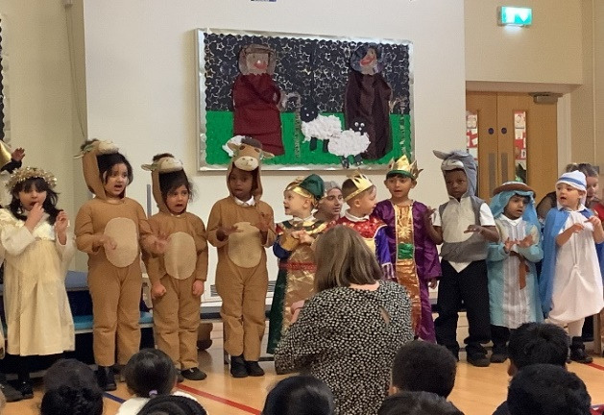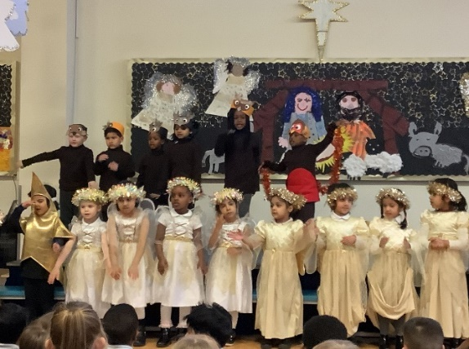

Roller-skating
We were lucky to get a free slot at the pop-up roller rink in Bolton Town Centre. We took children from the Y5 and Y6 classes. We had an absolute ball, there was much falling over and there would have been many bruises the next day. We couldn't stop laughing.

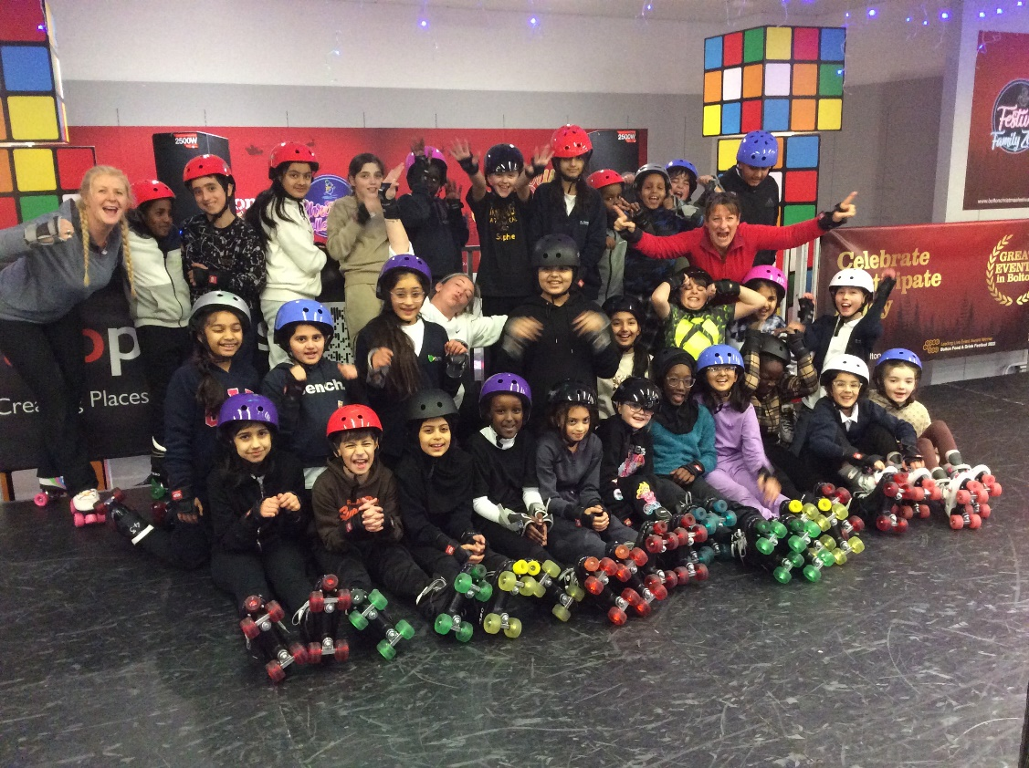

Octagon thetare
All of KS2 went to see A Christmas Carol at the Octagon theatre. It was a brilliant performance and we all enjoyed it, the ghost of Christmas Past made us scream and the pudding song made us dance.
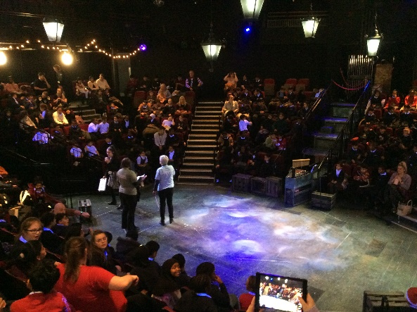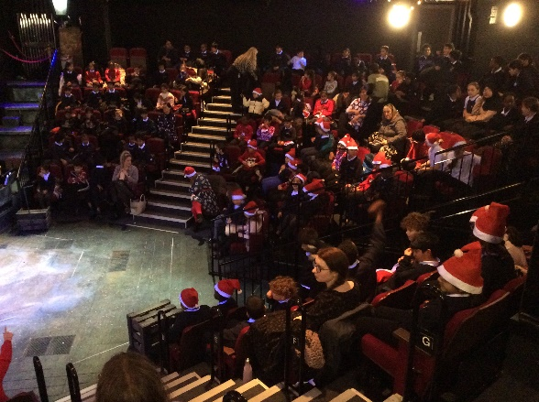

Choir
Choir had a fantastic time carol singing at Crompton Place Library and ASDA. They sounded beautiful!
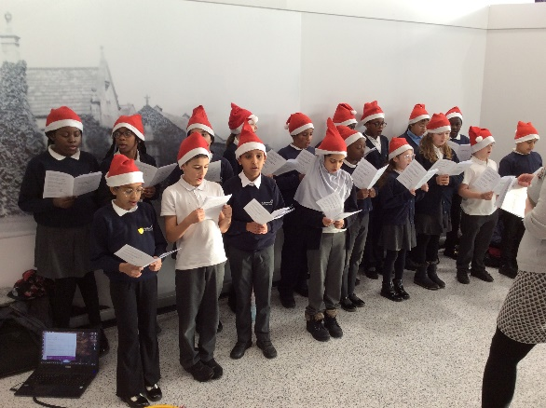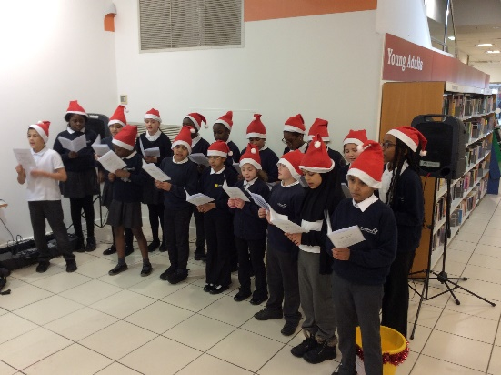

1S – Science
In science Y1S tested different materials to find out which one would make the best umbrella. We found out that the metal and the plastic were both waterproof.
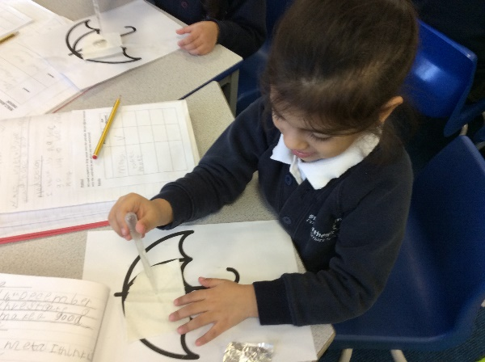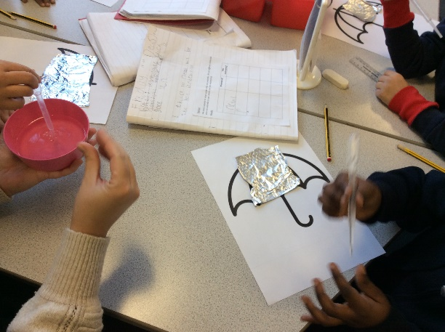

Violin Concert
Our violinists gave a Christmas concert to their parents and the children in Year 2. It was lovely to hear the progress they have made in their playing over the term. Well done.

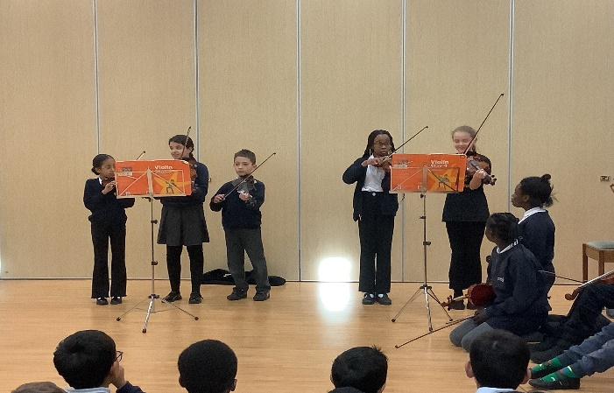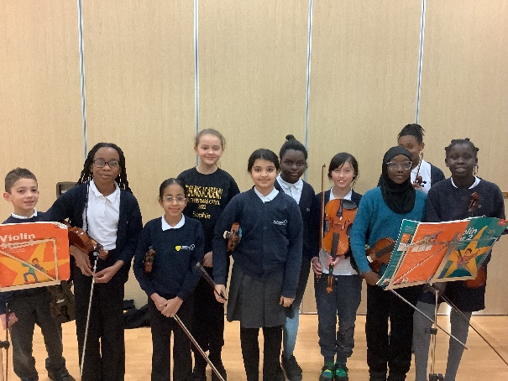

KS1 Nativity
Year 2 performed their nativity called ‘The Christmas Recipe’ and they all did incredibly well. They did lots of singing, dancing and acting and it was brilliant to watch.

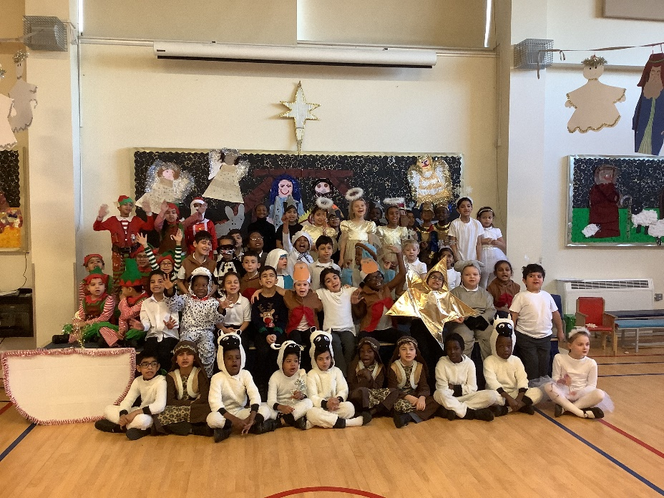

Nursery
Nursery have had a brilliant time celebrating Christmas! The children couldn't believe it when Father Christmas arrived at our Christmas Party!
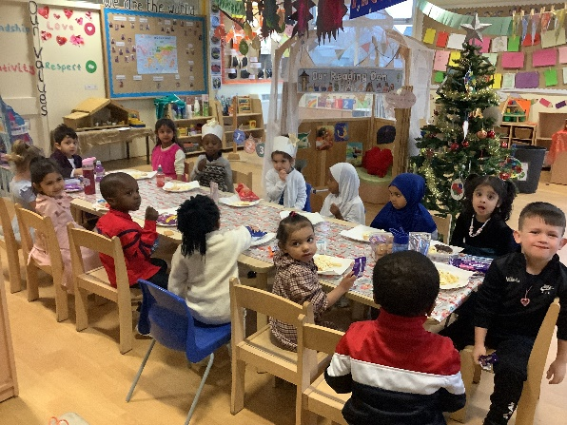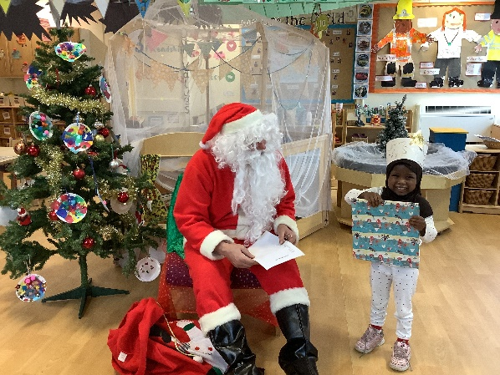
Christmas Fair
This year’s Christmas fair was a huge success. It was lovely to see all our families get into the Christmas spirit and have fun together.
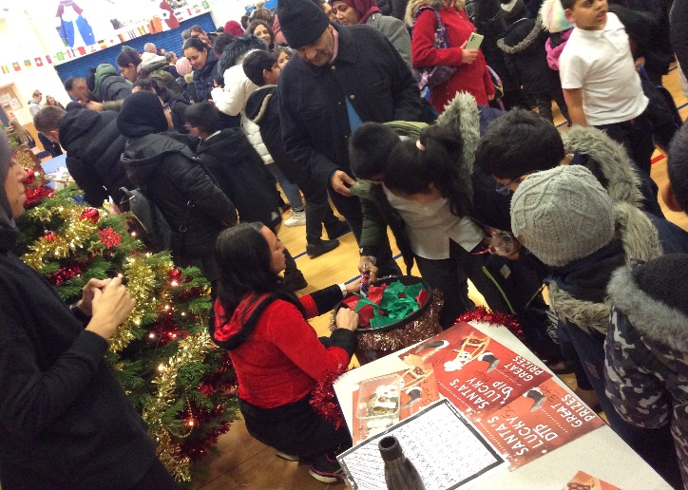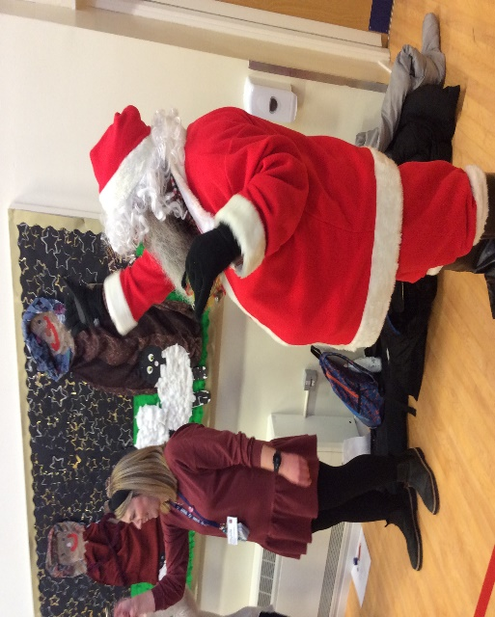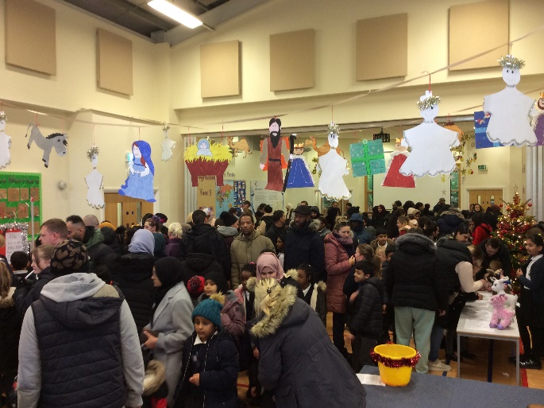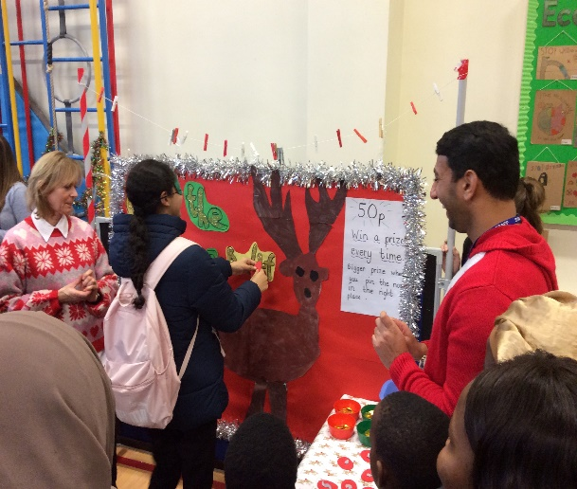

Key Stage 1 Panto
We had a pantomime perform in school for our nursey, reception and Y1 and Y2 classes. It was Mother Goose; we had a great time.

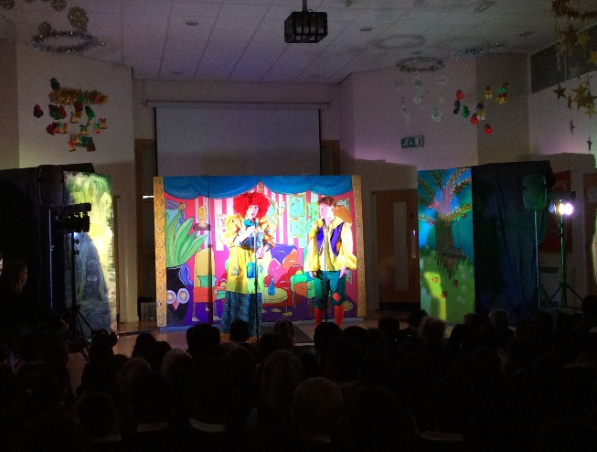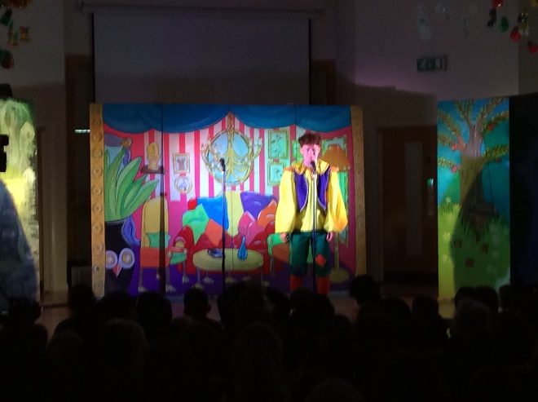

Attendance Matters!
Well done to our winning classes and a huge well done to all the children who received a prize today for coming to school EVERYDAY since September – You are 100% attendance Stars!

Attendance winners for December
Infants
1st | 92.90% | Y2 M Poppies
2nd | 92.30% | Y1M Snowdrops
3rd | 91.30% | Y2B Bluebell
Juniors
1st | 94.20% | Y5C Dragonflies
2nd | 93.70% | Y4M Woodpeckers
3rd | 91.50% | Y6C Butterflies

Attendance winners for Autumn Term
Infants
1st | 92.10% | Y1M Snowdrops
2nd | 91.80% | Y2B Bluebell
3rd | 90.60% | Y2M Poppies
Juniors
1st | 95.60% | Y5C Dragonflies
2nd | 95.20% | Y4M Woodpeckers
3rd | 94.70% | Y6C Butterflies

