Freeze Pop Friday

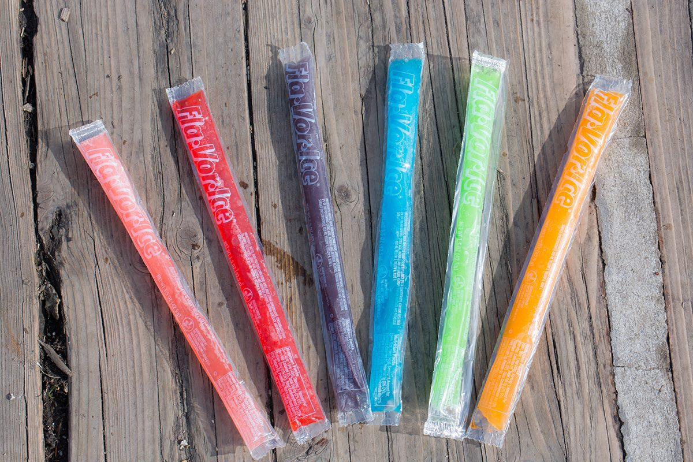

Pay 50p on the School Money App and wear non-uniform.

Pay 50p on the School Money App and buy an ice pop.

Friday 30th May 2025