St Michaels Catholic Academy - Careers Programme

Vision and Objectives:

At St Michaels Catholic Academy, we are committed to shaping and developing the character of our students, guided by virtue theory and the teachings of the Catholic Church. Our Careers programme is designed to reflect these core values, incorporating the Gatsby Benchmarks to ensure a comprehensive and effective approach. We comply with our legal obligations under Section 42B of the Education Act 1997, aiming to provide a stable, consistent, and inclusive careers education.

Our intent is to prepare students for their future, whether it be in further study or the world of work. We strive to raise aspirations and provide exposure to a diverse range of educational and employment opportunities, embedded within our school curriculum. Each student's experience is tailored to their individual needs and circumstances, ensuring equal opportunities and inclusion.

At St Michaels, we believe that a careers programme is an entitlement for every student. Our aim is to support all students in making positive transitions, living independently, and achieving their true potential in life. Our enriching, stimulating, and sensitive careers programme is designed to support these goals.

Key Aims and Objectives

* Understanding Transitions and Future Planning: Support students and their families in developing a clear understanding of transitions and future planning.

* Preparation for Post-School Life: Prepare students for successful and positive transitions into life after school.
* Exposure to the World of Work: Provide well-rounded and broad experiences of the ever-changing world of work.

* Development of Interpersonal Skills: Support the development of essential interpersonal skills, qualities, and attitudes needed for life.

* Fostering Ambition and Independence: Encourage ambition and determination, motivating students to live as independently as possible.

* Promoting Inclusion and Equal Opportunities: Ensure inclusion and equal opportunities by challenging stereotypes and encouraging diversity.

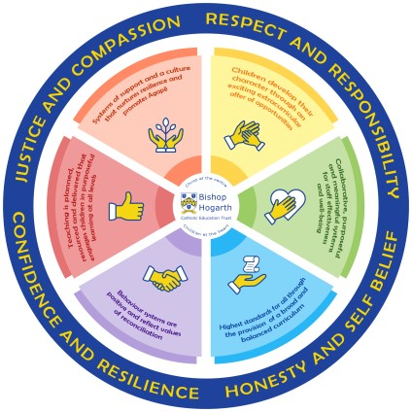

We emphasise eight virtues in particular, grouped into four key pairs. These are:
• Justice and Compassion
- Confidence and Resilience
- Honesty and Self Belief
- Respect and Responsibility

There are 8 Gatsby Benchmarks:

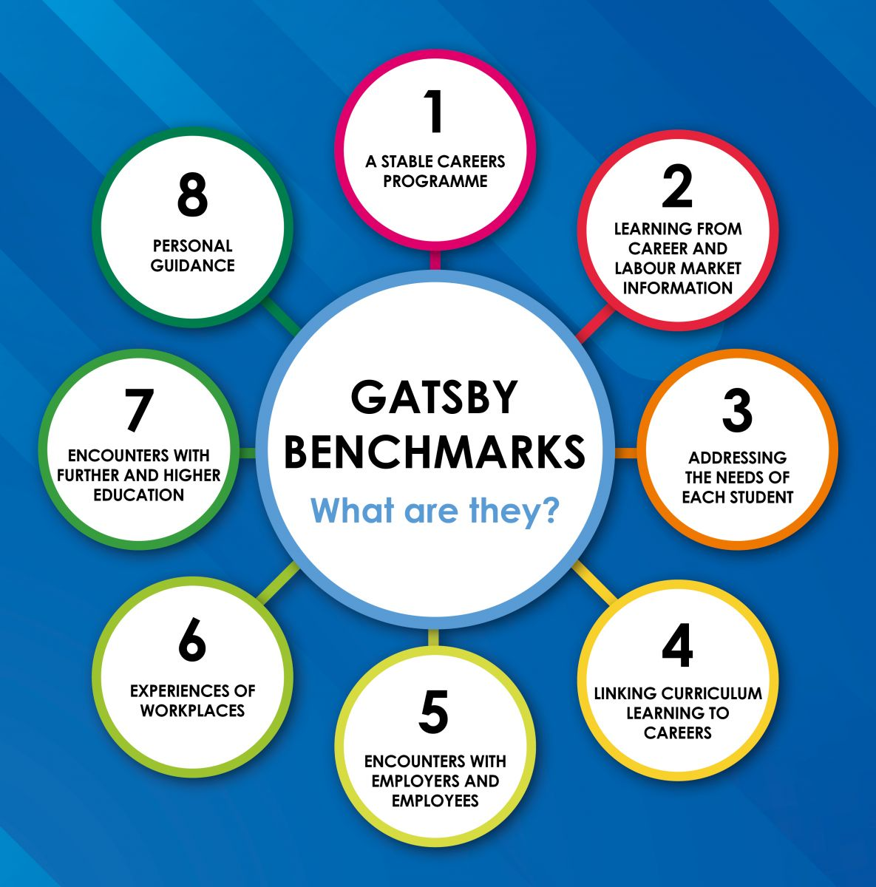

Together, they underpin our careers’ provision through PSHE, timetabled lessons, dedicated careers’ advisor appointments and specific interactions with external employers and educational stakeholders. The Gatsby Benchmark framework aims to ensure that all students in Years 7-11 are entitled to:
- To find out about technical education qualifications and apprenticeships opportunities, as part of a careers programme which provides information on the full range of education and training options available at each transition point.
- To hear from a range of local providers about the opportunities they offer, including technical education and apprenticeships – through options evenings, assemblies and group discussions and taster events.
- To understand how to make applications for the full range of academic and technical courses.

The Careers’ Team:

Mrs Iley & Mrs McCarten are our designated Strategic Leads for careers, they oversee the development of the careers’ programme. We also have Mr Butt who is our designated Works Experience Co-ordinator. He works with students in year 10 to ensure they find placements and gain experience of the workplace. We provide independent careers’ advice to student’s vis Mr Chris Rea. He offers independent advice and guidance to ensure we are compliant with government expectations.

Provision includes careers’ assemblies and sessions, CEIAG, workshops, employability skills and interview techniques, enterprise activities and partnerships with local business and industry. We work closely with the Tees Valley Combined Authority and have 1 Enterprise adviser.

The written guide below shows the variety of experiences that are on offer at St Michaels Academy, broken down into the Gatsby Benchmarks. From this you can see the range of exciting opportunities students at St Michaels can expect in each academic year.

If you are able to help with the provision of external speakers or employment opportunities for our students, please do not hesitate to get in touch – Judith Iley, Emily McCarten or Naeem Butt via telephone: 01642 870003; email: stm-careers@stmichaels.bhcet.org.uk

 | Gatsby Benchmark 1  A stable careers programme | Gatsby Benchmark 2  Learning about the Labour-Market | Gatsby Benchmark 3  Addressing the needs of each pupil | Gatsby Benchmark 4  Linking careers to the curriculum | Gatsby Benchmark 5  Encounters with employers/employees | Gatsby Benchmark 6  Experience of workplaces | Gatsby Benchmark 7  Encounters with  Further and Higher Education | Gatsby Benchmark 8 Personal guidance
YEAR 7 | Year 7 introduced to Unifrog and begin profiles September-December. This will be introduced from September 2024  Open door policy in the Careers Hub to give students access to Unifrog and careers support.  PSHE delivery on  Aspirations for Life. This will access goal setting and raising aspirations. | Designated PHSE lesson based around LMI:  - Transition Points  - Finding careers Information | PSHE delivery on careers routes throughout the year.  Open door policy in the Careers Hub to careers support and advice. | There are specific careers links made alongside relevant subject matter which is delivered in lesson time.  Employability skills will be explicitly linked within subjects.  Various STEM activities with the Maths & Science Departments | Careers Fair in the spring term.  Guest speakers from employers such as the BBC and the NHS throughout the year who will discuss the various routes into careers. | Virtual or in person visit to a local site.  Based on year group interests in the summer term. Previous visits have included:  - The Town Library  - Local Sports and Theatre Complex  - Activity centres | Local educational providers are invited to assemblies.  Careers fair in the spring term. | Open door policy in the Careers Hub to give students access to support and guidance and help with applications.
Learning Outcome  Year 7 | Students will be able to create an online profile using Unifrog and have completed both the personality quiz and their “frog type”.  Students will be able to discuss employers they have found interesting and understand more about the local labour market.

YEAR 8 | Year 8 introduced to Unifrog and begin profiles September-December. This will be introduced from September 2024  Open door policy in the Careers Hub to give students access to Unifrog and careers support.  PSHE delivery on  Aspirations for Life. This will access goal setting and raising aspirations. |  | Careers in the curriculum.  Designated PHSE lesson on LMI. |  | PSHE delivery on careers routes.  Open door policy in the Careers Hub to careers support and advice. | There are specific careers links made alongside relevant subject matter which is delivered in lesson time.  Employability skills will be explicitly linked within subjects. |  | Careers Fair in the spring term. |  | Virtual or in person visit to a local site  based on year group interests in the summer term. |  | Local educational providers are invited to assemblies.  Careers fair in the spring term. |  | Open door policy in the Careers Hub to give students access to support and guidance and help with applications.
Learning Outcome  Year 8 | Students are beginning to build their employability skills portfolio by accessing Unifrog to build their online profile.  Students will be able to confidently discuss the different routes in to post 16 educations including, T-Levels, Traineeships, Apprenticeships, A-Levels and other vocational courses.
YEAR 9 | Year 9 introduced to Unifrog and begin profiles September-December. This will be introduced from September 2024  Open door policy in the Careers Hub to give students access to Unifrog and careers support.  PSHE delivery on Aspirations for Life. This will access CV writing and interpersonal skills. |  | Local LMI is shared in assembly. |  | KS4 options event with support from careers team available.  Options assemblies which discuss the courses available at St Michaels.  Open door policy in the Careers Hub to careers support and advice. | There are specific careers links made alongside relevant subject matter which is delivered in lesson time.  Employability skills will be explicitly linked within subjects. |  | Careers Fair in the spring term. |  | Army Explorer Days – site visits and employability |  | Local educational providers are invited to assemblies.  Careers fair in the spring term.  Targeted trip to a university to raise aspirations. |  | Open door policy in the Careers Hub to give students access to support and guidance and help with applications.
Learning Outcome  Year 9 | Incorporating Year 7and 8 students will have used developed skills to create a Careers Pathway map for a chosen career. This will include their post 14 choices for secondary education they will be able to reflect on whether their choices for GCSE are appropriate and have successfully made their choices for KS4.  Students will be able to discuss employers they have found interesting and begin to link local labour market to their chosen career pathway. They will have a reflection based on their ideas from the previous years.
YEAR 10 | Open door policy in the Careers Hub to give students access to Unifrog and careers support.  PSHEE delivery on Aspirations for Life during Spring Half Term. This will access goal setting and beginning to look at post 16 options. |  | Works Experience Placement - 3 days in the work place.  Employability Skills workshops |  | Open door policy in the Careers Hub to careers support and advice. | There are specific careers links made alongside relevant subject matter which is delivered in lesson time.  Employability skills will be explicitly linked within subjects. |  | Local employers are invited to join assemblies throughout the year.  Workplace visits for all Year 10 students targeted through interests to meet a wide range of employees from that workplace.  Careers Fair in the spring term. |  | Local educational providers are invited to assemblies.  Careers fair in the spring term.  Work experience for all Year 10 students targeted through interests to gain a valuable experience of a workplace.  Army Explorer Days – site visits and employability. |  | All students will be invited to trips to local colleges and post 16 destinations.  Local educational providers are invited to assemblies, students will also meet providers through the careers fair.  Targeted Students go to Oxford University for a Visit. |  | Open door policy in the Careers Hub to give students access to support and guidance and help with applications.  Individual session with Careers advisor scheduled May/June/July.
Learning Outcome  Year 10 | Students will have considered their post 16 education options and completed the Post 16 options activity on Unifrog  Students will be confident in explaining the various post 16 routes in education and how that affects their career pathway. This will be a reflection task and will add to their current careers portfolio and online profile on Unifrog.  Students will have completed another 3 competencies and will have developed a CV using previous years competencies.
YEAR 11 | PSHEE delivery on Aspirations for Life during Spring Half Term. This will access interview skills, interpersonal skills and goal setting. | When appropriate LMI is shared through the PREP PowerPoint which is then discussed during form time.  Local LMI is shared in targeted assembly. |  | All students have at least one appointment with either the academic tutors, careers advisor or a member from the Senior Leadership Team to tailor careers pathway and post 16 opportunities.  Targeted students are given teacher mentors to help and address their individual needs.  Open door policy in the Careers Hub to careers support and advice. |  |  | There are specific careers links made alongside relevant subject matter which is delivered in lesson time.  Employability skills will be explicitly linked within subjects. |  | Local employers are invited to join assemblies throughout the year.  Students meet employers through the careers fair.  Careers Fair in the spring term. |  | Opportunity to go on summer placement with the NCS. |  | Selected students will be invited to trips to local colleges and post 16 destinations.  Local educational providers are invited to assemblies, students will also meet providers through the careers fair. |  | All students to receive 1:1 session with careers advisor.  Open door policy in the Careers Hub to give students access to support and guidance and help with applications.
Learning Outcome  Year 11 | Students will have completed all competencies on Unifrog. This completes their online careers profile.  Students will be confident in their post 16 choices, evidenced by their career plan and they will be able to articulate how their post 16 choices affect their career plan. All students will have had at least one 1:1 career advice appointment.

Partnerships:
We welcome partnership with local employers and training providers. You could get involved by volunteering for mock interview, our careers fair, mentoring, offering work experience placements, providing industry tours or subjects talks. If you would like to discuss ways to get involved, please get in contact.
Parents and Carers:
Parent and Carers are welcome to review and give feedback on the careers provision. This will be done through a parent text through our MyEd app. This will be done yearly to ensure your feedback can be used to improve our careers provision. There are also several opportunities through parents evening that you can feedback to the school.

Monitoring and Evaluation:
The careers team will review our programme through a full evaluation. We use the CDI framework and the Gatsby Benchmarks.
We are also required to complete a compass review every half term to help us focus where our provision is needed most. Data generated through feedback from students, parents and staff is used to ensure the evaluations can be as accurate as possible. Finally, as a school we report on KS4 destination data. Please see our Careers Policy for more information.

UPDATED: May 2024

